## GOOGLE KOTLIN fundamentals GUIDE

## Main link: https://developer.android.com/courses/android-basics-compose/unit-1

### [Introduction to Kotlin](https://developer.android.com/courses/pathways/android-basics-compose-unit-1-pathway-1)

## [1. Before you begin](https://developer.android.com/codelabs/basic-android-kotlin-compose-before-you-begin?continue=https%3A%2F%2Fdeveloper.android.com%2Fcourses%2Fpathways%2Fandroid-basics-compose-unit-1-pathway-1%23codelab-https%3A%2F%2Fdeveloper.android.com%2Fcodelabs%2Fbasic-android-kotlin-compose-before-you-begin#0)

Welcome to Android Basics with Compose!

This course is for people who want to learn how to build Android apps in the Kotlin programming language using the latest best practices recommended by Google. You will build a series of apps using Jetpack Compose, which is the modern way to create beautiful user interfaces (UIs) in your Android apps.

You'll work through codelabs, which are step-by-step coding instructions for how to build an app or a feature for an app. If you're more of a visual learner who wants to watch how it's done first, some of these codelabs are accompanied by code-along videos. There are also practice problems to reinforce what you learned, and projects that provide you with the opportunity to experiment and learn more on your own.

Learning is a personal experience that's different for everyone. Depending on your background and experience, there are several options for how you can navigate this course most effectively.

## ****For people who are new to programming****

If you're new to programming, start at the beginning of the course and work your way through each learning pathway in order. The programming and Android concepts build on each other, which is why it's important to go through the content sequentially. You're also encouraged to work through the practice problems and projects as additional ways to build your confidence as a new developer.

## ****For existing developers****

If you already have programming experience, you can skip some of the material to move through the course at a quicker pace. The beginning of each unit contains codelabs for any necessary Kotlin programming concepts you need to build the apps in that unit. If you feel confident in those topics about the Kotlin language, you can skip those sections and move into the content on building apps.

If you're already an Android developer, you may be more interested in the Compose topics presented in this course. [Compose](https://developer.android.com/jetpack/compose) is Android's modern toolkit for building native UI, which simplifies and accelerates UI development. It requires less code to implement a UI compared to the Android View system, which makes your app easier to maintain. If you want to learn more about Compose, the first half of this course is the most relevant because it covers UIs, Material Design, and navigation. Alternatively, you can work through the [Jetpack Compose for Android Developers course](https://developer.android.com/courses/pathways/compose) with articles, videos, and codelabs on important topics for developers switching to Compose.

## ****Other training materials****

If you're specifically interested in learning Android with the older UI toolkit (that uses Views) instead of Compose, you can take the [Android Basics in Kotlin course](https://g.co/android/basics).

Regardless of which route you take to learn Android, we hope these resources help you bring your app ideas to life!

Have fun learning,

Your instructors from the Android Team at Google



Create and use variables in Kotlin

[1. Before you begin](https://developer.android.com/codelabs/basic-android-kotlin-compose-variables?continue=https%3A%2F%2Fdeveloper.android.com%2Fcourses%2Fpathways%2Fandroid-basics-compose-unit-1-pathway-1%23codelab-https%3A%2F%2Fdeveloper.android.com%2Fcodelabs%2Fbasic-android-kotlin-compose-variables#0)

In the apps that you use on your phone, notice that some parts of the app stay the same, while other parts change (or are variable).

For example, the names of the categories within the Settings app stay the same – Network & internet, Connected devices, Apps, and more.

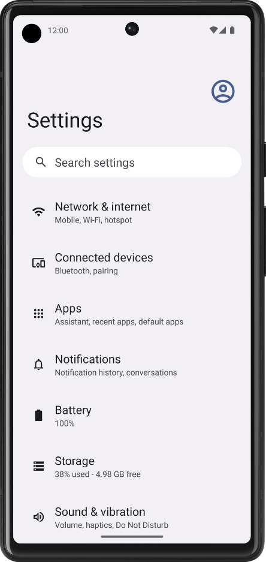

On the other hand, if you look at a news app, the articles will change often. The article name, source, time posted, and images change.

How do you write your code so that content changes over time? You can't rewrite the code in your app every time there are new articles to post, which happens every day, every hour, and every minute!

In this codelab, you learn how to write code that uses variables so that certain parts of your program can change without having to write a whole new set of instructions. You will use the Kotlin Playground as you did in the previous codelab.

**What you'll build**

* Short programs in Kotlin that use variables.

**What you'll learn**

* How to define a variable and update its value.
* How to select an appropriate data type for a variable from the basic data types in Kotlin.
* How to add comments to your code.

**What you'll need**

* A computer with internet access and a web browser.

[2. Variables and data types](https://developer.android.com/codelabs/basic-android-kotlin-compose-variables?continue=https%3A%2F%2Fdeveloper.android.com%2Fcourses%2Fpathways%2Fandroid-basics-compose-unit-1-pathway-1%23codelab-https%3A%2F%2Fdeveloper.android.com%2Fcodelabs%2Fbasic-android-kotlin-compose-variables#1)

In computer programming, there's the concept of a *variable*, which is a container for a single piece of data. You can envision it as a box that contains a value. The box has a label, which is the name of the variable. By referring to the box by its name, you have access to the value it holds.

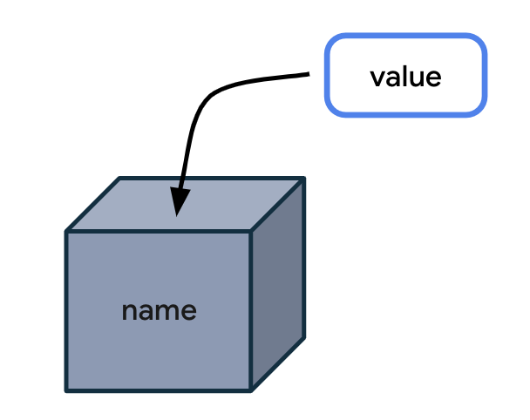

Why store the value in a box and reference the box by its name when you can simply use the value directly? The problem is that when your code uses values directly in all the instructions, your program will only work for that specific case.

Here's an analogy that can make it easier to understand why variables are useful. The following is a letter for someone you recently met.

*Dear Lauren,*

*It was great meeting you today at the office. I look forward to seeing you on Friday.*

*Have a nice day!*

This letter is great, but it only works for your specific situation with Lauren. What if you find yourself writing the same letter many times but with slight variations for different people? It would be more efficient to create a single letter template, leaving blanks for the parts that can change.

*Dear \_\_\_\_ ,*

*It was great meeting you today at \_\_\_\_\_. I look forward to seeing you on \_\_\_\_ .*

*Have a nice day!*

You can also specify the type of information that goes in each blank space. This ensures that the letter template will be used as you expected.

*Dear { name } ,*

*It was great meeting you today at { location } . I look forward to seeing you on { date } .*

*Have a nice day!*

Conceptually, building an app is similar. You have placeholders for some data, while other parts of the app stay the same.

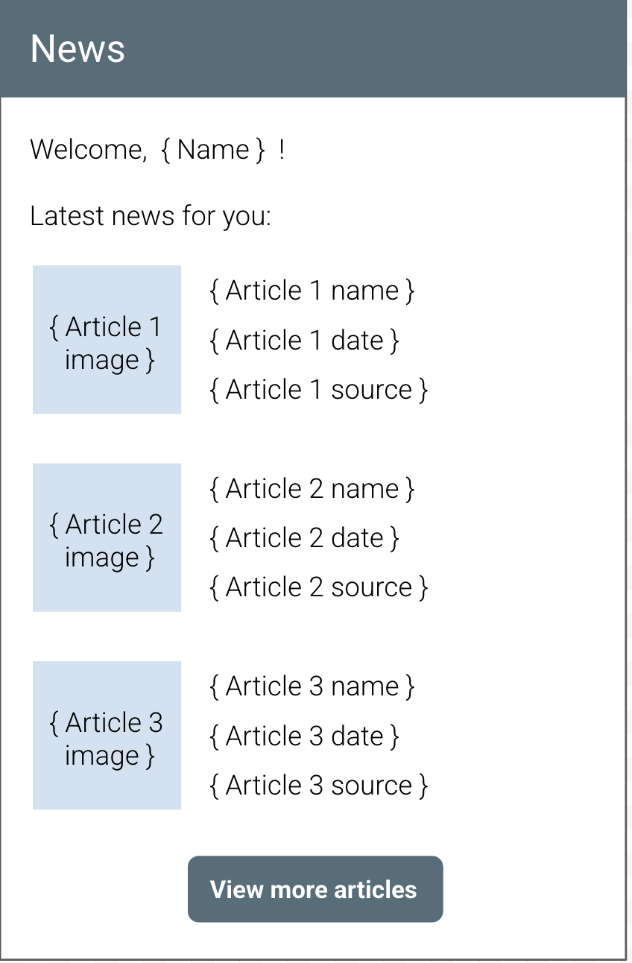

In the above illustration of a news app, the "Welcome" text, the "Latest news for you" heading, and the "View more articles" button text always stay the same. Conversely, the name of the user and the contents of each article will change, so that would be a great opportunity to use variables to hold each piece of information.

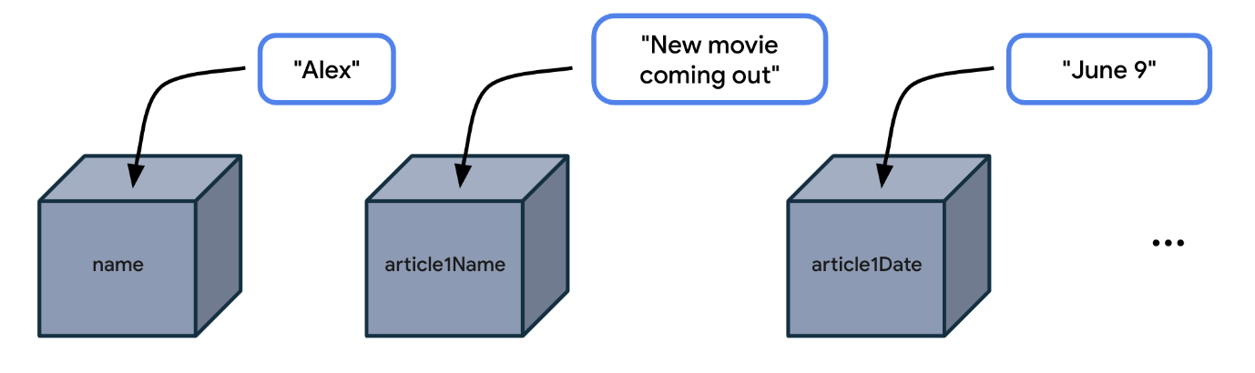

You don't want to write the code (or instructions) in your news app to only work for a user named Alex, or for a news article that always has the same title and publication date. Instead, you want a more flexible app, so you should write your code by referencing variable names like name, article1Name, article1Date, and so on. Then your code becomes general enough to work for many different use cases where the user's name could be different and the article details could be different.

**Example app with variables**

Let's look at an app example to see where it may use variables.

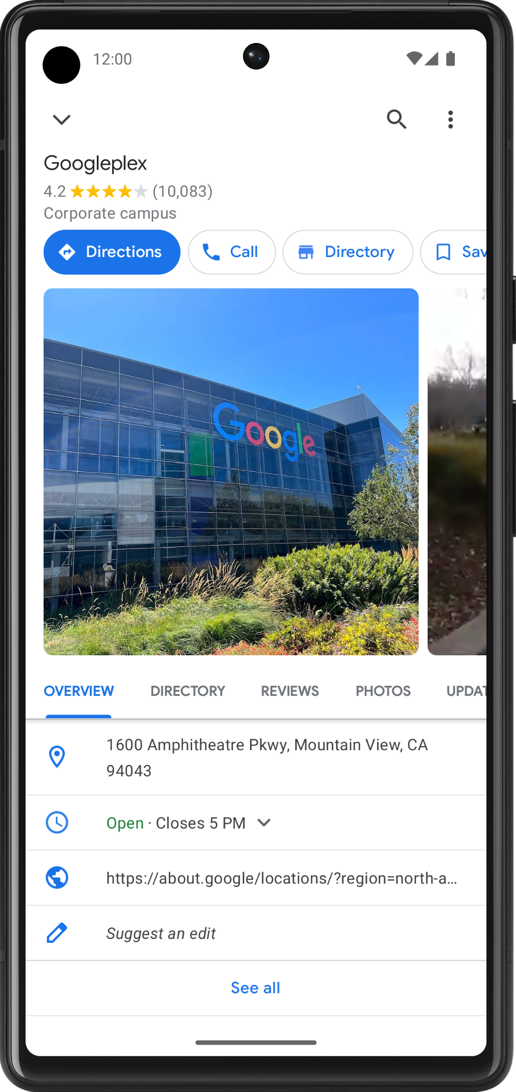

In a maps app, you may find a details screen for each location, such as a restaurant or business. The above screenshot from the Google Maps app shows the details for Google's company headquarters, which is called the Googleplex. Which pieces of data do you think are stored as variables in the app?

* **Name** of the location
* **Star rating** of the location
* **Number of reviews** of the location
* Whether the user **saved** (or bookmarked) this location
* **Address** of the location

Change the data that's stored in these variables and you have a maps app that's flexible enough to display the details of other locations too.

Data types

When you decide what aspects of your app can be variable, it's important to specify *what type of data* can be stored in those variables. In Kotlin, there are some common basic data types. The table below shows a different data type in each row. For each data type, there's a description of what kind of data it can hold and example values.

|  |  |  |
| --- | --- | --- |
| **Kotlin data type** | **What kind of data it can contain** | **Example literal values** |
| String | Text | "Add contact" "Search" "Sign in" |
| Int | Integer number | 32 1293490 -59281 |
| Double | Decimal number | 2.0 501.0292 -31723.99999 |
| Float | Decimal number (that is less precise than a Double). Has an f or F at the end of the number. | 5.0f -1630.209f 1.2940278F |
| Boolean | true or false. Use this data type when there are only two possible values. Note that true and false are keywords in Kotlin. | true false |

**Note:** For the valid ranges for the numerical data types (Int, Double, and Float), see [Numbers](https://kotlinlang.org/docs/numbers.html). For specifics on the difference between Double and Float, look at [this table](https://kotlinlang.org/docs/numbers.html#floating-point-types) comparing the two data types.

Now that you are aware of some common Kotlin data types, which data type would be appropriate for each of the variables identified in the location detail page you saw earlier?



* **Name** of the location is text, so it can be stored in a variable whose data type is String.
* **Star rating** of the location is a decimal number (such as 4.2 stars), so it can be stored as a Double.
* **Number of reviews** of the location is a whole number, so it should be stored as an Int.
* Whether the user **saved** this location only has two possible values (saved or not saved), so it's stored as a Boolean, where true and false can represent each of those states.
* **Address** of the location is text, so it should be a String.

Practice on two more scenarios below. Identify the use of variables and their data types in the following apps.

1. In an app for watching videos, such as the YouTube app, there's a video details screen. Where are variables likely used? What's the data type of those variables?

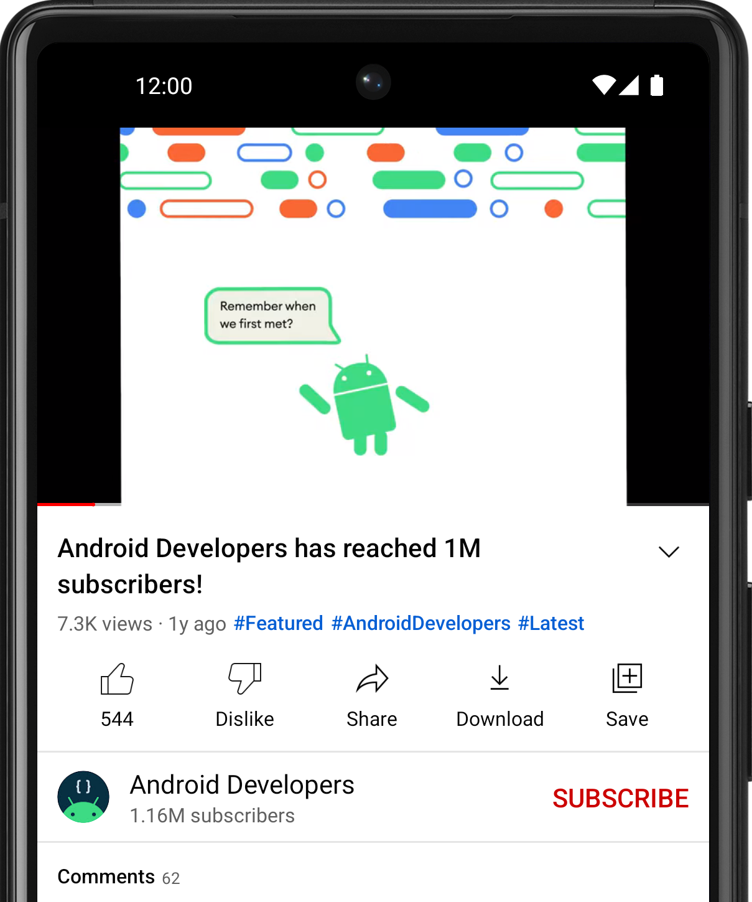

There isn't a single correct answer, but in a video-watching app, variables can be used for the following pieces of data:

* **Name** of the video (String)
* **Name** of the channel (String)
* **Number of views** on the video (Int)
* **Number of likes** on the video (Int)
* **Number of comments** on the video (Int)

1. In an app like Messages, the screen lists the most recent text messages received. Where are variables likely used? What's the data type of those variables?

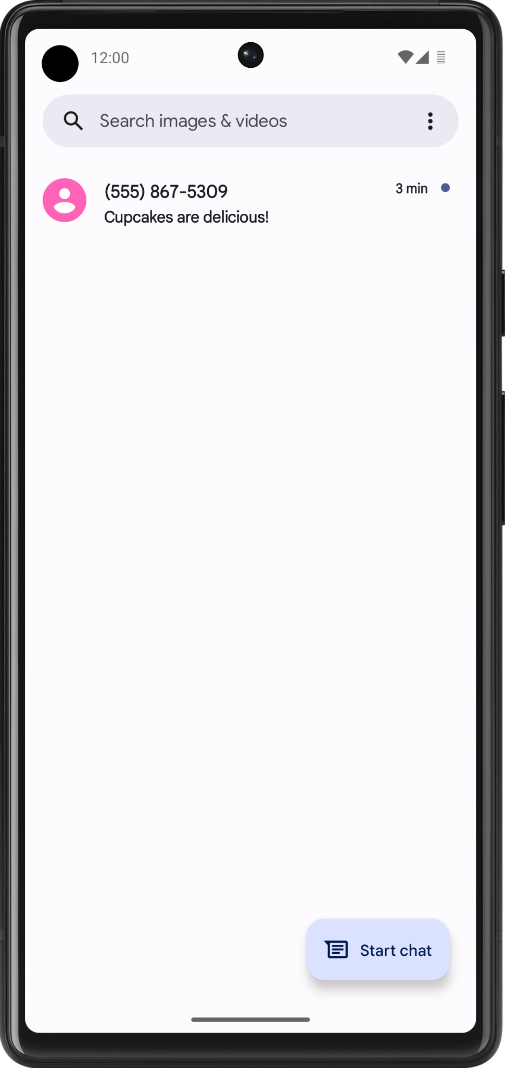

Again, there isn't a single correct answer. In an text messaging app, variables can be used for the following pieces of data:

* **Phone number** of the sender (String)
* **Timestamp** of the message (String)
* **Preview** of the message contents (String)
* Whether the text message is **unread** (Boolean)

**Try it**

1. Open your favorite app on your phone.
2. Identify where you think variables are used in the app on that particular screen.
3. Guess what data type those variables are.
4. Share your answers on social media with a [screenshot](https://support.google.com/pixelphone/answer/2811098) of the app, an explanation of where you think variables are used, and the hashtag #AndroidBasics.

Great work in this codelab so far! Move onto the next section to learn more about how variables and data types are used in your code.

## [3. Define and use variables](https://developer.android.com/codelabs/basic-android-kotlin-compose-variables?continue=https%3A%2F%2Fdeveloper.android.com%2Fcourses%2Fpathways%2Fandroid-basics-compose-unit-1-pathway-1%23codelab-https%3A%2F%2Fdeveloper.android.com%2Fcodelabs%2Fbasic-android-kotlin-compose-variables#2)

## Define versus use a variable

You must define a variable first in your code before you can use the variable. This is similar to what you learned in the last codelab about defining functions before calling them.

When you *define* a variable, you assign a name to uniquely identify it. You also decide what type of data it can hold by specifying the data type. Lastly, you can provide an initial value that will be stored in the variable, but this is optional.

**Note:** You may hear the alternate phrase "declare a variable." The words declare and define can be used interchangeably and have the same meaning. You may also hear the term "variable definition" or "variable declaration", which refer to the code that defines a variable. In other languages, declare and define have different meanings.

Once you define a variable, you can *use* that variable in your program. To use a variable, type out the variable name in your code, which tells the Kotlin compiler that you want to use the variable's value at that point in the code.

For example, define a variable for the number of unread messages in a user's inbox. The variable can have the name count. Store a value such as the number 2 inside the variable, representing 2 unread messages in the user's inbox. (You can pick a different number to store in the variable, but for the purpose of this example, use the number 2.)

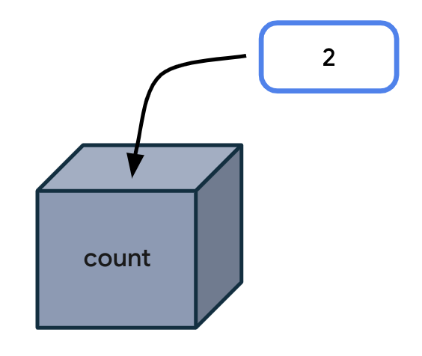

Every time your code needs to access the number of unread messages, type count in your code. When executing your instructions, the Kotlin compiler sees the variable name in your code and uses the variable value in its place.

Technically, there are more specific vocabulary words to describe this process:

An *expression* is a small unit of code that evaluates to a value. An expression can be made up of variables, function calls, and more. In the following case, the *expression* is made up of one variable: the count variable. This expression evaluates to 2.

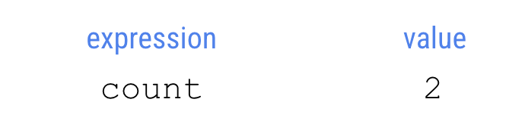

*Evaluate* means determining the value of an expression. In this case, the expression evaluates to 2. The compiler evaluates expressions in the code and uses those values when executing the instructions in the program.

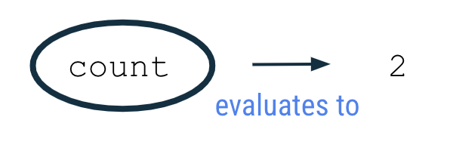

To observe this behavior in the Kotlin Playground, run the program in the next section.

**Example**

1. Open the [Kotlin Playground](https://developer.android.com/training/kotlinplayground) in a web browser.
2. Replace the existing code in the Kotlin Playground with the following program.

This program creates a variable called count with an initial value of 2 and uses it by printing out the value of the count variable to the output. Don't worry if you don't understand all aspects of the code syntax yet. It will be explained in more detail in upcoming sections.

fun main() {  
    val count: Int = 2  
    println(count)  
}

1. Run the program and the output should be:

2

**Variable declaration**

In the program you ran, the second line of code says:

val count: Int = 2

This statement creates an integer variable called count that holds the number 2.



It can take a while to become familiar with reading the syntax (or format) for declaring a variable in Kotlin. The following diagram shows where each detail about the variable should be located, as well as the location of spaces and symbols.

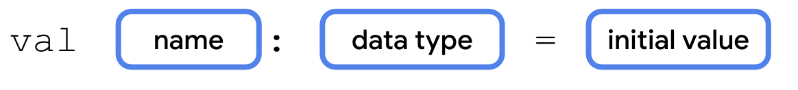

In the context of the count variable example, you can see that the variable declaration starts with the word val. The name of the variable is count. The data type is Int, and the initial value is 2.

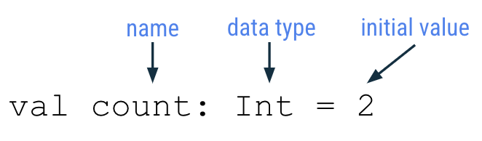

Each part of the variable declaration is explained in more detail below.

Keyword to define new variable

To define a new variable, start with the Kotlin keyword val (which stands for value). Then the Kotlin compiler knows that a variable declaration is in this statement.

**Variable name**

Just like you name a function, you also name a variable. In the variable declaration, the variable name follows the val keyword.

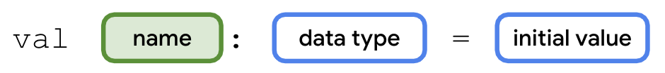

You can choose any variable name you want, but as a best practice, avoid using Kotlin [keywords](https://kotlinlang.org/docs/keyword-reference.html) as a variable name.

It's best to choose a name that describes the data that the variable holds so that your code is easier to read.

Variable names should follow the camel case convention, as you learned with function names. The first word of the variable name is all lower case. If there are multiple words in the name, there are no spaces between words, and all other words should begin with a capital letter.

Example variable names:

* numberOfEmails
* cityName
* bookPublicationDate

For the code example shown earlier, count is the name of the variable.

val count: Int = 2

**Variable data type**

After the variable name, you add a colon, a space, and then the data type of the variable. As mentioned earlier, String, Int, Double, Float, and Boolean are some of the basic Kotlin data types. You'll learn more data types later in this course. Remember to spell data types exactly as shown and begin each with a capital letter.

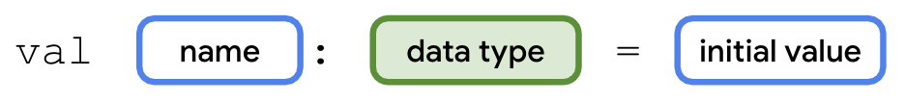

For the count variable example, Int is the data type of the variable.

val count: Int = 2

**Assignment operator**

In the variable declaration, the equal sign symbol (=) follows the data type. The equal sign symbol is called the *assignment operator*. The assignment operator assigns a value to the variable. In other words, the value on the right-hand side of the equal sign gets stored in the variable on the left-hand side of the equal sign.

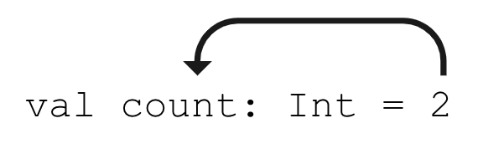

**Variable initial value**

The variable value is the actual data that's stored in the variable.

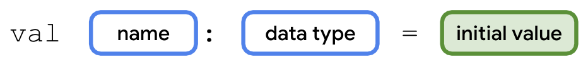

For the count variable example, the number 2 is the initial value of the variable.

val count: Int = 2

You may also hear the phrase: "the count variable is *initialized* to 2." This means that 2 is the first value stored in the variable when the variable is declared.

The initial value will be different depending on the data type declared for the variable.

Refer to the following table which you may recognize from earlier in the codelab. The third column shows example values that can be stored in a variable of each corresponding type. These values are called *literals* because they are fixed or constant values (the value is constantly the same). As an example, the integer 32 is always going to have the value of 32. In contrast, a variable is not a literal because its value can change. You may hear these literal values referred to based on their type: string literal, integer literal, boolean literal, etc.

|  |  |  |
| --- | --- | --- |
| **Kotlin data type** | **What kind of data it can contain** | **Example literal values** |
| String | Text | "Add contact" "Search" "Sign in" |
| Int | Integer number | 32 1293490 -59281 |
| Double | Decimal number | 2.0 501.0292 -31723.99999 |
| Float | Decimal number (that is less precise than a Double). Has an f or F at the end of the number. | 5.0f -1630.209f 1.2940278F |
| Boolean | true or false. Use this data type when there are only two possible values. Note that true and false are keywords in Kotlin. | true false |

It's important to provide an appropriate and valid value according to the data type of the variable. For instance, you can't store a string literal like "Hello" inside a variable of type Int because the Kotlin compiler will give you an error.

**Use a variable**

The following is the original program you ran in the Kotlin Playground. So far you learned that the second line of code creates a new integer variable called count with a value of 2.

fun main() {  
    val count: Int = 2  
    println(count)  
}

Now look at the third line of code. You are printing the count variable to the output:

println(count)

Notice there are no quotation marks around the word count. It is a variable name, not a string literal. (You would find quotation marks around the word if it was a string literal.) When you run the program, the Kotlin compiler evaluates the expression inside the parentheses, which is count, for the println() instruction. Since the expression evaluates to 2, then the println() method is called with 2 as the input: println(2).

Hence the output of the program is:

2

The number by itself in the output is not very useful. It would be more helpful to have a more detailed message printed in the output to explain what the 2 represents.

String template

A more helpful message to display in the output is:

You have 2 unread messages.

Follow these steps so that the program outputs a more helpful message.

1. Update your program in the Kotlin Playground with the following code. For the println() call, pass in a string literal that contains the count variable name. Remember to surround the text with quotation marks. Note that this will not give you the results you expect. You'll fix the issue in a later step.

fun main() {  
    val count: Int = 2  
    println("You have count unread messages.")  
}

1. Run the program and the output should display:

You have count unread messages.

That sentence doesn't make sense! You want the value of the count variable to be displayed in the message, not the variable name.

1. To fix the output, you need a string template. This is a *string template* because it contains a *template expression*, which is a dollar sign ($) followed by a variable name. A template expression is evaluated, and its value gets substituted into the string.



Add a dollar sign $ before the count variable. In this case, the template expression $count evaluates to 2, and the 2 gets substituted into the string where the expression was located.

fun main() {  
    val count: Int = 2  
    println("You have $count unread messages.")  
}

1. When you run the program, the output matches the desired goal:

You have 2 unread messages.

That sentence makes much more sense to the user!

1. Now change the initial value of the count variable to a different integer literal. For example, you could choose the number 10. Leave the rest of the code in the program unchanged.

fun main() {  
    val count: Int = 10  
    println("You have $count unread messages.")  
}

1. Run the program. Notice that the output changes accordingly and you didn't even need to change the println() statement in your program.

You have 10 unread messages.

You can see how useful a string template can be. You only wrote the string template once in your code ("You have $count unread messages."). If you change the initial value of the count variable, the println() statement still works. Your code is more flexible now!

To further emphasize this point, compare the following two programs. The first program uses a string literal, with the exact number of unread messages directly in the string. This program only works when your user has 10 unread messages.

fun main() {  
    println("You have 10 unread messages.")  
}

By using a variable and a string template in the second program, your code can adapt to more scenarios. This second program is more flexible!

fun main() {  
    val count: Int = 10  
    println("You have $count unread messages.")  
}

**Type inference**

Here's a tip that allows you to write less code when declaring variables.

Type inference is when the Kotlin compiler can infer (or determine) what data type a variable should be, without the type being explicitly written in the code. That means you can omit the data type in a variable declaration, if you provide an initial value for the variable. The Kotlin compiler looks at the data type of the initial value, and assumes that you want the variable to hold data of that type.

The following syntax is for a variable declaration that uses type inference:

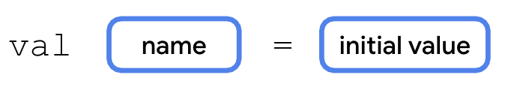

Returning to the count example, the program initially contained this line of code:

val count: Int = 2

However, this line of code can also be written as follows. Notice that the colon symbol (:) and Int data type are omitted. The updated syntax has fewer words to type, and it achieves the same outcome of creating an Int variable called count with a value of 2.

val count = 2

The Kotlin compiler knows that you want to store 2 (a whole number integer) into the variable count, so it can infer that the count variable is of type Int. Convenient, right? This is one example of how writing Kotlin code is more concise!

**Note:** If you don't provide an initial value when you declare a variable, you must specify the type.

In this line of code, no initial value is provided, so you must specify the data type:

val count: Int

In this line of code, an assigned value is provided, so you can omit the data type:

val count = 2

Even though this example only discusses a variable of type Int, the concept of type inference applies to all data types in Kotlin.

**Basic math operations with integers**

What is the difference between an Int variable with value 2 and a String variable with value "2"? When they both get printed to the output, they look the same.

The advantage to storing integers as an Int (as opposed to a String) is that you can perform math operations with Int variables, such as addition, subtraction, division, and multiplication (see other [operators](https://kotlinlang.org/docs/keyword-reference.html#operators-and-special-symbols)). For example, two integer variables can be added together to get their sum. There are certainly cases where it's reasonable to have integers stored as Strings, but the purpose of this section is to show you what you can do with Int variables.

1. Return to the Kotlin Playground and remove all the code in the code editor.
2. Create a new program where you define an integer variable for the number of unread emails in an inbox, and initialize it to a value such as 5. You can pick a different number if you'd like. Define a second integer variable for the number of read emails in an inbox. Initialize it to a value such as 100. You can pick a different number if you'd like. Then print out the total number of messages in the inbox by adding the two integer numbers together.

fun main() {  
    val unreadCount = 5  
    val readCount = 100  
    println("You have ${unreadCount + readCount} total messages in your inbox.")  
}

1. Run the program and it should display the total number of messages in the inbox:

You have 105 total messages in your inbox.

For a string template, you learned that you can put the $ symbol before a single variable name. However, if you have a more complex expression, you must enclose the expression in curly braces with the $ symbol before the curly braces: ${unreadCount + readCount}. The expression within the curly braces, unreadCount + readCount, evaluates to 105. Then the value 105 is substituted within the string literal.

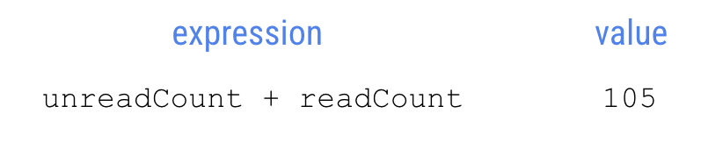

**Warning:** If you forget the curly braces around the template expression, you will get unexpected results. You can test that out in the Kotlin Playground by changing the println() statement to println("You have $unreadCount + readCount total messages in your inbox.") and observing the output.

1. To explore this topic further, create variables with different names and different initial values, and use template expressions to print messages to the output.

For example, modify your program to print this out:

100 photos

10 photos deleted

90 photos left

Here's one way that you can write your program, though there are other correct ways to write it too!

fun main() {  
    val numberOfPhotos = 100  
    val photosDeleted = 10  
    println("$numberOfPhotos photos")  
    println("$photosDeleted photos deleted")  
    println("${numberOfPhotos - photosDeleted} photos left")  
}

[4. Update variables](https://developer.android.com/codelabs/basic-android-kotlin-compose-variables?continue=https%3A%2F%2Fdeveloper.android.com%2Fcourses%2Fpathways%2Fandroid-basics-compose-unit-1-pathway-1%23codelab-https%3A%2F%2Fdeveloper.android.com%2Fcodelabs%2Fbasic-android-kotlin-compose-variables#3)

When an app is running, the value of a variable may need to be updated. For example, in a shopping app, as the user adds items to the shopping cart, the cart total increases.

Let's simplify the shopping use case into a simple program. The logic is written out below with human language, not in Kotlin. This is called *pseudocode* because it describes the key points of how the code will be written, but it doesn't contain all the details of the code.

**Note:** Pseudocode is not meant to be working code that can be compiled, that's why it's called pseudo code.

In the main function of a program:

* Create an integer cartTotal variable that starts at the value 0.
* The user adds a sweater that costs $20 to their shopping cart.
* Update the cartTotal variable to 20, which is the current cost of the items in their shopping cart.
* Print the total cost of the items in their cart, which is the cartTotal variable, to the output.

To further simplify the code, you don't need to write the code for when the user adds items to the shopping cart. (You haven't learned about how a program can respond to user input yet. That will come in a later unit.) Hence, focus on the parts where you create, update, and print out the cartTotal variable.

1. Replace the existing code in the Kotlin Playground with the below program. In line 2 of the program, you initialize the cartTotal variable to the value 0. Since you provide an initial value, there's no need to specify the Int data type due to type inference. In line 3 of the program, you attempt to update the cartTotal variable to 20 with the assignment operator (=). In line 4 of the program, you print out the cartTotal variable using a string template.

fun main() {  
    val cartTotal = 0  
    cartTotal = 20  
    println("Total: $cartTotal")  
}

1. Run the program, and you will get a compile error.
2. Notice the error says that the val can't be reassigned. The error is on the third line of the program, which tries to change the value of the cartTotal variable to 20. The val cartTotal can't be reassigned to another value (20) after it's been assigned an initial value (0).

Val cannot be reassigned

If you need to update the value of a variable, declare the variable with the Kotlin keyword var, instead of val.

* val keyword - Use when you expect the variable value will not change.
* var keyword - Use when you expect the variable value can change.

With val, the variable is *read-only*, which means you can only read, or access, the value of the variable. Once the value is set, you cannot edit or modify its value. With var, the variable is *mutable*, which means the value can be changed or modified. The value can be mutated.

To remember the difference, think of val as a fixed *value* and var as *variable*. In Kotlin, it's recommended to use the val keyword over the var keyword when possible.

1. Update the variable declaration for cartTotal on line 2 of the program to use var instead of val. This is how the code should look:

fun main() {  
    var cartTotal = 0  
    cartTotal = 20  
    println("Total: $cartTotal")  
}

1. Notice the syntax of the code on line 3 of the program which updates the variable.

cartTotal = 20

Use the assignment operator (=) to assign a new value (20) to the existing variable (cartTotal). You don't need to use the var keyword again because the variable is already defined.

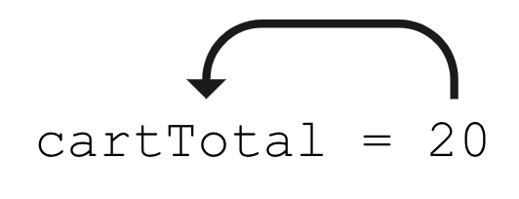

Using the box analogy, picture the value 20 being stored in the box labeled cartTotal.

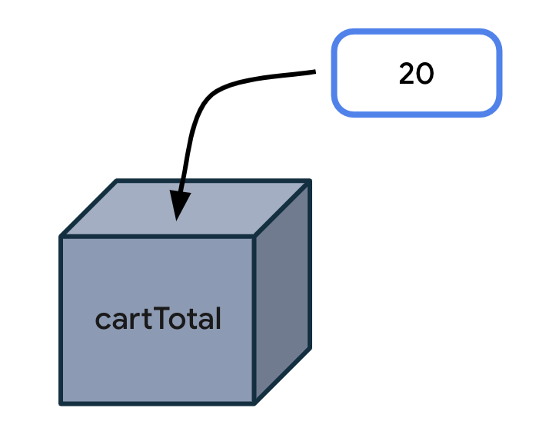

Here's a diagram for the general syntax for updating a variable, which has already been declared on an earlier line of code. Start the statement with the name of the variable you want to update. Add a space, the equal sign, followed by another space. Then write out the updated value for the variable.

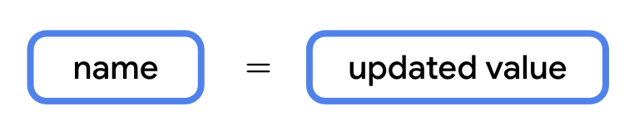

1. Run your program and the code should successfully compile. It should print this output :

Total: 20

1. To see how the variable value changes while the program is running, print the cartTotal variable to the output after the variable is initially declared. See the code changes below. Line 3 has a new println() statement. There's also a blank line added on line 4 of the code. Blank lines do not have any impact on how the compiler understands the code. Add a blank line where it would make it easier to read your code by separating out related blocks of code.

fun main() {  
    var cartTotal = 0  
    println("Total: $cartTotal")  
  
    cartTotal = 20  
    println("Total: $cartTotal")  
}

1. Run the program again and the output should be:

Total: 0  
Total: 20

You can see that initially the shopping cart total is 0. Then it updates to 20. You successfully updated a variable! This was possible because you changed cartTotal from a read-only variable (with val) to a mutable variable (with var).

Remember that you should only use var to declare a variable if you expect the value to change. Otherwise you should default to using val to declare a variable. This practice makes your code safer. Using val ensures that variables won't get updated in your program if you don't expect them to. Once a val is assigned a value, it always stays that value.

**Note:** If you are familiar with other programming languages, declaring a val is like declaring a constant value because it is a read-only variable. There are additional conventions to follow when declaring constants in Kotlin, which is more advanced for this codelab, but you can find them in the [Constants](https://developer.android.com/kotlin/style-guide#constant_names) section of the style guide.

**Increment and decrement operators**

Now you know that a variable must be declared as a var in order to update its value. Apply this knowledge to the email message example below that should look familiar.

1. Replace the code in the Kotlin Playground with this program:

fun main() {  
    val count: Int = 10  
    println("You have $count unread messages.")  
}

1. Run the program. It should print out:

You have 10 unread messages.

1. Replace the val keyword with the var keyword to make the count variable a mutable variable. There should be no change in the output when you run the program.

fun main() {  
    var count: Int = 10  
    println("You have $count unread messages.")  
}

1. However, now you can update the count to a different value. For example, when one new email arrives in the user's inbox, you can increase count by 1. (You don't need to write the code for the arrival of an email. Getting data from the internet is a more advanced topic for a much later unit.) For now, focus on the count variable increasing by 1 with this line of code:

count = count + 1

The expression to the right of the equal sign is count + 1 and evaluates to 11. That is because the current value of count is 10 (which is on line 2 of the program) and 10 + 1 equals 11. Then with the assignment operator, the value 11 gets assigned or stored in the count variable.

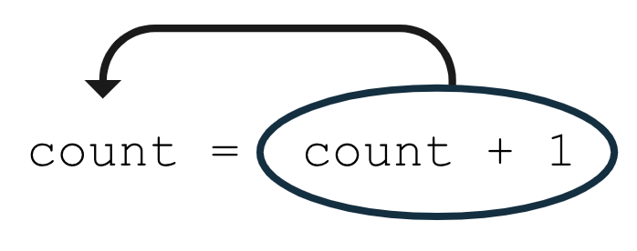

Add this line of code to your program at the bottom of the main() function. Your code should look like the following:

fun main() {  
    var count = 10  
    println("You have $count unread messages.")  
    count = count + 1  
}

If you run the program now, the output is the same as before because you haven't added any code to use the count variable after you updated it.

1. Add another print statement that prints out the number of unread messages after the variable has been updated.

fun main() {  
    var count = 10  
    println("You have $count unread messages.")  
    count = count + 1  
    println("You have $count unread messages.")  
}

1. Run the program. The second message should display the updated count of 11 messages.

You have 10 unread messages.

You have 11 unread messages.

1. For shorthand, if you want to increase a variable by 1, you can use the *increment operator* (++) which is made up of two plus symbols. By using these symbols directly after a variable name, you tell the compiler that you want to add 1 to the current value of the variable, and then store the new value in the variable. The following two lines of code are equivalent, but using the ++ increment operator involves less typing.

count = count + 1

count++

Make this modification to your code and then run your program. There should be no spaces between the variable name and the increment operator.

fun main() {  
    var count = 10  
    println("You have $count unread messages.")  
    count++  
    println("You have $count unread messages.")  
}

1. Run the program. The output is the same, but now you learned about a new operator!

You have 10 unread messages.

You have 11 unread messages.

1. Now modify line 4 of your program to use the *decrement operator* (--) after the count variable name. The decrement operator is made up of two minus symbols. By placing the decrement operator after the variable name, you tell the compiler that you want to decrease the value of the variable by 1 and store the new value into the variable.

fun main() {  
    var count = 10  
    println("You have $count unread messages.")  
    count--  
    println("You have $count unread messages.")  
}

1. Run the program. It should print this output:

You have 10 unread messages.

You have 9 unread messages.

In this section, you learned how to update a mutable variable using the increment operator (++) and the decrement operator (--). More specifically, count++ is the same as count = count + 1 and count-- is the same as count = count - 1.

[5. Explore other data types](https://developer.android.com/codelabs/basic-android-kotlin-compose-variables?continue=https%3A%2F%2Fdeveloper.android.com%2Fcourses%2Fpathways%2Fandroid-basics-compose-unit-1-pathway-1%23codelab-https%3A%2F%2Fdeveloper.android.com%2Fcodelabs%2Fbasic-android-kotlin-compose-variables#4)

Earlier in the codelab, you were introduced to some common basic data types: String, Int, Double, and Boolean. You just used the Int data type, now you will explore other data types.

|  |  |
| --- | --- |
| **Kotlin data type** | **What kind of data it can contain** |
| String | Text |
| Int | Integer number |
| Double | Decimal number |
| Boolean | true or false (only two possible values) |

Try these programs in the Kotlin Playground to see what the output is.

Double

When you need a variable with a decimal value, use a Double variable. To learn about its valid range, refer to [this table](https://kotlinlang.org/docs/numbers.html#floating-point-types) and look at the decimal digits it can store for example.

**Note:** The name of the Double data type comes from the data type having double precision compared to the Float data type, which has single precision. Precision is how many decimal digits they can hold. Hence, a Double variable can store a more precise value. [This table](https://kotlinlang.org/docs/numbers.html#floating-point-types) shows more details about the specific differences between Double and Float types if you're curious. This section of the codelab focuses on using Double for working with decimal numbers.

Imagine you're navigating to a destination, and your trip is split into three separate parts because you need to make stops along the way. This program displays the total distance left to reach your destination.

1. Enter this code in the Kotlin Playground. Can you understand what is happening on each line of code?

fun main() {  
    val trip1: Double = 3.20  
    val trip2: Double = 4.10  
    val trip3: Double = 1.72  
    val totalTripLength: Double = 0.0  
    println("$totalTripLength miles left to destination")  
}

Three variables called trip1, trip2, and trip3 are declared to represent the distance of each part of the trip. All of them are Double variables because they store decimal values. Use val to declare each variable because their values do not change over the course of the program. The program also creates a fourth variable called totalTripLength which is currently initialized to 0.0. The last line of the program prints a message with the value of the totalTripLength variable.

1. Fix the code so that the totalTripLength variable is the sum of all three trip lengths.

val totalTripLength: Double = trip1 + trip2 + trip3

The expression on the right of the equal sign evaluates to 9.02 because 3.20 + 4.10 + 1.72 equals 9.02. The value of 9.02 gets stored into the totalTripLength variable.

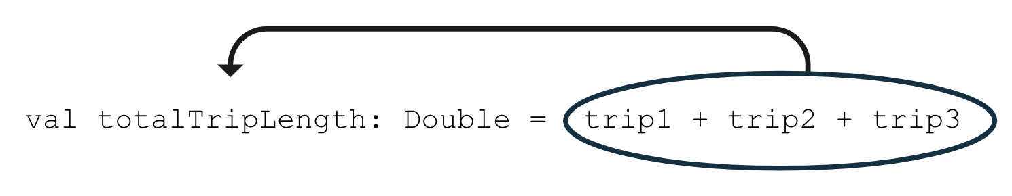

Your whole program should look like the below code:

fun main() {  
    val trip1: Double = 3.20  
    val trip2: Double = 4.10  
    val trip3: Double = 1.72  
    val totalTripLength: Double = trip1 + trip2 + trip3  
    println("$totalTripLength miles left to destination")  
}

1. Run the program. It should print this out:

9.02 miles left to destination

1. Fix your code to remove the unnecessary Double data type from the variable declarations because of type inference. The Kotlin compiler can infer that these variables are Double data types based on the decimal numbers provided as initial values.

fun main() {  
    val trip1 = 3.20  
    val trip2 = 4.10  
    val trip3 = 1.72  
    val totalTripLength = trip1 + trip2 + trip3  
    println("$totalTripLength miles left to destination")  
}

1. Run your code again to ensure that your code still compiles. The output should be the same, but now your code is simpler!

**String**

When you need a variable that can store text, use a String variable. Remember to use quotation marks around String literal values, such as "Hello Kotlin", whereas the Int and Double literal values do not have quotes around them.

1. Copy and paste this program into the Kotlin Playground.

fun main() {  
    val nextMeeting = "Next meeting:"  
    val date = "January 1"  
    val reminder = nextMeeting + date  
    println(reminder)  
}

Notice that there are two String variables declared, a nextMeeting variable and a date variable. Then a third String variable called reminder is declared, which is set equal to the nextMeeting variable plus the date variable.

With the + symbol, you can add two strings together, which is called *concatenation*. The two strings are combined together, one after the other. The result of the expression, nextMeeting + date is "Next meeting:January 1" as shown in the diagram below.



The value "Next meeting:January 1" is then stored into the reminder variable using the assignment operator on line 4 of the program.

1. Run your program. It should print this out:

Next meeting:January 1

When you concatenate two strings together, there are no extra spaces added between the strings. If you want a space after the colon in the resulting string, you need to add the space to one string or the other.

1. Update your nextMeeting variable to have an extra space at the end of the string before the closing quotation mark. (Alternatively, you could have added an extra space to the beginning of the date variable). Your program should look like the following:

fun main() {  
    val nextMeeting = "Next meeting: "  
    val date = "January 1"  
    val reminder = nextMeeting + date  
    println(reminder)  
}

1. Run your program again and now there should be a space after the colon in the output message.

Next meeting: January 1

1. Modify the code so that you concatenate - or add - another piece of text to the expression that gets stored in the reminder variable.

Use the + symbol to add the string literal " at work" to the end of the reminder string.

1. Run the program.

It should print this output:

Next meeting: January 1 at work

The code below shows you one way that you could implement the behavior.

fun main() {  
    val nextMeeting = "Next meeting: "  
    val date = "January 1"  
    val reminder = nextMeeting + date + " at work"  
    println(reminder)  
}

Notice that there are no quotation marks around nextMeeting and date because they are names of existing string variables (where their respective values are text with quotes around them). Conversely, the literal " at work" is not previously defined in any variable, so use quotations around this text in order for the compiler to know that this is a string that should be concatenated onto the other strings.

Technically, you can achieve the same output by declaring a single String variable with the full text instead of using separate variables. However, the purpose of this exercise is to demonstrate how you can declare and manipulate String variables, especially how to concatenate separate strings.

1. When reading code that contains strings, you may come across *escape sequences*. Escape sequences are characters that are preceded with a backslash symbol (\), which is also called an escaping backslash.

An example is seeing \" within a string literal like in the below example. Copy and paste this code into the Kotlin Playground.

fun main() {  
    println("Say \"hello\"")  
}

You learned earlier to use double quotation marks around a string literal. But what if you want to use the " symbol in your string? Then you need to add the backslash symbol before the double quotation mark as \" within your string. Remember that there should still be double quotation marks around the whole string.

1. Run the program to see the output. It should show:

Say "hello"

In the output, there are quotation marks displayed around hello because we added \" before and after hello in the println() statement.

For other escape sequences supported in Kotlin, refer to the documentation page on [escape sequences](https://kotlinlang.org/docs/characters.html). For example, if you want a new line in your string, use the \ symbol before the character n as in \n.

Now you've learned about concatenating strings and also escape sequences within strings. Move onto the last data type that this codelab covers.

**Boolean**

The Boolean data type is useful when your variable only has two possible values represented by true or false.

An example is a variable that represents whether a device's airplane mode is on or off, or whether an app's notifications are enabled or disabled.

1. Enter this code in the Kotlin Playground. In line 2 of this program, you declare a Boolean variable called notificationsEnabled and initialize it to true. Technically, you can omit : Boolean in the declaration, so you can remove it if you'd like. In line 3 of the program, you print out the value of the notificationsEnabled variable.

fun main() {  
    val notificationsEnabled: Boolean = true  
    println(notificationsEnabled)  
}

Run the program, and it should print this out:

true

1. Change the initial value of the Boolean to false on line 2 of the program.

fun main() {  
    val notificationsEnabled: Boolean = false  
    println(notificationsEnabled)  
}

Run the program, and it should print this out:

false

1. Other data types can be concatenated to Strings. For example, you can concatenate Booleans to Strings. Use the + symbol to concatenate (or append) the value of the notificationsEnabled boolean variable onto the end of the "Are notifications enabled? " string.

fun main() {  
    val notificationsEnabled: Boolean = false  
    println("Are notifications enabled? " + notificationsEnabled)  
}

Run the program to see the result of the concatenation. The program should print this output:

Are notifications enabled? false

You can see that it's possible to set the Boolean variable to a true or false value. Boolean variables enable you to code more interesting scenarios in which you execute some set of instructions when a Boolean variable has a true value. Or if the Boolean has a false value, you skip those instructions. You learn more about Booleans in a future codelab.

[6. Coding conventions](https://developer.android.com/codelabs/basic-android-kotlin-compose-variables?continue=https%3A%2F%2Fdeveloper.android.com%2Fcourses%2Fpathways%2Fandroid-basics-compose-unit-1-pathway-1%23codelab-https%3A%2F%2Fdeveloper.android.com%2Fcodelabs%2Fbasic-android-kotlin-compose-variables#5)

In the previous codelab, you were introduced to the Kotlin style guide for writing Android code in a consistent way as recommended by Google and followed by other professional developers.

Here are a couple of other formatting and coding conventions for you to follow based on the new topics you learned:

* Variable names should be in camel case and start with a lowercase letter.
* In a variable declaration, there should be a space after a colon when you specify the data type.

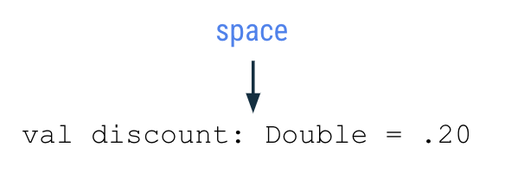

* There should be a space before and after an operator like the assignment (=), addition (+), subtraction (-), multiplication (\*), division (/) operators and more.

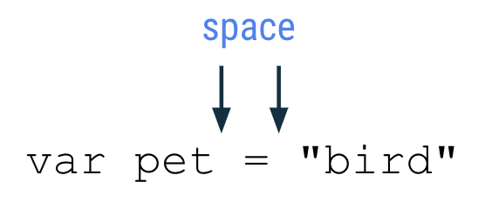

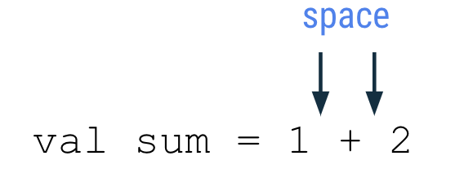

* As you write more complex programs, there is a recommended limit of [100 characters per line](https://developer.android.com/kotlin/style-guide#line_wrapping). That ensures that you can read all the code in a program easily on your computer screen, without needing to scroll horizontally when reading code.

[7. Commenting in your code](https://developer.android.com/codelabs/basic-android-kotlin-compose-variables?continue=https%3A%2F%2Fdeveloper.android.com%2Fcourses%2Fpathways%2Fandroid-basics-compose-unit-1-pathway-1%23codelab-https%3A%2F%2Fdeveloper.android.com%2Fcodelabs%2Fbasic-android-kotlin-compose-variables#6)

When coding, another good practice to follow is to add *comments* that describe what the code is intended to do. Comments can help people who read your code follow it more easily. Two forward slash symbols, or //, indicate that the text after it on the rest of the line is considered a comment, so it isn't interpreted as code. It's common practice to add a space after the two forward slash symbols.

// This is a comment.

A comment can also start in the middle of a line of code. In this example, height = 1 is a normal coding statement. // Assume the height is 1 to start with is interpreted as a comment and not considered part of the code.

height = 1 // Assume the height is 1 to start with

If you want to describe the code in more detail with a long comment that exceeds 100 characters on a line, use a multi-line comment. Start the multi-line comment with a forward slash (/) and an asterisk symbol (\*) as /\*. Add an asterisk at the beginning of each new line of the comment. Then finally end the comment with an asterisk and forward slash symbol \*/.

/\*  
 \* This is a very long comment that can  
 \* take up multiple lines.  
 \*/

This program contains single-line and multi-line comments that describe what's happening:

/\*\*  
 \* This program displays the number of messages  
 \* in the user's inbox.  
 \*/  
fun main() {  
    // Create a variable for the number of unread messages.  
    var count = 10  
    println("You have $count unread messages.")  
  
    // Decrease the number of messages by 1.  
    count--  
    println("You have $count unread messages.")  
}

As mentioned earlier, you can add blank empty lines to your code to group related statements together and make the code easier to read.

1. Add some comments to an earlier code snippet that you used.
2. Run the program to ensure that the behavior didn't change because comments shouldn't affect the output.

[8. Conclusion](https://developer.android.com/codelabs/basic-android-kotlin-compose-variables?continue=https%3A%2F%2Fdeveloper.android.com%2Fcourses%2Fpathways%2Fandroid-basics-compose-unit-1-pathway-1%23codelab-https%3A%2F%2Fdeveloper.android.com%2Fcodelabs%2Fbasic-android-kotlin-compose-variables#7)

Excellent work! You learned about variables in Kotlin, why variables are useful in programming, and how to create, update, and use them. You experimented with different basic data types in Kotlin, including the Int, Double, String, and Boolean data types. You also learned about the difference between the val and var keywords.

All of these concepts are critical building blocks on your journey to become a developer.

See you in the next codelab!

**Summary**

* A variable is a container for a single piece of data.
* You must declare a variable first before you use it.
* Use the val keyword to define a variable that is read-only where the value cannot change once it's been assigned.
* Use the var keyword to define a variable that is mutable or changeable.
* In Kotlin, it's preferred to use val over var when possible.
* To declare a variable, start with the val or var keyword. Then specify the variable name, data type, and initial value. For example: val count: Int = 2.
* With type inference, omit the data type in the variable declaration if an initial value is provided.
* Some common basic Kotlin data types include: Int, String, Boolean, Float, and Double.
* Use the assignment operator (=) to assign a value to a variable either during declaration of the variable or updating the variable.
* You can only update a variable that has been declared as a mutable variable (with var).
* Use the increment operator (++) or decrement operator (--) to increase or decrease the value of an integer variable by 1, respectively.
* Use the + symbol to concatenate strings together. You can also concatenate variables of other data types like Int and Boolean to Strings.

**Learn more**

* [Variables](https://play.kotlinlang.org/byExample/01_introduction/03_Variables)
* [Basic types](https://kotlinlang.org/docs/basic-types.html)
* [String templates](https://kotlinlang.org/docs/basic-syntax.html#string-templates)
* [Keywords and operators](https://kotlinlang.org/docs/keyword-reference.html)
* [Basic syntax](https://kotlinlang.org/docs/basic-syntax.html)

Create and use functions in Kotlin

[1. Before you begin](https://developer.android.com/codelabs/basic-android-kotlin-compose-functions?continue=https%3A%2F%2Fdeveloper.android.com%2Fcourses%2Fpathways%2Fandroid-basics-compose-unit-1-pathway-1%23codelab-https%3A%2F%2Fdeveloper.android.com%2Fcodelabs%2Fbasic-android-kotlin-compose-functions#0)

In an earlier codelab, you saw a simple program that printed Hello, world!. In the programs you've written so far, you've seen two functions:

* a main() function, which is required in every Kotlin program. It is the entry point, or starting point, of the program.
* a println() function, which you called from main() to output text.

In this codelab, you will learn more about functions.

Functions let you break up your code into reusable pieces, rather than include everything in main(). Functions are an essential building block of Android apps and learning how to define and use them is a major step on your journey to become an Android developer.

Prerequisites

* Knowledge of Kotlin programming basics, including variables, and the println() and main() functions

What you'll learn

* How to define and call your own functions.
* How to return values from a function that you can store in a variable.
* How to define and call functions with multiple parameters.
* How to call functions with named arguments.
* How to set default values for function parameters.

What you'll need

* A web browser with access to Kotlin Playground

[2. Define and call a function](https://developer.android.com/codelabs/basic-android-kotlin-compose-functions?continue=https%3A%2F%2Fdeveloper.android.com%2Fcourses%2Fpathways%2Fandroid-basics-compose-unit-1-pathway-1%23codelab-https%3A%2F%2Fdeveloper.android.com%2Fcodelabs%2Fbasic-android-kotlin-compose-functions#1)

Before exploring functions in-depth, let's review some basic terminology.

* Declaring (or defining) a function uses the fun keyword and includes code within the curly braces which contains the instructions needed to execute a task.
* Calling a function causes all the code contained in that function to execute.

So far, you've written all your code in the main() function. The main() function doesn't actually get called anywhere in your code; the Kotlin compiler uses it as a starting point. The main() function is intended only to include other code you want to execute, such as calls to the println() function.

The println() function is part of the Kotlin language. However, you can define your own functions. This allows your code to be reused if you need to call it more than once. Take the following program as an example.

fun main() {  
    println("Happy Birthday, Rover!")  
    println("You are now 5 years old!")  
}

The main() function consists of two println() statements—one to wish Rover a happy birthday, and another stating Rover's age.

While Kotlin allows you to put all your code in the main() function, you might not always want to. For example, if you also want your program to contain a New Year's greeting, the main function would have to include those calls to println() as well. Or perhaps you want to greet Rover multiple times. You could simply copy and paste the code, or you could create a separate function for the birthday greeting. You'll do the latter. Creating separate functions for specific tasks has a number of benefits.

* Reusable code: Rather than copying and pasting code that you need to use more than once, you can simply call a function wherever needed.
* Readability: Ensuring functions do one and only one specific task helps other developers and teammates, as well as your future self to know exactly what a piece of code does.

The syntax for defining a function is shown in the following diagram.

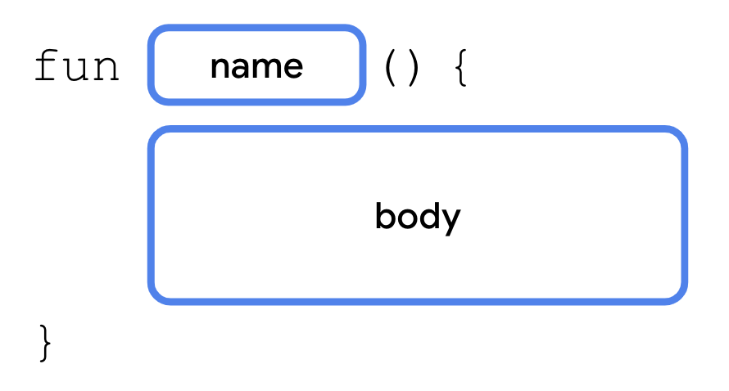

A function definition starts with the fun keyword, followed by the name of the function, a set of opening and closing parentheses, and a set of opening and closing curly braces. Contained in curly braces is the code that will run when the function is called.

You'll create a new function to move the two println() statements out of the main() function.

1. In your browser, open the [Kotlin Playground](https://developer.android.com/training/kotlinplayground) and replace the contents with the following code.

fun main() {  
    println("Happy Birthday, Rover!")  
    println("You are now 5 years old!")  
}

1. After the main() function, define a new function named birthdayGreeting(). This function is declared with the same syntax as the main() function.

fun main() {  
    println("Happy Birthday, Rover!")  
    println("You are now 5 years old!")  
}  
  
fun birthdayGreeting() {  
      
}

1. Move the two println() statements from main() into the curly braces of the birthdayGreeting() function.

fun main() {  
      
}  
  
fun birthdayGreeting() {  
    println("Happy Birthday, Rover!")  
    println("You are now 5 years old!")  
}

1. In the main() function, call the birthdayGreeting() function. Your finished code should look as follows:

fun main() {  
    birthdayGreeting()  
}  
  
fun birthdayGreeting() {  
    println("Happy Birthday, Rover!")  
    println("You are now 5 years old!")  
}

1. Run your code. You should see the following output:

Happy Birthday, Rover!

You are now 5 years old!

[3. Return a value from a function](https://developer.android.com/codelabs/basic-android-kotlin-compose-functions?continue=https%3A%2F%2Fdeveloper.android.com%2Fcourses%2Fpathways%2Fandroid-basics-compose-unit-1-pathway-1%23codelab-https%3A%2F%2Fdeveloper.android.com%2Fcodelabs%2Fbasic-android-kotlin-compose-functions#2)

In more complex apps, functions do more than print text.

Kotlin functions can also generate data called a *return value* which is stored in a variable that you can use elsewhere in your code.

When defining a function, you can specify the data type of the value you want it to return. The return type is specified by placing a colon (:) after the parentheses and the name of a type (Int, String, etc) after the colon. A single space is placed after the return type and before the opening curly brace. Within the function body, after all the statements, you use a return statement to specify the value you want the function to return. A return statement consists of the return keyword followed by the value, such as a variable, you want the function to return as an output.

The syntax for declaring a function with a return type is as follows.

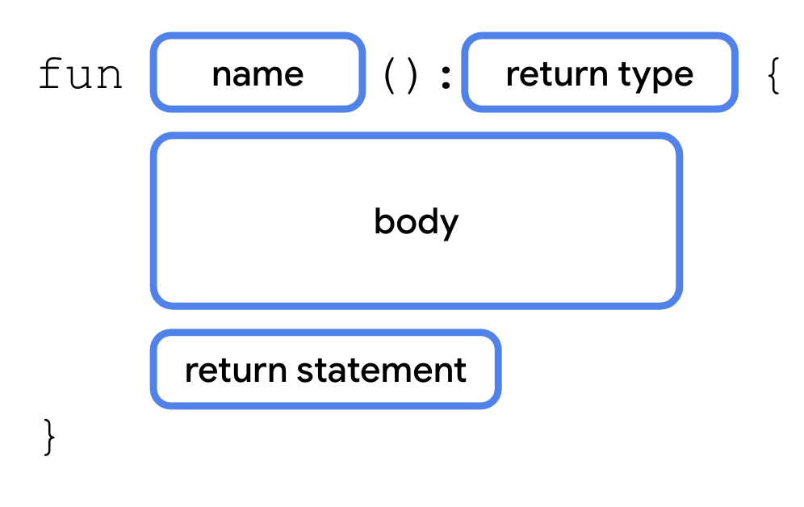

The Unit type

By default, if you don't specify a return type, the default return type is Unit. Unit means the function doesn't return a value. Unit is equivalent to void return types in other languages (void in Java and C; Void/empty tuple () in Swift; None in Python, etc.). Any function that doesn't return a value implicitly returns Unit. You can observe this by modifying your code to return Unit.

1. In the function declaration for birthdayGreeting(), add a colon after the closing parenthesis and specify the return type as Unit.

fun main() {  
    birthdayGreeting()  
}  
  
fun birthdayGreeting(): Unit {  
    println("Happy Birthday, Rover!")  
    println("You are now 5 years old!")  
}

1. Run the code and observe that everything still works.

Happy Birthday, Rover!

You are now 5 years old!

It's optional to specify the Unit return type in Kotlin. For functions that don't return anything, or returning Unit, you don't need a return statement.

**Note:** You'll see the Unit type again when you learn about a Kotlin feature called lambdas in a later codelab.

Return a String from birthdayGreeting()

To demonstrate how a function can return a value, you'll modify the birthdayGreeting() function to return a string, rather than simply print the result.

1. Replace the Unit return type with String.

fun birthdayGreeting(): String {  
    println("Happy Birthday, Rover!")  
    println("You are now 5 years old!")  
}

1. Run your code. You'll get an error. If you declare a return type for a function (e.g., String), that function must include a return statement.

A 'return' expression required in a function with a block body ('{...}')

1. You can only return one string from a function, not two. Replace the println() statements with two variables, nameGreeting and ageGreeting, using the val keyword. Because you removed the calls to println() from birthdayGreeting(), calling birthdayGreeting() won't print anything.

fun birthdayGreeting(): String {  
    val nameGreeting = "Happy Birthday, Rover!"  
    val ageGreeting = "You are now 5 years old!"  
}

1. Using the string formatting syntax you learned in an earlier codelab, add a return statement to return a string from the function consisting of both greetings.

In order to format the greetings on a separate line, you also need to use the \n escape character. This is just like the \" escape character you learned about in a previous codelab. The \n character is replaced for a newline so that the two greetings are each on a separate line.

fun birthdayGreeting(): String {  
    val nameGreeting = "Happy Birthday, Rover!"  
    val ageGreeting = "You are now 5 years old!"  
    return "$nameGreeting\n$ageGreeting"  
}

1. In main(), because birthdayGreeting() returns a value, you can store the result in a string variable. Declare a greeting variable using val to store the result of calling birthdayGreeting().

fun main() {  
    val greeting = birthdayGreeting()  
}

1. In main(), call println() to print the greeting string. The main() function should now look as follows.

fun main() {  
    val greeting = birthdayGreeting()  
    println(greeting)  
}

1. Run your code and then observe that the result is the same as before. Returning a value lets you store the result in a variable, but what do you think happens if you call the birthdayGreeting() function inside the println() function?

Happy Birthday, Rover!

You are now 5 years old!

1. Remove the variable and then pass the result of calling the birthdayGreeting() function into the println() function:

fun main() {  
    println(birthdayGreeting())  
}

1. Run your code and observe the output. The return value of calling birthdayGreeting() is passed directly into println().

Happy Birthday, Rover!

You are now 5 years old!

[4. Add a parameter to the birthdayGreeting() function](https://developer.android.com/codelabs/basic-android-kotlin-compose-functions?continue=https%3A%2F%2Fdeveloper.android.com%2Fcourses%2Fpathways%2Fandroid-basics-compose-unit-1-pathway-1%23codelab-https%3A%2F%2Fdeveloper.android.com%2Fcodelabs%2Fbasic-android-kotlin-compose-functions#3)

As you've seen, when you call println(), you can include a string within the parentheses or *pass a value* to the function. You can do the same with your birthdayGreeting() function. However, you first need to add a *parameter* to birthdayGreeting().

A parameter specifies the name of a variable and a data type that you can pass into a function as data to be accessed inside the function. Parameters are declared within the parentheses after the function name.

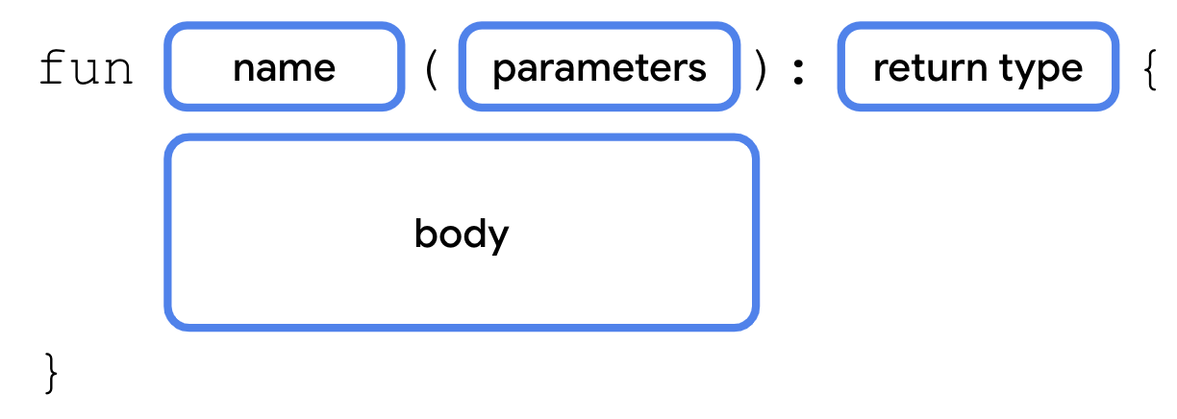

Each parameter consists of a variable name and data type, separated by a colon and a space. Multiple parameters are separated by a comma.

Right now, the birthdayGreeting() function can only be used to greet Rover. You'll add a parameter to the birthdayGreeting() function so that you can greet any name that you pass into the function.

1. Within the parentheses of the birthdayGreeting() function, add a name parameter of type String, using the syntax name: String.

fun birthdayGreeting(name: String): String {  
    val nameGreeting = "Happy Birthday, Rover!"  
    val ageGreeting = "You are now 5 years old!"  
    return "$nameGreeting\n$ageGreeting"  
}

The parameter defined in the previous step works like a variable declared with the val keyword. Its value can be used anywhere in the birthdayGreeting() function. In an earlier codelab, you learned about how you can insert the value of a variable into a string.

1. Replace Rover in the nameGreeting string with the $ symbol followed by the name parameter.

fun birthdayGreeting(name: String): String {  
    val nameGreeting = "Happy Birthday, $name!"  
    val ageGreeting = "You are now 5 years old!"  
    return "$nameGreeting\n$ageGreeting"  
}

1. Run your code and observe the error. Now that you declared the name parameter, you need to pass in a String when you call birthdayGreeting(). When you call a function that takes a parameter, you pass an argument to the function. The argument is the value that you pass, such as "Rover".

No value passed for parameter 'name'

1. Pass "Rover" into the birthdayGreeting() call in main().

fun main() {  
    println(birthdayGreeting("Rover"))  
}

1. Run your code and observe the output. The name Rover comes from the name parameter.

Happy Birthday, Rover!

You are now 5 years old!

1. Because birthdayGreeting() takes a parameter, you can call it with a name other than Rover. Add another call to birthdayGreeting() inside the call to println(), passing in the argument "Rex".

println(birthdayGreeting("Rover"))  
println(birthdayGreeting("Rex"))

1. Run the code again and then observe that the output differs based on the argument passed into birthdayGreeting().

Happy Birthday, Rover!

You are now 5 years old!

Happy Birthday, Rex!

You are now 5 years old!

**Note:** Although you often find them used interchangeably, a parameter and an argument aren't the same thing. When you define a function, you define the parameters that are to be passed to it when the function is called. When you call a function, you pass arguments for the parameters. Parameters are the variables accessible to the function, such as a name variable, while arguments are the actual values that you pass, such as the "Rover" string.

**Warning:** Unlike in some languages, such as Java, where a function can change the value passed into a parameter, parameters in Kotlin are immutable. You cannot reassign the value of a parameter from within the function body.

[5. Functions with multiple parameters](https://developer.android.com/codelabs/basic-android-kotlin-compose-functions?continue=https%3A%2F%2Fdeveloper.android.com%2Fcourses%2Fpathways%2Fandroid-basics-compose-unit-1-pathway-1%23codelab-https%3A%2F%2Fdeveloper.android.com%2Fcodelabs%2Fbasic-android-kotlin-compose-functions#4)

Previously, you added a parameter to change the greeting based on the name. However, you can also define more than one parameter for a function, even parameters of different data types. In this section, you'll modify the greeting so that it also changes based on the dog's age.



Parameter definitions are separated by commas. Similarly, when you call a function with multiple parameters, you separate the arguments passed in with commas as well. Let's see this in action.

1. After the name parameter, add an age parameter of type Int, to the birthdayGreeting() function. The new function declaration should have the two parameters, name and age, separated by a comma:

fun birthdayGreeting(name: String, age: Int): String {  
    val nameGreeting = "Happy Birthday, $name!"  
    val ageGreeting = "You are now 5 years old!"  
    return "$nameGreeting\n$ageGreeting"  
}

1. The new greeting string should use the age parameter. Update the birthdayGreeting() function to use the value of the age parameter in the ageGreeting string.

fun birthdayGreeting(name: String, age: Int): String {  
    val nameGreeting = "Happy Birthday, $name!"  
    val ageGreeting = "You are now $age years old!"  
    return "$nameGreeting\n$ageGreeting"  
}

1. Run the function and then notice the errors in the output:

No value passed for parameter 'age'

No value passed for parameter 'age'

1. Modify the two calls to the birthdayGreeting() function in main() to pass in a different age for each dog. Pass in 5 for Rover's age and 2 for Rex's age.

fun main() {  
    println(birthdayGreeting("Rover", 5))  
    println(birthdayGreeting("Rex", 2))  
}

1. Run your code. Now that you passed in values for both parameters, the output should reflect the name and age of each dog when you call the function.

Happy Birthday, Rover!

You are now 5 years old!

Happy Birthday, Rex!

You are now 2 years old!

Function Signature

So far you've seen how to define the function name, inputs (parameters), and outputs. The function name with its inputs (parameters) are collectively known as the *function signature*. The function signature consists of everything before the return type and is shown in the following code snippet.

fun birthdayGreeting(name: String, age: Int)

The parameters, separated by commas, are sometimes called the parameter list.

You'll often see these terms in documentation for code written by other developers. The function signature tells you the name of the function and what data types can be passed in.

You've learned a lot of new syntax around defining functions. Take a look at the following diagram for a recap of function syntax.

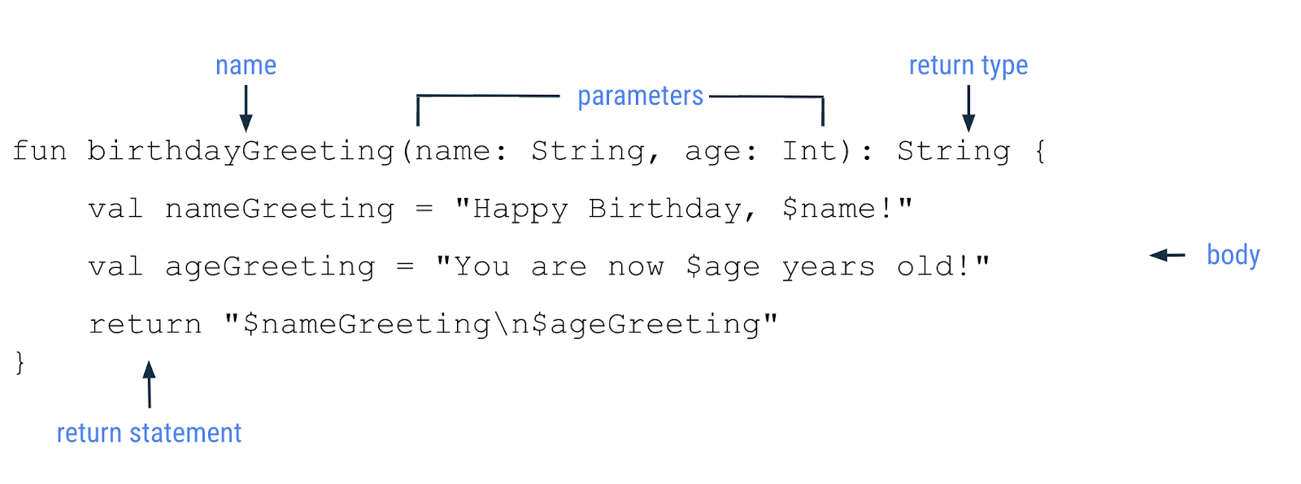

[6. Named arguments](https://developer.android.com/codelabs/basic-android-kotlin-compose-functions?continue=https%3A%2F%2Fdeveloper.android.com%2Fcourses%2Fpathways%2Fandroid-basics-compose-unit-1-pathway-1%23codelab-https%3A%2F%2Fdeveloper.android.com%2Fcodelabs%2Fbasic-android-kotlin-compose-functions#5)

In the previous examples, you didn't need to specify the parameter names, name or age, when you called a function. However, you're able to do so if you choose. For example, you may call a function with many parameters or you may want to pass your arguments in a different order, such as putting the age parameter before the name parameter. When you include the parameter name when you call a function, it's called a [*named argument*](https://kotlinlang.org/docs/functions.html#named-arguments). Try using a named argument with the birthdayGreeting() function.

1. Modify the call for Rex to use named arguments as shown in this code snippet. You can do this by including the parameter name followed by an equal sign, and then the value (e.g. name = "Rex").

println(birthdayGreeting(name = "Rex", age = 2))

1. Run the code and then observe that the output is unchanged:

Happy Birthday, Rover!

You are now 5 years old!

Happy Birthday, Rex!

You are now 2 years old!

1. Reorder the named arguments. For example, put the age named argument before the name named argument.

println(birthdayGreeting(age = 2, name = "Rex"))

1. Run the code and observe that the output remains the same. Even though you changed the order of the arguments, the same values are passed in for the same parameters.

Happy Birthday, Rover!

You are now 5 years old!

Happy Birthday, Rex!

You are now 2 years old!

[7. Default arguments](https://developer.android.com/codelabs/basic-android-kotlin-compose-functions?continue=https%3A%2F%2Fdeveloper.android.com%2Fcourses%2Fpathways%2Fandroid-basics-compose-unit-1-pathway-1%23codelab-https%3A%2F%2Fdeveloper.android.com%2Fcodelabs%2Fbasic-android-kotlin-compose-functions#6)

Function parameters can also specify default arguments. Maybe Rover is your favorite dog, or you expect a function to be called with specific arguments in most cases. When you call a function, you can choose to omit arguments for which there is a default, in which case, the default is used.

To add a default argument, you add the assignment operator (=) after the data type for the parameter and set it equal to a value. Modify your code to use a default argument.

1. In the birthdayGreeting() function, set the name parameter to the default value "Rover".

fun birthdayGreeting(name: String = "Rover", age: Int): String {  
    return "Happy Birthday, $name! You are now $age years old!"  
}

1. In the first call to birthdayGreeting() for Rover in main(), set the age named argument to 5. Because the age parameter is defined after the name, you need to use the named argument age. Without named arguments, Kotlin assumes the order of arguments is the same order in which parameters are defined. The named argument is used to ensure Kotlin is expecting an Int for the age parameter.

println(birthdayGreeting(age = 5))  
println(birthdayGreeting("Rex", 2))

1. Run your code. The first call to the birthdayGreeting() function prints "Rover" as the name because you never specified the name. The second call to birthdayGreeting() still uses the Rex value, which you passed in for the name.

Happy Birthday, Rover! You are now 5 years old!

Happy Birthday, Rex! You are now 2 years old!

1. Remove the name from the second call to the birthdayGreeting() function. Again, because name is omitted, you need to use a named argument for the age.

println(birthdayGreeting(age = 5))  
println(birthdayGreeting(age = 2))

1. Run your code and then observe that now both calls to birthdayGreeting() print "Rover" as the name because no name argument is passed in.

Happy Birthday, Rover! You are now 5 years old!

Happy Birthday, Rover! You are now 2 years old!

[8. Conclusion](https://developer.android.com/codelabs/basic-android-kotlin-compose-functions?continue=https%3A%2F%2Fdeveloper.android.com%2Fcourses%2Fpathways%2Fandroid-basics-compose-unit-1-pathway-1%23codelab-https%3A%2F%2Fdeveloper.android.com%2Fcodelabs%2Fbasic-android-kotlin-compose-functions#7)

Congratulations! You learned how to define and call functions in Kotlin.

Summary

* Functions are defined with the fun keyword and contain reusable pieces of code.
* Functions help make larger programs easier to maintain and prevent the unnecessary repetition of code.
* Functions can return a value that you can store in a variable for later use.
* Functions can take parameters, which are variables available inside a function body.
* Arguments are the values that you pass in when you call a function.
* You can name arguments when you call a function. When you use named arguments, you can reorder the arguments without affecting the output.
* You can specify a default argument that lets you omit the argument when you call a function.
* Practice Problems:
* Kotlin Basics

[1. Before you begin](https://developer.android.com/codelabs/basic-android-kotlin-compose-intro-kotlin-practice-problems?continue=https%3A%2F%2Fdeveloper.android.com%2Fcourses%2Fpathways%2Fandroid-basics-compose-unit-1-pathway-1%23codelab-https%3A%2F%2Fdeveloper.android.com%2Fcodelabs%2Fbasic-android-kotlin-compose-intro-kotlin-practice-problems#0)

While you've put in the hard work to gain knowledge of the basics of Kotlin programming, now it's time to put what you learned into practice.

These exercises test your understanding of the concepts that you studied. They're themed around real-world use cases, some of which you probably encountered before.

Follow the instructions to find a solution for each problem. If you get stuck, some of the exercises have hints that can help you. The solution code is available at the end, but it's strongly recommended that you solve the exercises before you check your answers.

Consider the solutions as one way to solve the problems and feel free to experiment however you feel comfortable. You can solve some of the exercises in multiple ways, and use different names for the functions and variables.

Work through the problems at a pace that's comfortable to you. There is a duration listed, but it is not necessary to adhere to those timings, as they are only estimates. You are encouraged to take as much time as you need to solve each problem thoughtfully.

It's recommended that you use [Kotlin Playground](https://developer.android.com/training/kotlinplayground) to solve these exercises.

Prerequisites

* Familiarity with [Kotlin Playground](https://developer.android.com/training/kotlinplayground)
* Ability to define and call functions
* Knowledge of basic Kotlin data types
* Knowledge of immutable and mutable variables
* Knowledge of the println() function
* Completion of the [Your first program in Kotlin](https://developer.android.com/codelabs/basic-android-kotlin-compose-first-program), [Create and use variables in Kotlin](https://developer.android.com/codelabs/basic-android-kotlin-compose-variables), and [Create and use functions in Kotlin](https://developer.android.com/codelabs/basic-android-kotlin-compose-functions) codelabs

What you'll need

* A computer with internet access and a web browser

[2. Print messages](https://developer.android.com/codelabs/basic-android-kotlin-compose-intro-kotlin-practice-problems?continue=https%3A%2F%2Fdeveloper.android.com%2Fcourses%2Fpathways%2Fandroid-basics-compose-unit-1-pathway-1%23codelab-https%3A%2F%2Fdeveloper.android.com%2Fcodelabs%2Fbasic-android-kotlin-compose-intro-kotlin-practice-problems#1)

Tell your friends what you learned in this pathway.

* Can you write a main() function that prints these messages on four separate lines?

Use the val keyword when the value doesn't change.

Use the var keyword when the value can change.

When you define a function, you define the parameters that can be passed to it.

When you call a function, you pass arguments for the parameters.

[3. Fix compile error](https://developer.android.com/codelabs/basic-android-kotlin-compose-intro-kotlin-practice-problems?continue=https%3A%2F%2Fdeveloper.android.com%2Fcourses%2Fpathways%2Fandroid-basics-compose-unit-1-pathway-1%23codelab-https%3A%2F%2Fdeveloper.android.com%2Fcodelabs%2Fbasic-android-kotlin-compose-intro-kotlin-practice-problems#2)

This program prints a message that notifies the user that they received a chat message from a friend.

fun main() {   
    println("New chat message from a friend'}  
}

1. Can you figure out the root cause of the compile errors in this program and fix them?
2. Does the code use appropriate symbols to indicate the open and close of the string and function argument?

**Hint:** You can use Kotlin Playground to run the code and view the compilation errors.

After you fix the errors, the program should compile without errors and print this output:

New chat message from a friend

[4. String templates](https://developer.android.com/codelabs/basic-android-kotlin-compose-intro-kotlin-practice-problems?continue=https%3A%2F%2Fdeveloper.android.com%2Fcourses%2Fpathways%2Fandroid-basics-compose-unit-1-pathway-1%23codelab-https%3A%2F%2Fdeveloper.android.com%2Fcodelabs%2Fbasic-android-kotlin-compose-intro-kotlin-practice-problems#3)

This program informs users about the upcoming promotional sale on a particular item. It has a string template, which relies on the discountPercentage variable for the percent discount and the item variable for the item on sale. However, there are compilation errors in the code.

fun main() {  
    val discountPercentage: Int = 0  
    val offer: String = ""  
    val item = "Google Chromecast"  
    discountPercentage = 20  
    offer = "Sale - Up to $discountPercentage% discount on $item! Hurry up!"  
      
    println(offer)  
}

1. Can you figure out the root cause of the errors and fix them?
2. Can you determine the output of this program before you run the code in Kotlin Playground?

**Hint:** Can you re-assign a value to a read-only variable?

After you fix the errors, the program should compile without errors and print this output:

Sale - Up to 20% discount on Google Chromecast! Hurry up!

[5. String concatenation](https://developer.android.com/codelabs/basic-android-kotlin-compose-intro-kotlin-practice-problems?continue=https%3A%2F%2Fdeveloper.android.com%2Fcourses%2Fpathways%2Fandroid-basics-compose-unit-1-pathway-1%23codelab-https%3A%2F%2Fdeveloper.android.com%2Fcodelabs%2Fbasic-android-kotlin-compose-intro-kotlin-practice-problems#4)

This program displays the total party size. There are adults and kids at the party. The numberOfAdults variable holds the number of adults at the party and the numberOfKids variable holds the number of kids.

fun main() {  
    val numberOfAdults = "20"  
    val numberOfKids = "30"  
    val total = numberOfAdults + numberOfKids  
    println("The total party size is: $total")  
}

Step 1

* Can you determine the output of this program before you run the code in Kotlin Playground?

After you determine the output, run the code in Kotlin Playground and then check if your output matches the output displayed.

**Hint:** What happens when you use the + operator on two strings?

Step 2

The code works and prints some output, but the output doesn't show the total number of people attending the party.

* Can you find the issue in the code and fix it so that it prints this output?

The total party size is: 50

[6. Message formatting](https://developer.android.com/codelabs/basic-android-kotlin-compose-intro-kotlin-practice-problems?continue=https%3A%2F%2Fdeveloper.android.com%2Fcourses%2Fpathways%2Fandroid-basics-compose-unit-1-pathway-1%23codelab-https%3A%2F%2Fdeveloper.android.com%2Fcodelabs%2Fbasic-android-kotlin-compose-intro-kotlin-practice-problems#5)

This program displays the total salary that an employee receives this month. The total salary is divided in two parts: the baseSalary variable, which the employee receives every month, and the bonusAmount variable, which is an additional bonus awarded to the employee.

fun main() {  
    val baseSalary = 5000  
    val bonusAmount = 1000  
    val totalSalary = "$baseSalary + $bonusAmount"  
    println("Congratulations for your bonus! You will receive a total of $totalSalary (additional bonus).")  
}

1. Can you figure out the output of this code before you run it in Kotlin Playground?
2. When you run the code in Kotlin Playground, does it print the output that you expected?

[7. Implement basic math operations](https://developer.android.com/codelabs/basic-android-kotlin-compose-intro-kotlin-practice-problems?continue=https%3A%2F%2Fdeveloper.android.com%2Fcourses%2Fpathways%2Fandroid-basics-compose-unit-1-pathway-1%23codelab-https%3A%2F%2Fdeveloper.android.com%2Fcodelabs%2Fbasic-android-kotlin-compose-intro-kotlin-practice-problems#6)

In this exercise, you write a program that performs basic math operations and prints the output.

Step 1

This main() function contains one compile error:

fun main() {  
    val firstNumber = 10  
    val secondNumber = 5  
      
    println("$firstNumber + $secondNumber = $result")  
}

* Can you fix the error so that the program prints this output?

10 + 5 = 15

Step 2

The code works, but the logic for adding two numbers is located within the result variable, making your code less flexible to reuse. Instead, you can extract the addition operation into an add() function so that the code is reusable. To do this, update your code with the code listed below. Notice that the code now introduces a new val called thirdNumber and prints the result of this new variable with firstNumber.

fun main() {  
    val firstNumber = 10  
    val secondNumber = 5  
    val thirdNumber = 8  
      
    val result = add(firstNumber, secondNumber)  
    val anotherResult = add(firstNumber, thirdNumber)  
  
    println("$firstNumber + $secondNumber = $result")  
    println("$firstNumber + $thirdNumber = $anotherResult")  
}  
  
// Define add() function below this line

* Can you define the add() function so that the program prints this output?

10 + 5 = 15

10 + 8 = 18

Step 3

Now you have a reusable function to add two numbers.

* Can you implement the subtract() function the same way you implemented the add() function? Modify the main() function as well to use the subtract() function so you can verify that it works as expected.

**Hint:** Think about the difference between addition, subtraction and other math operations. Start work on the solution code from there.

[8. Default parameters](https://developer.android.com/codelabs/basic-android-kotlin-compose-intro-kotlin-practice-problems?continue=https%3A%2F%2Fdeveloper.android.com%2Fcourses%2Fpathways%2Fandroid-basics-compose-unit-1-pathway-1%23codelab-https%3A%2F%2Fdeveloper.android.com%2Fcodelabs%2Fbasic-android-kotlin-compose-intro-kotlin-practice-problems#7)

Gmail has a feature that sends a notification to the user whenever a login attempt is made on a new device.

In this exercise, you write a program that displays a message to users with this message template:

There's a new sign-in request on operatingSystem for your Google Account emailId.

You need to implement a function that accepts an operatingSystem parameter and an emailId parameter, constructs a message in the given format, and returns the message.

For example, if the function was called with "Chrome OS" for the operatingSystem and "sample@gmail.com" for the emailId, it should return this string:

There's a new sign-in request on Chrome OS for your Google Account sample@gmail.com.

Step 1

1. Can you implement the displayAlertMessage() function in this program so that it prints the output displayed?

fun main() {  
    val operatingSystem = "Chrome OS"  
    val emailId = "sample@gmail.com"  
  
    println(displayAlertMessage(operatingSystem, emailId))  
}  
  
// Define your displayAlertMessage() below this line.

1. Does your program print this output?

There's a new sign-in request on Chrome OS for your Google Account sample@gmail.com.

Step 2

Great job! You displayed the message. However, in some cases, you discover that you can't determine the user's operating system. In such cases, you need to specify the operating system name as Unknown OS. You can further optimize the code so that you don't need to pass the Unknown OS argument each time that the function is called.

1. Can you find a way to optimize the code with this information so that it prints this output?

There's a new sign-in request on Unknown OS for your Google Account user\_one@gmail.com.

There's a new sign-in request on Windows for your Google Account user\_two@gmail.com.

There's a new sign-in request on Mac OS for your Google Account user\_three@gmail.com.

1. To print the above message, replace the main() function implementation with this one:

fun main() {  
    val firstUserEmailId = "user\_one@gmail.com"  
  
    // The following line of code assumes that you named your parameter as emailId.   
    // If you named it differently, feel free to update the name.  
    println(displayAlertMessage(emailId = firstUserEmailId))  
    println()  
  
    val secondUserOperatingSystem = "Windows"  
    val secondUserEmailId = "user\_two@gmail.com"  
  
    println(displayAlertMessage(secondUserOperatingSystem, secondUserEmailId))  
    println()  
  
    val thirdUserOperatingSystem = "Mac OS"  
    val thirdUserEmailId = "user\_three@gmail.com"  
  
    println(displayAlertMessage(thirdUserOperatingSystem, thirdUserEmailId))  
    println()  
}

[9. Pedometer](https://developer.android.com/codelabs/basic-android-kotlin-compose-intro-kotlin-practice-problems?continue=https%3A%2F%2Fdeveloper.android.com%2Fcourses%2Fpathways%2Fandroid-basics-compose-unit-1-pathway-1%23codelab-https%3A%2F%2Fdeveloper.android.com%2Fcodelabs%2Fbasic-android-kotlin-compose-intro-kotlin-practice-problems#8)

The pedometer is an electronic device that counts the number of steps taken. Nowadays, almost all mobile phones, smart watches, and fitness gear come with pedometers built into them. The health and fitness app uses built-in pedometers to calculate the number of steps taken. This function calculates the number of calories that the user burns based on the user's number of steps.

* Can you rename the functions, function parameters, and variables in this program based on best practices?

fun main() {  
    val Steps = 4000  
    val caloriesBurned = PEDOMETERstepsTOcalories(Steps);  
    println("Walking $Steps steps burns $caloriesBurned calories")   
}  
  
fun PEDOMETERstepsTOcalories(NumberOFStepS: Int): Double {  
    val CaloriesBURNEDforEachStep = 0.04  
    val TotalCALORIESburned = NumberOFStepS \* CaloriesBURNEDforEachStep  
    return TotalCALORIESburned  
}

[10. Compare two numbers](https://developer.android.com/codelabs/basic-android-kotlin-compose-intro-kotlin-practice-problems?continue=https%3A%2F%2Fdeveloper.android.com%2Fcourses%2Fpathways%2Fandroid-basics-compose-unit-1-pathway-1%23codelab-https%3A%2F%2Fdeveloper.android.com%2Fcodelabs%2Fbasic-android-kotlin-compose-intro-kotlin-practice-problems#9)

Modern mobile phones have a built-in feature that tracks screen time, or the time you spend on your phone each day.

In this exercise, you implement a function that compares the time in minutes that you spent on your phone today versus the time spent yesterday. The function accepts two integer parameters and returns a boolean value.

The first parameter holds the number of minutes that you spent today and the second parameter holds the number of minutes that you spent yesterday. The function returns a true value if you spent more time on the phone today compared to yesterday. Otherwise, it returns a false value.

For example, if you called the function with these named arguments:

* timeSpentToday = 300 and timeSpentYesterday = 250, the function returns a true value.
* timeSpentToday = 300 and timeSpentYesterday = 300, the function returns a false value.
* timeSpentToday = 200 and timeSpentYesterday = 220, the function returns a false value.

**Hint:** The > comparison operator returns a true value if the value before the operator is greater than the value after it. Otherwise, it returns a false value.

[11. Move duplicate code into a function](https://developer.android.com/codelabs/basic-android-kotlin-compose-intro-kotlin-practice-problems?continue=https%3A%2F%2Fdeveloper.android.com%2Fcourses%2Fpathways%2Fandroid-basics-compose-unit-1-pathway-1%23codelab-https%3A%2F%2Fdeveloper.android.com%2Fcodelabs%2Fbasic-android-kotlin-compose-intro-kotlin-practice-problems#10)

This program displays the weather for different cities. It includes the city name, the high and low temperature for the day, and the chance of rain.

fun main() {  
    println("City: Ankara")  
    println("Low temperature: 27, High temperature: 31")  
    println("Chance of rain: 82%")  
    println()  
  
    println("City: Tokyo")  
    println("Low temperature: 32, High temperature: 36")  
    println("Chance of rain: 10%")  
    println()  
      
    println("City: Cape Town")  
    println("Low temperature: 59, High temperature: 64")  
    println("Chance of rain: 2%")  
    println()  
      
    println("City: Guatemala City")  
    println("Low temperature: 50, High temperature: 55")  
    println("Chance of rain: 7%")  
    println()  
}

There are many similarities in the code that prints the weather for each city. For example, there are phrases that are repeated multiple times, such as "City:" and "Low temperature:". Similar, repeated code creates the risk of errors in your program. For one of the cities, you may have a typo or you may forget one of the weather details.

1. Can you create a function that prints the weather details for a single city to reduce the repetition in the main() function and then do the same for the remaining cities?
2. Can you update the main() function to call the function that you created for each city and pass in the appropriate weather details as arguments?

[12. Solution code](https://developer.android.com/codelabs/basic-android-kotlin-compose-intro-kotlin-practice-problems?continue=https%3A%2F%2Fdeveloper.android.com%2Fcourses%2Fpathways%2Fandroid-basics-compose-unit-1-pathway-1%23codelab-https%3A%2F%2Fdeveloper.android.com%2Fcodelabs%2Fbasic-android-kotlin-compose-intro-kotlin-practice-problems#11)

Print messages

The solution uses the println() function to print the messages on each line.

fun main() {  
    println("Use the val keyword when the value doesn't change.")  
    println("Use the var keyword when the value can change.")  
    println("When you define a function, you define the parameters that can be passed to it.")  
    println("When you call a function, you pass arguments for the parameters.")  
}

Fix compile error

The code contained two compilation errors:

1. The string should end with a double quotation mark rather than a single quotation mark.
2. The function argument should end with a parenthesis rather than a curly bracket.

fun main() {   
    println("New chat message from a friend")  
}

String templates

The compilation errors are the result from the assignment of the discountPercentage and offer read-only variables to new values; this assignment isn't allowed.

fun main() {  
    val discountPercentage = 20  
    val item = "Google Chromecast"  
    val offer = "Sale  - Up to $discountPercentage% discount off $item! Hurry Up!"  
  
    println(offer)  
}

As an alternative solution, you could declare the discountPercentage integer and offer string with the var keyword. However, their values are immutable in the context of the program, so you can stick with the val keyword.

String concatenation

Step 1

The program prints this output:

The total party size is: 2030

This was a trick question. When the + operator is used on String values, it produces a concatenated string. The integers are wrapped in double quotation marks, so they're treated as strings instead of integers, hence the output of 2030.

Step 2

You could remove the double quotation marks around the numberOfAdults and numberOfKids variables to convert them to Int variables.

fun main() {  
    val numberOfAdults = 20  
    val numberOfKids = 30  
    val total = numberOfAdults + numberOfKids  
    println("The total party size is: $total")  
}

If you remember, the Kotlin compiler can infer the type of variables based on the values assigned to them. In this case, the compiler infers that the numberOfAdults and numberOfKids variables are Int types.

Message formatting

The program prints this output:

Congratulations for your bonus! You will receive a total of 5000 + 1000 (additional bonus).

"$baseSalary + $bonusAmount" uses the template expressions syntax. In template expressions, the code is evaluated first and then the result is concatenated in a string.

In the question, the $baseSalary variable is evaluated to a 5000 value and the $bonusAmount variable is evaluated to a 1000 value. Then, the result is concatenated to produce "5000 + 1000" and assigned to the result variable.

Implement basic math operations

Step 1

Define an immutable result variable with the val keyword and then assign the result of the addition operation to it:

fun main() {  
    val firstNumber = 10  
    val secondNumber = 5  
      
    val result = firstNumber + secondNumber  
    println("$firstNumber + $secondNumber = $result")  
}

Step 2

1. Create an add() function that accepts a firstNumber parameter and secondNumber parameter, both of Int type, and returns an Int value.
2. Enter the code for the addition operation inside the add() function body and then use the return keyword to return the result of the operation.

fun add(firstNumber: Int, secondNumber: Int): Int {  
    return firstNumber + secondNumber  
}

Step 3

1. Define a subtract() function that accepts a firstNumber parameter and secondNumber parameter, both of Int type, and returns an Int value.
2. Enter the code for the subtraction operation inside the subtract() function body and then use the return keyword to return the result of the operation.

fun subtract(firstNumber: Int, secondNumber: Int): Int {  
    return firstNumber - secondNumber  
}

1. Modify the main() function to use the new subtract() function. An example solution could look like this:

fun main() {  
    val firstNumber = 10  
    val secondNumber = 5  
    val thirdNumber = 8  
      
    val result = add(firstNumber, secondNumber)  
    val anotherResult = subtract(firstNumber, thirdNumber)  
  
    println("$firstNumber + $secondNumber = $result")  
    println("$firstNumber - $thirdNumber = $anotherResult")  
}  
  
fun add(firstNumber: Int, secondNumber: Int): Int {  
    return firstNumber + secondNumber  
}  
  
fun subtract(firstNumber: Int, secondNumber: Int): Int {  
    return firstNumber - secondNumber  
}

Default parameters

Step 1

1. Create a displayAlertMessage() function that accepts an operatingSystem parameter and emailId parameter, both of String type, and returns a String value.
2. In the function body, use a template expression to update the message and return it.

fun displayAlertMessage(operatingSystem: String, emailId: String): String {  
    return "There is a new sign-in request on $operatingSystem for your Google Account $emailId."  
}

Step 2

* Assign an "Unknown OS" value to the operatingSystem parameter.

fun displayAlertMessage(  
    operatingSystem: String = "Unknown OS",  
    emailId: String  
): String {  
    return "There is a new sign-in request on $operatingSystem for your Google Account $emailId."  
}

Pedometer

Function names and variable names should follow the *camel case* convention.

If the names contain multiple words, lowercase the first letter of the first word, capitalize the first letter of subsequent words, and remove any spaces between the words.

Example function names include:

* calculateTip
* displayMessage
* takePhoto

Example variable names include:

* numberOfEmails
* cityName
* bookPublicationDate

To learn more about names, see [Naming rules](https://kotlinlang.org/docs/coding-conventions.html#naming-rules).

Avoid using a [Kotlin keyword](https://kotlinlang.org/docs/keyword-reference.html) as a function name because those words are already assigned specific meanings in the Kotlin language.

Your solution code should look something like this code snippet:

fun main() {  
    val steps = 4000  
    val caloriesBurned = pedometerStepsToCalories(steps);  
    println("Walking $steps steps burns $caloriesBurned calories")   
}  
  
fun pedometerStepsToCalories(numberOfSteps: Int): Double {  
    val caloriesBurnedForEachStep = 0.04  
    val totalCaloriesBurned = numberOfSteps \* caloriesBurnedForEachStep  
    return totalCaloriesBurned  
}

Compare two numbers

* Create a compareTime() function that accepts a timeSpentToday parameter and a timeSpentYesterday parameter, both of Int type, and returns a Boolean value.

The solution relies on the > comparison operator. The operator evaluates to a Boolean value, so the compareTime() function simply returns the result of timeSpentToday > timeSpentYesterday.

For example, if you pass a 300 argument to the timeSpentToday parameter and a 250 argument to the timeSpentYesterday parameter, the function body evaluates to 300 > 250, which returns a true value because 300 is greater than 250.

fun main() {  
    println("Have I spent more time using my phone today: ${compareTime(300, 250)}")  
    println("Have I spent more time using my phone today: ${compareTime(300, 300)}")  
    println("Have I spent more time using my phone today: ${compareTime(200, 220)}")  
}  
  
fun compareTime(timeSpentToday: Int, timeSpentYesterday: Int): Boolean {  
    return timeSpentToday > timeSpentYesterday  
}

Have I spent more time using my phone today: true

Have I spent more time using my phone today: false

Have I spent more time using my phone today: false

Move duplicate code into a function

1. Create a function that prints out the weather details for the city of Ankara after the main() function.

For the function name, you can use printWeatherForCity() or something similar.

1. Call the function from the main() function.

The program should print the weather details for Ankara.

fun main() {  
    printWeatherForCity()  
}  
  
fun printWeatherForCity() {  
    println("City: Ankara")  
    println("Low temperature: 27, High temperature: 31")  
    println("Chance of rain: 82%")  
    println()  
}

Now you can create another function that's more flexible so that it can print weather details for other cities.

1. Replace the Ankara-specific parts of the println() statements with variables.

Remember to use camel case convention for the variable names and the $ symbol before the variable so that the value of the variable gets used instead of the variable name. These are string templates which you learned about in an earlier codelab.

fun printWeatherForCity() {  
    println("City: $cityName")  
    println("Low temperature: $lowTemp, High temperature: $highTemp")  
    println("Chance of rain: $chanceOfRain%")  
    println()  
}

1. Change the function definition so that those variables are parameters that must be passed into the function when it's called and specify the data type for each parameter.

The cityName parameter is of String type, while the lowTemp, highTemp, and chanceOfRain parameters are of Int type.

There's no return value needed in the function definition because the messages are printed to the output.

fun printWeatherForCity(cityName: String, lowTemp: Int, highTemp: Int, chanceOfRain: Int) {  
    println("City: $cityName")  
    println("Low temperature: $lowTemp, High temperature: $highTemp")  
    println("Chance of rain: $chanceOfRain%")  
    println()  
}

1. Update the main() function to call the printWeatherForCity() function and pass in the weather details for Ankara.

The city name is "Ankara", the low temperature is 27, the high temperature is 31, and the chance of rain is 82.

fun main() {  
    printWeatherForCity("Ankara", 27, 31, 82)  
}  
  
fun printWeatherForCity(cityName: String, lowTemp: Int, highTemp: Int, chanceOfRain: Int) {  
    println("City: $cityName")  
    println("Low temperature: $lowTemp, High temperature: $highTemp")  
    println("Chance of rain: $chanceOfRain%")  
    println()  
}

1. Run the program to verify that the output shows the weather details for Ankara.
2. Call the printWeatherForCity() function with the weather details for the other cities.

fun main() {  
    printWeatherForCity("Ankara", 27, 31, 82)  
    printWeatherForCity("Tokyo", 32, 36, 10)  
    printWeatherForCity("Cape Town", 59, 64, 2)  
    printWeatherForCity("Guatemala City", 50, 55, 7)  
}  
  
fun printWeatherForCity(cityName: String, lowTemp: Int, highTemp: Int, chanceOfRain: Int) {  
    println("City: $cityName")  
    println("Low temperature: $lowTemp, High temperature: $highTemp")  
    println("Chance of rain: $chanceOfRain%")  
    println()  
}

1. Run the program.

It should print the same output as the original program, but now your code is more concise and doesn't contain unnecessary repetition! All the code for printing weather details of a city is centralized in a single place: the printWeatherForCity() function. If you ever want to change how weather details are displayed, you can change them in a single place that applies to all the cities.

## [13. Additional Practice](https://developer.android.com/codelabs/basic-android-kotlin-compose-intro-kotlin-practice-problems?continue=https%3A%2F%2Fdeveloper.android.com%2Fcourses%2Fpathways%2Fandroid-basics-compose-unit-1-pathway-1%23codelab-https%3A%2F%2Fdeveloper.android.com%2Fcodelabs%2Fbasic-android-kotlin-compose-intro-kotlin-practice-problems#12)

For more practice on the Kotlin language, check out the [Kotlin Basics track](https://hyperskill.org/tracks/18) in JetBrains Academy. To jump to a specific topic, go to the [knowledge map](https://hyperskill.org/knowledge-map) to view the list of topics covered in the track.

[1. Before you begin](https://developer.android.com/codelabs/basic-android-kotlin-compose-install-android-studio?continue=https%3A%2F%2Fdeveloper.android.com%2Fcourses%2Fpathways%2Fandroid-basics-compose-unit-1-pathway-2%23codelab-https%3A%2F%2Fdeveloper.android.com%2Fcodelabs%2Fbasic-android-kotlin-compose-install-android-studio#0)

In this codelab, you will install Android Studio.

Android Studio is the official integrated development environment (IDE) for Android app development, built and distributed by Google. An IDE contains tools that enable software developers to design, build, run, and test software, in this case, apps for the Android platform. Android Studio uses IntelliJ IDEA as its foundation and includes the Android plugin pre-installed along with some modifications specifically for the Android platform.

Prerequisites

* Intermediate computer skills, familiarity with files and folders, and using apps, such as a spreadsheet, word processor, or photo editor.
* Ability to download, install, and update software.

What you'll learn

* How to check that your computer configuration meets the minimum requirements for running Android Studio.
* How to download and install the Android Studio.

What you'll need

* A computer running a 64-bit version of Windows (8, 10, or 11), Linux, macOS (10.14 Mojave or later), or ChromeOS.
* Internet access for your computer.

[2. Windows: Verify system requirements](https://developer.android.com/codelabs/basic-android-kotlin-compose-install-android-studio?continue=https%3A%2F%2Fdeveloper.android.com%2Fcourses%2Fpathways%2Fandroid-basics-compose-unit-1-pathway-2%23codelab-https%3A%2F%2Fdeveloper.android.com%2Fcodelabs%2Fbasic-android-kotlin-compose-install-android-studio#1)

Android Studio system requirements

The following are the system requirements for Android Studio on Windows.

* 64-bit Microsoft® Windows® 8/10/11
* x86\_64 CPU architecture; 2nd generation Intel Core or newer, or AMD CPU with support for a [Windows Hypervisor](https://developer.android.com/studio/run/emulator-acceleration#vm-windows)
* 8 GB RAM or more
* 8 GB of available disk space minimum (IDE + Android SDK + Android Emulator)
* 1280 x 800 minimum screen resolution

Check system requirements (Windows 10)

On a Windows computer, you can find all the information that you need to verify the system requirements in the Settings app.

1. Open **Settings**.

**Tip:** You can use the search tool next to the Start button at the bottom of your screen to locate it.

1. Click **System**.
2. At the bottom of the left-hand navigation pane, click **About**.
3. Make sure that the **Windows specifications** meet or exceed the requirements. 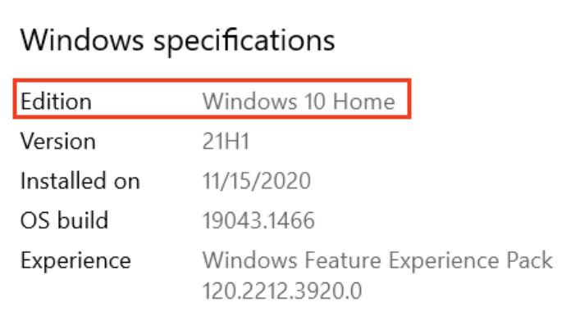
4. Select **Device specifications**. Make sure that the Installed RAM is at least as much as is required and that the system type is the 64-bit version of the operating system.

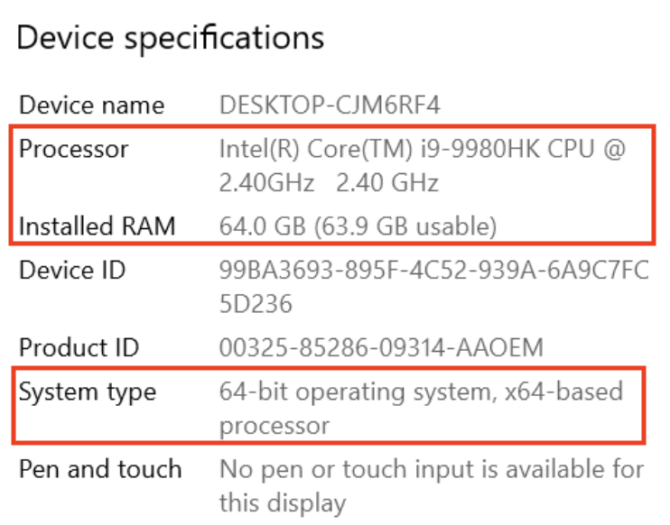

1. In the navigation pane, click **Display**. Make sure that the **Resolution** is the same or better than what's required.

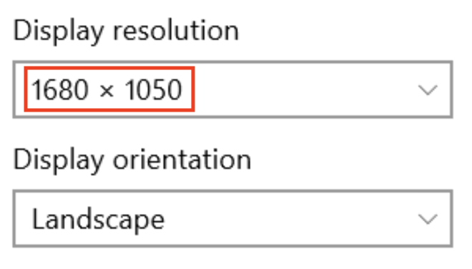

Verify storage

1. Open the file explorer.
2. In the left-hand navigation pane, click **This PC**.
3. Ensure that the local storage has enough free space to install Android Studio.

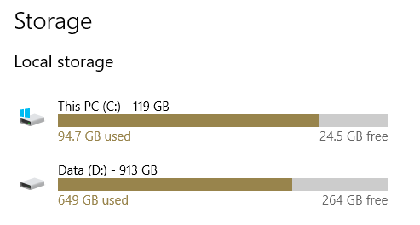

Check system requirements (Windows 8.1)

If you're using Windows 8.1, the steps to find device specifications are as follows:

1. Open the Settings App.
2. In the navigation pane, click **PC and devices**.
3. In the navigation pane, click **PC info**. Check that your CPU and RAM meet the minimum requirements, and ensure you're using a 64-bit operating system.

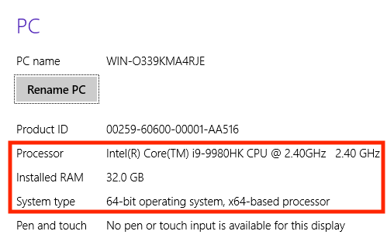

1. In the navigation pane, click **Display**. Check that your display meets the requirements. 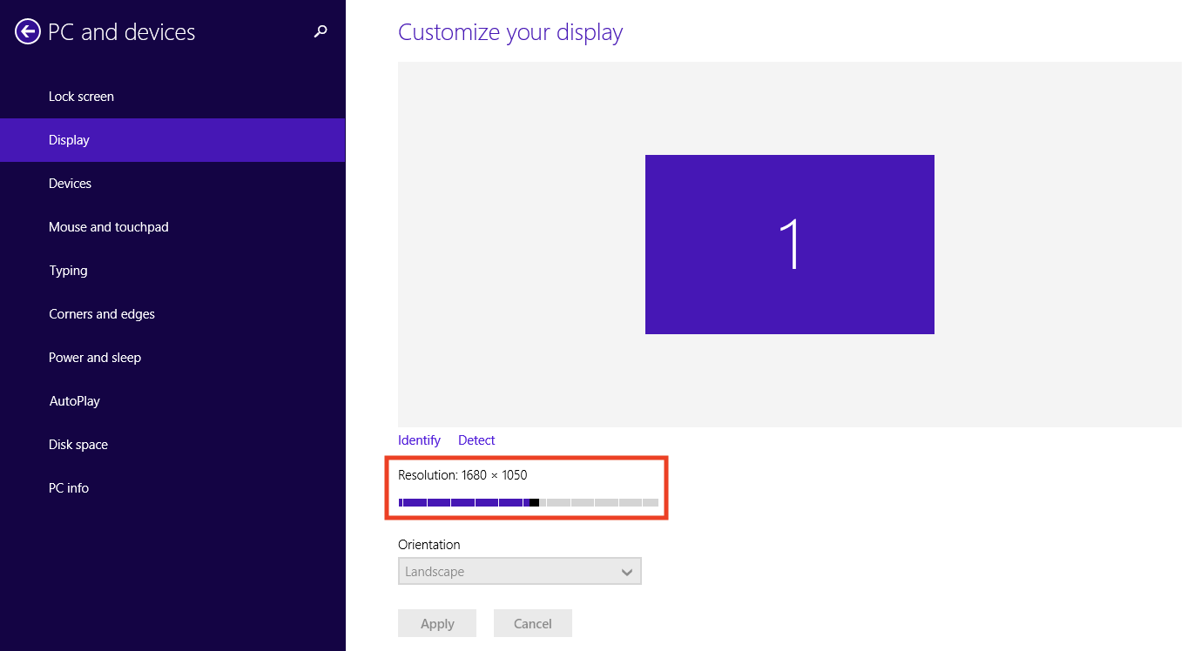
2. Open the file explorer, click **This PC**, and check that you have enough disk space. 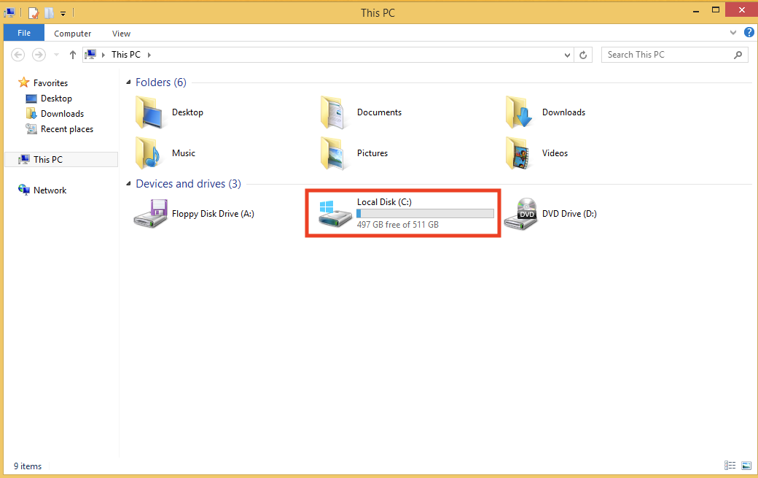

[3. Windows: Download and install Android Studio](https://developer.android.com/codelabs/basic-android-kotlin-compose-install-android-studio?continue=https%3A%2F%2Fdeveloper.android.com%2Fcourses%2Fpathways%2Fandroid-basics-compose-unit-1-pathway-2%23codelab-https%3A%2F%2Fdeveloper.android.com%2Fcodelabs%2Fbasic-android-kotlin-compose-install-android-studio#2)

Download Android Studio

1. Open any web browser and navigate to the [Android Studio download page](https://developer.android.com/studio#get-android-studio).

This is the Android Developers website, where you can download Android Studio. This page automatically detects your operating system.

1. Click **Download Android Studio**. The **Terms and Conditions** page with the Android Studio **License Agreement** opens.
2. Read the **License Agreement**.
3. At the bottom of the page, if you agree with the terms and conditions, select the **I have read and agree with the above terms and conditions** checkbox.
4. Click **Download Android Studio** to start the download.
5. When prompted, save the file to a location where you can easily locate it, such as the Downloads folder.
6. Wait for the download to complete. This may take a while and may be a good moment to enjoy some tea!

Install Android Studio on Windows

1. Open the folder where you downloaded and saved the Android Studio installation file.
2. Double-click the downloaded file.
3. If you see a **User Account Control** dialog about allowing the installation to make changes to your computer, click **Yes** to confirm the installation.

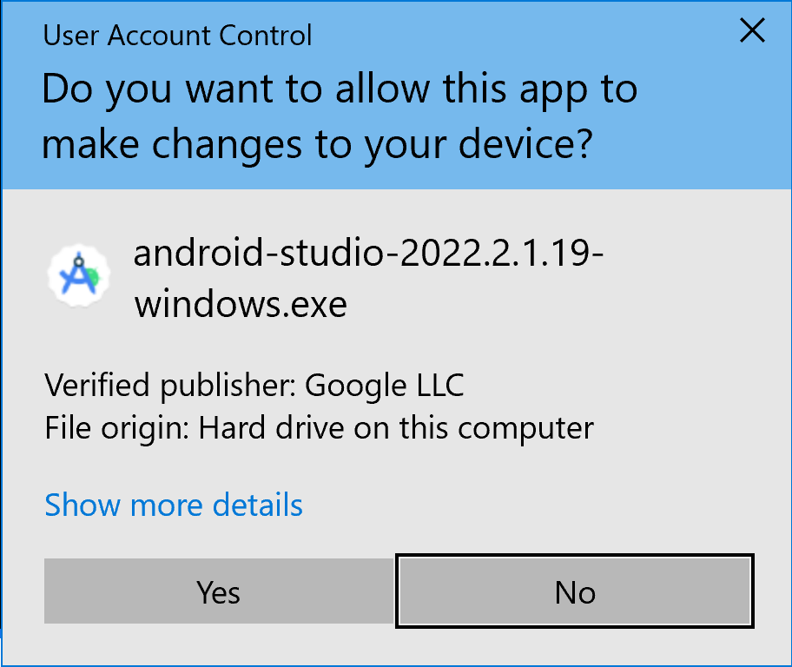

The **Welcome to Android Studio Setup** dialog displays.

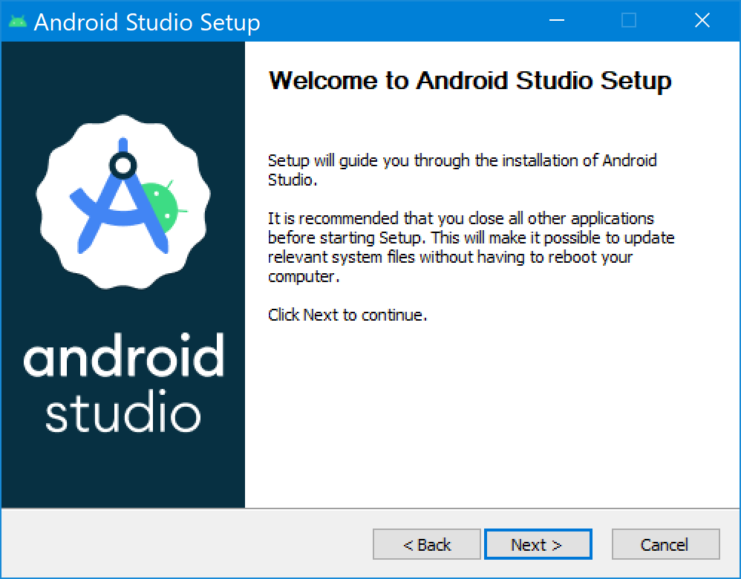

1. Click **Next** to start the installation.
2. Accept the default installation settings for all steps.
3. Click **Finish** when the installation is done to launch Android Studio.

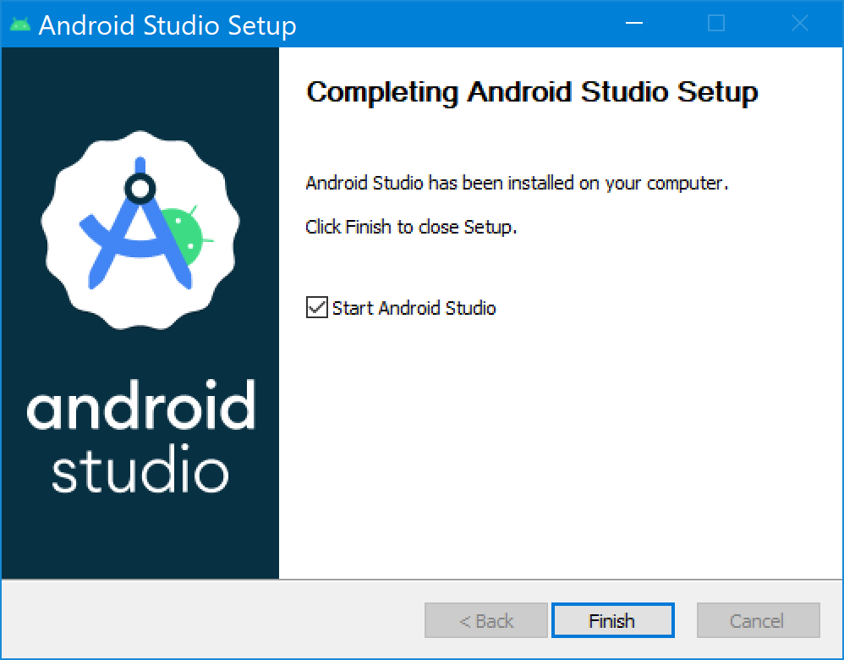

1. Choose your preference of light or dark theme when Android Studio first launches. Screenshots in this course use the light theme, but choose whichever one you prefer.

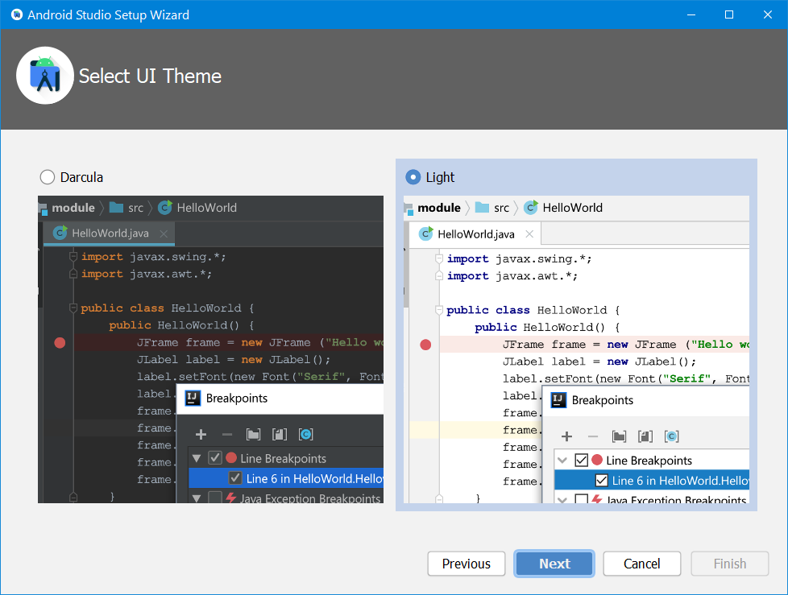

1. During the installation, the setup wizard downloads and installs additional components and tools needed for Android app development. This may take some time depending on your internet speed. During this time, you may see a **User Account Control** dialog for **Windows Command Processor**. Click **Yes** to accept the dialog.

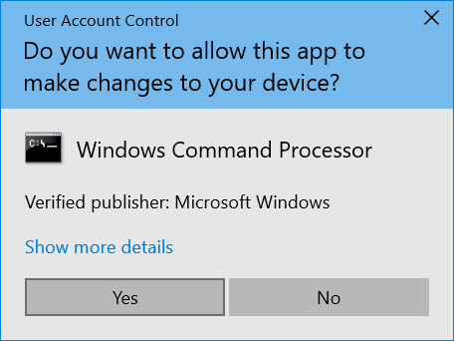

1. You may also receive a **Windows Security Alert** about adb.exe. Click **Allow Access,** if needed, to continue the installation.



1. When the download and installation completes, click **Finish**.

The **Welcome to Android Studio** window displays and you're ready to start creating apps!

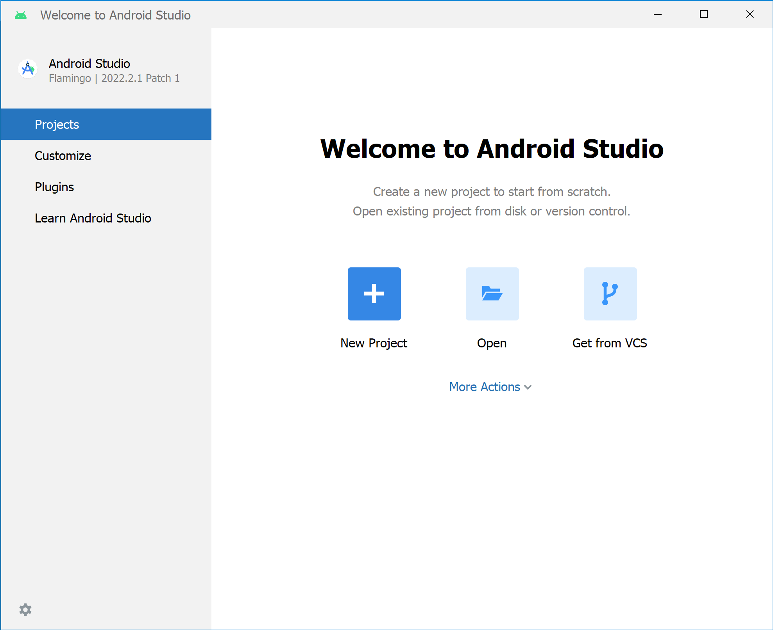

[4. macOS: Verify system requirements](https://developer.android.com/codelabs/basic-android-kotlin-compose-install-android-studio?continue=https%3A%2F%2Fdeveloper.android.com%2Fcourses%2Fpathways%2Fandroid-basics-compose-unit-1-pathway-2%23codelab-https%3A%2F%2Fdeveloper.android.com%2Fcodelabs%2Fbasic-android-kotlin-compose-install-android-studio#3)

Android Studio system requirements (macOS)

The following are the system requirements for Android Studio on macOS.

* MacOS® 10.14 (Mojave) or higher
* ARM-based chips, or 2nd generation Intel Core or newer with support for [Hypervisor Framework](https://developer.android.com/studio/run/emulator-acceleration#vm-mac)
* 8 GB RAM or more
* 8 GB of available disk space minimum (IDE + Android SDK + Android Emulator)
* 1280 x 800 minimum screen resolution

Check system requirements

1. Select **> About This Mac**.
2. In the dialog, under the **Overview** tab, look for the OS version number and ensure that it's within the required range.
3. In the **Memory** tab, check that the listed total memory meets or exceeds the required minimum.

For example, in the screenshot below, the OS version is 12.2.1 and memory is 16 GB.

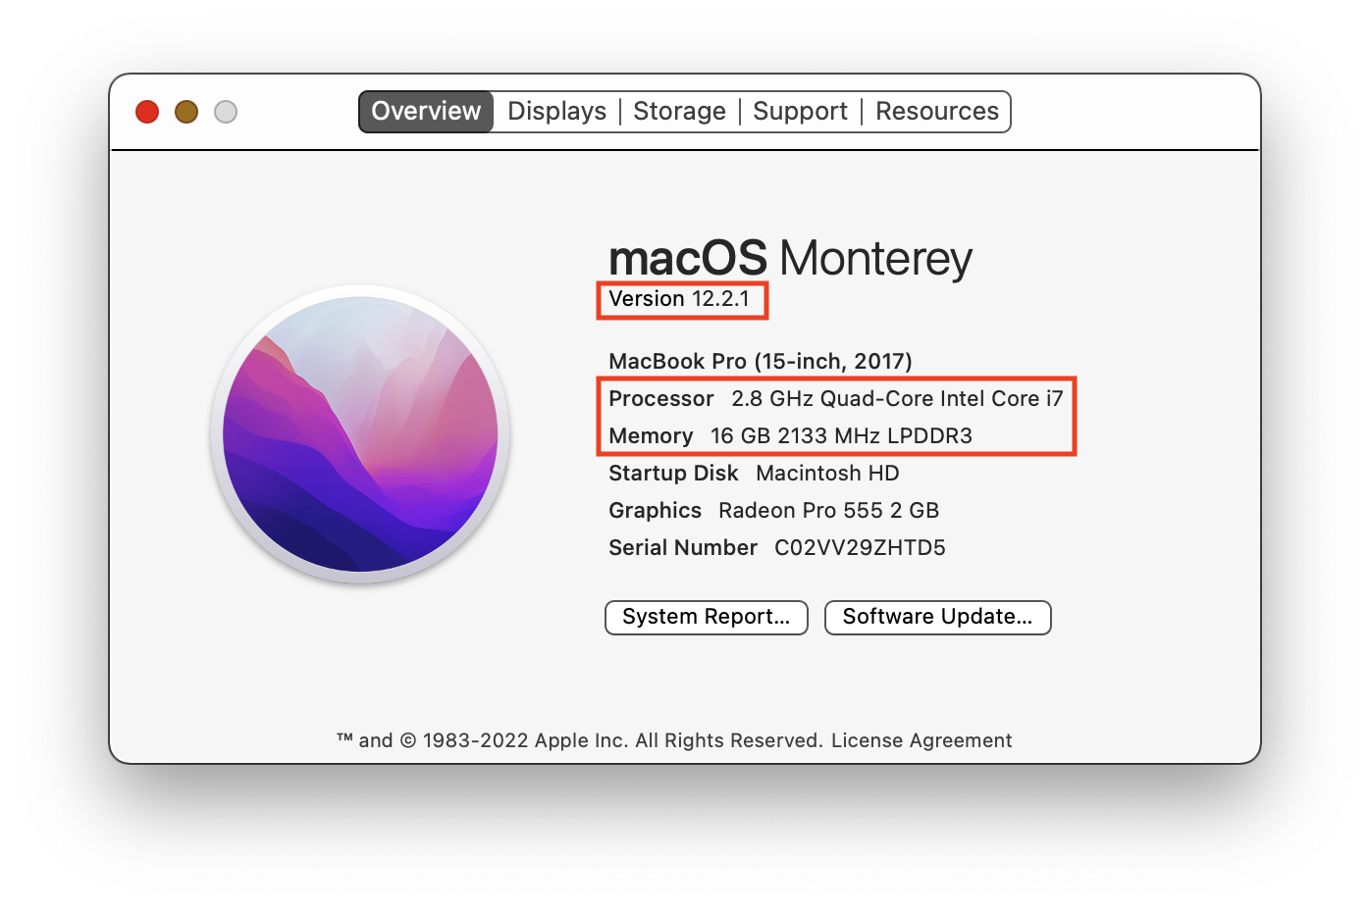

1. In the same dialog, click the **Displays** tab.
2. In the description of the display, ensure that your computer's screen resolution meets or exceeds the recommended resolution.

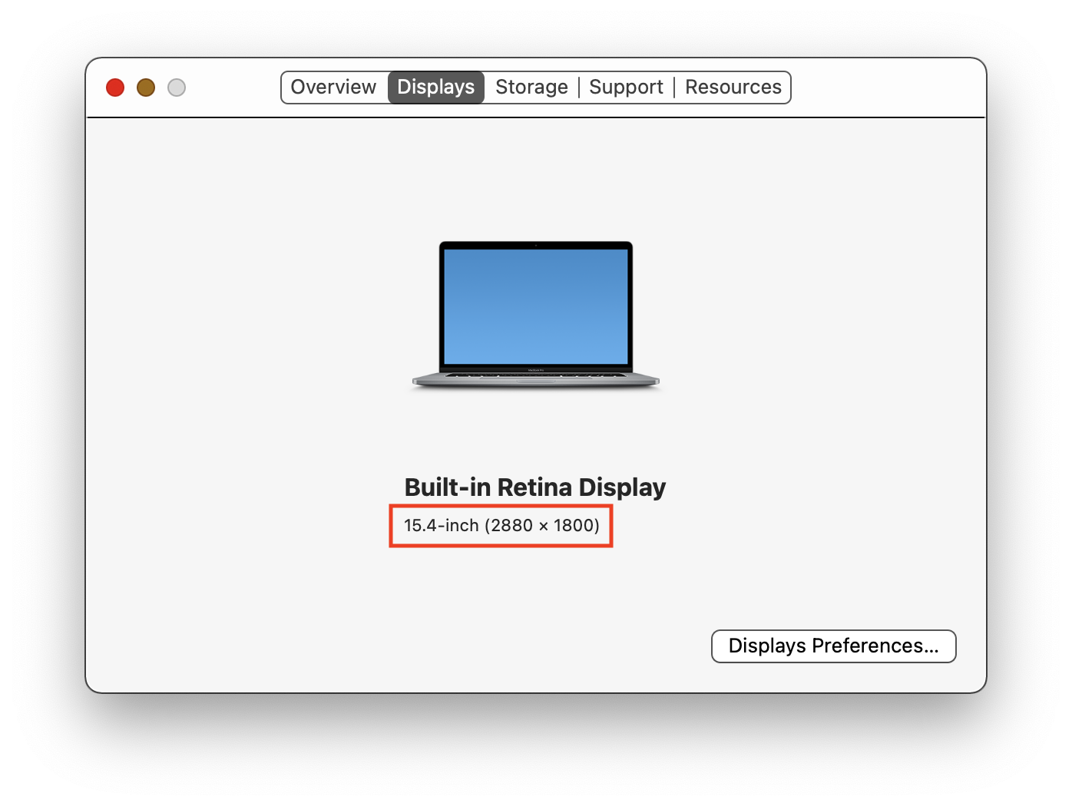

1. Click the **Storage** tab.
2. Check the available disk space and ensure that it meets or exceeds the required disk space for installing and running Android Studio.

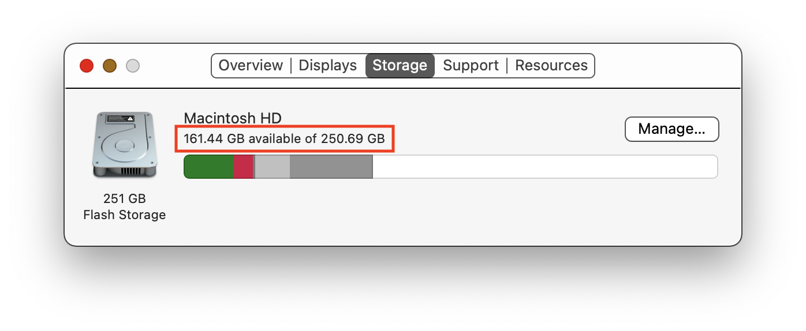

[5. macOS: Download and install Android Studio](https://developer.android.com/codelabs/basic-android-kotlin-compose-install-android-studio?continue=https%3A%2F%2Fdeveloper.android.com%2Fcourses%2Fpathways%2Fandroid-basics-compose-unit-1-pathway-2%23codelab-https%3A%2F%2Fdeveloper.android.com%2Fcodelabs%2Fbasic-android-kotlin-compose-install-android-studio#4)

Download Android Studio

1. Open any web browser and navigate to the [Android Studio download page](https://developer.android.com/studio/?gclid=Cj0KCQiAjJOQBhCkARIsAEKMtO3zEhdK4_I0CEZic3UH4dl-9gVXuHFR9dCl3TOHKjmv3xWLU3UxfhYaApfAEALw_wcB&gclsrc=aw.ds). This is the Android Developers website, where you can download Android Studio. This page automatically detects your operating system.
2. Click **Download Android Studio**. The **Terms and Conditions** page with the Android Studio **License Agreement** opens.
3. Read the **License Agreement**.
4. At the bottom of the page, if you agree with the terms and conditions, select the **I have read and agree with the above terms and conditions** checkbox.
5. Click **Mac with Intel chip** or **Mac with Apple chip** to start the download.
6. When prompted, save the file to a location where you can easily locate it, such as the Downloads folder.
7. Wait for the download to complete. This may take a while and may be a good moment to enjoy some tea!

**Note:** If you need more help or want to customize your installation, refer to the instructions to [install Android Studio](https://developer.android.com/studio/install.html), which includes screencasts.

Install Android Studio on macOS

1. Open the folder where you downloaded and saved the Android Studio installation file.
2. Double-click the downloaded file. The following dialog displays:

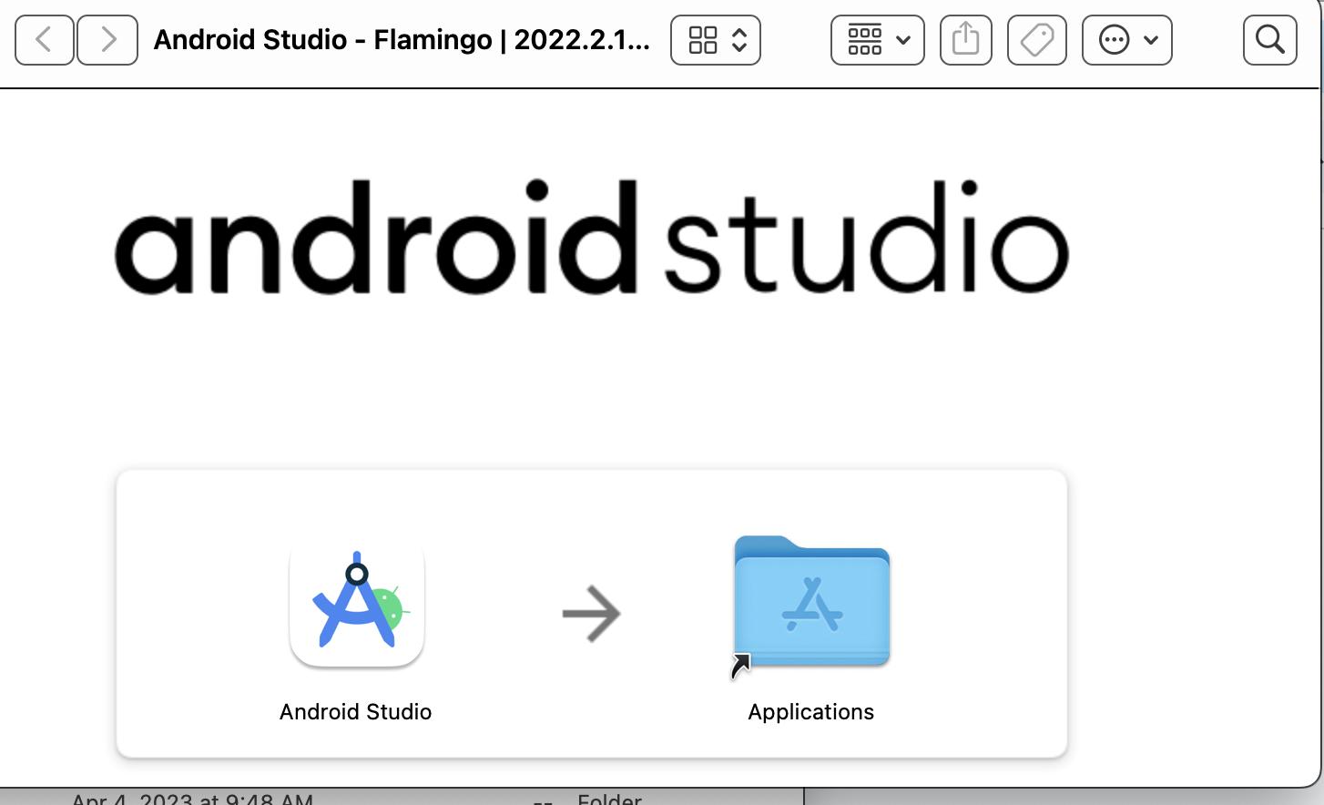

1. Drag the **Android Studio** icon to the Applications folder.
2. In the Applications folder, double-click the **Android Studio** icon to launch the **Android Studio Setup Wizard**.
3. If you see a warning about installing or running a file downloaded from the Internet, accept the installation.

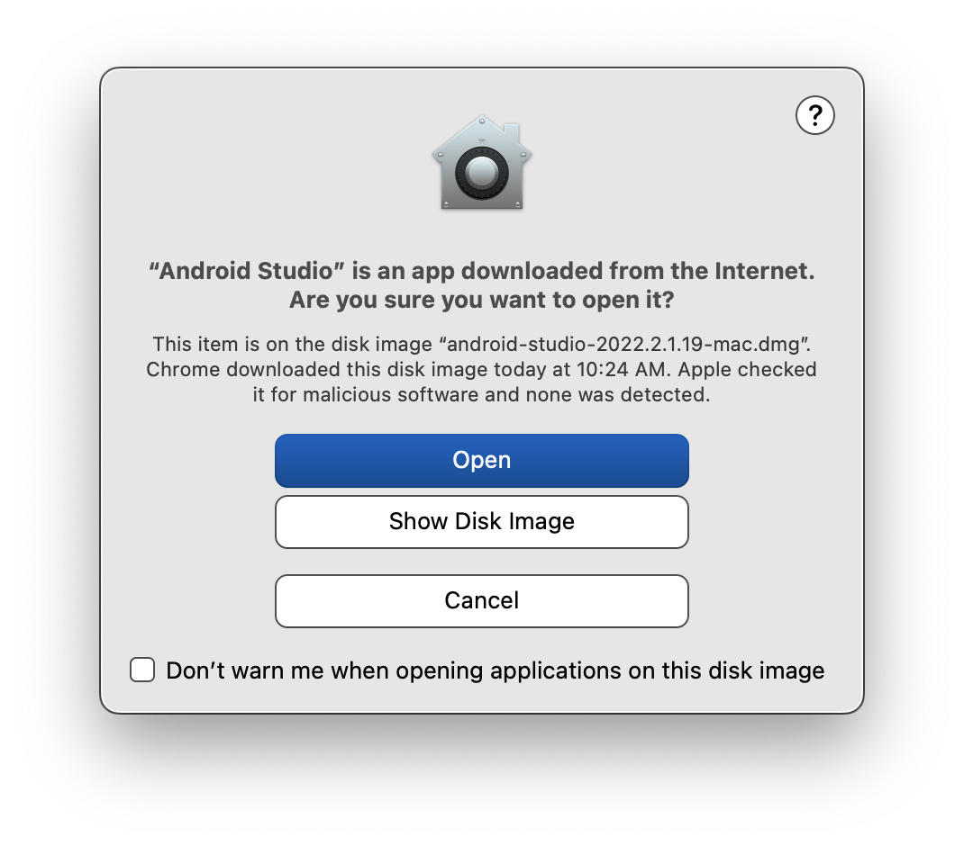

1. Follow the **Android Studio Setup Wizard** and accept the default settings for all steps. During the installation, the setup wizard downloads and installs additional components and tools needed for Android app development. This may take some time, depending on your internet speed. So, you could go refill your tea cup!
2. When the installation completes, Android Studio starts automatically.

The **Welcome to Android Studio** window opens and you're ready to start creating apps!

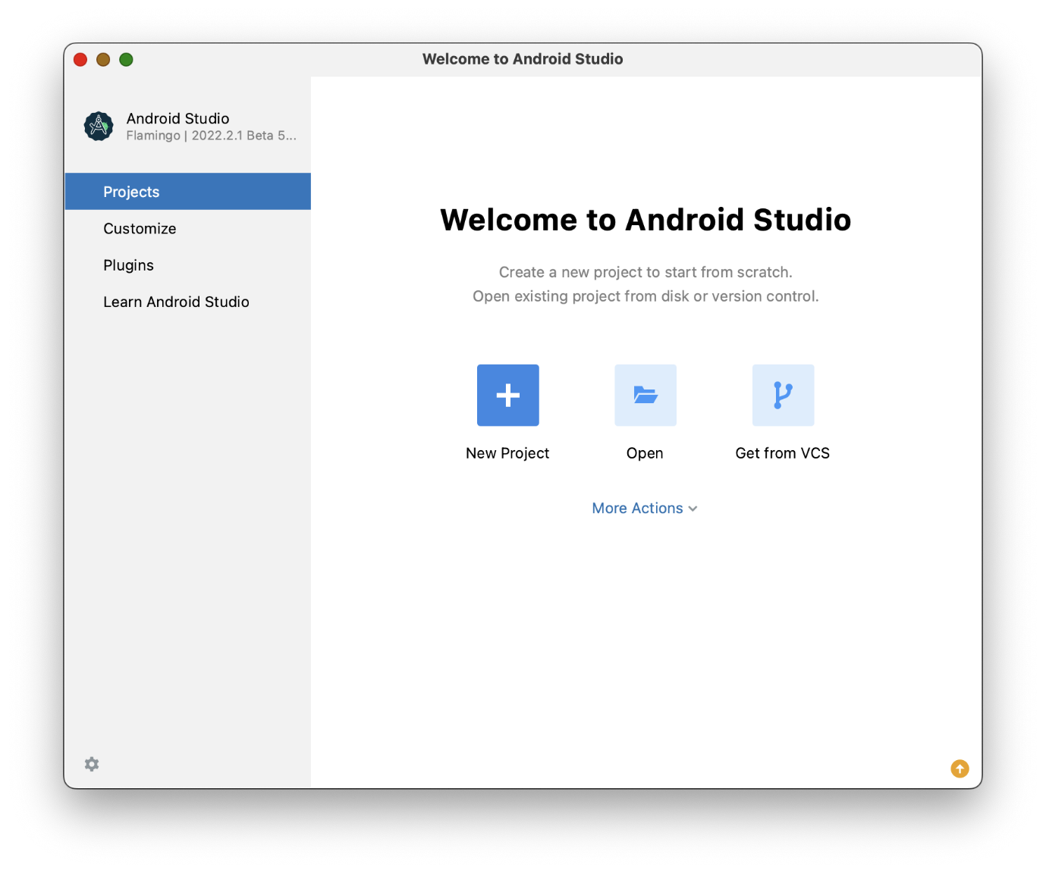

[6. Linux: Verify system requirements](https://developer.android.com/codelabs/basic-android-kotlin-compose-install-android-studio?continue=https%3A%2F%2Fdeveloper.android.com%2Fcourses%2Fpathways%2Fandroid-basics-compose-unit-1-pathway-2%23codelab-https%3A%2F%2Fdeveloper.android.com%2Fcodelabs%2Fbasic-android-kotlin-compose-install-android-studio#5)

Android Studio system requirements

The following are the Android Studio system requirements for Linux.

* Any 64-bit Linux distribution that supports Gnome, KDE, or Unity DE; GNU C Library (glibc) 2.31 or later.
* x86\_64 CPU architecture; 2nd generation Intel Core or newer, or AMD processor with support for AMD Virtualization (AMD-V) and SSSE3
* 8 GB RAM or more
* 8 GB of available disk space minimum (IDE + Android SDK + Android Emulator)
* 1280 x 800 minimum screen resolution

Check system requirements

Use the terminal commands to check if your computer meets the hardware requirements before installing.

**Tip:** You can quickly open a Terminal window using the keyboard shortcut Ctrl+Alt+T.

1. Use lscpu to check your processor specifications.

lscpu

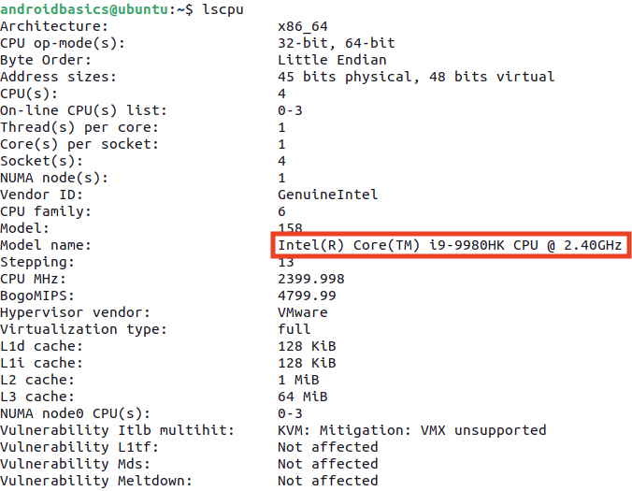

1. Use the free command to check total system memory.

The output is in megabytes, so the system below has 32 GB of total memory.

free -m



1. Use the df command to check available disk space.

df -h

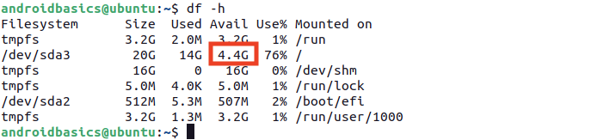

1. Use xrandr to check the screen resolution.

xrandr | grep '\*'



[7. Linux: Download and install Android Studio](https://developer.android.com/codelabs/basic-android-kotlin-compose-install-android-studio?continue=https%3A%2F%2Fdeveloper.android.com%2Fcourses%2Fpathways%2Fandroid-basics-compose-unit-1-pathway-2%23codelab-https%3A%2F%2Fdeveloper.android.com%2Fcodelabs%2Fbasic-android-kotlin-compose-install-android-studio#6)

Download Android Studio

1. Open any web browser and navigate to the [Android Studio download page](https://developer.android.com/studio/?gclid=Cj0KCQiAjJOQBhCkARIsAEKMtO3zEhdK4_I0CEZic3UH4dl-9gVXuHFR9dCl3TOHKjmv3xWLU3UxfhYaApfAEALw_wcB&gclsrc=aw.ds).
2. This is the Android Developers website, where you can download Android Studio. This page automatically detects your operating system. Click **Download Android Studio**. The **Terms and Conditions** page with the **Android Studio License Agreement** opens.
3. Read the **License Agreement**.
4. At the bottom of the page, if you agree with the terms and conditions, select the **I have read and agree with the above terms and conditions** checkbox.
5. Click **Download Android Studio** to start the download.
6. When prompted, save the file to a location where you can easily locate it, such as the Downloads folder.
7. Wait for the download to complete. This may take a while and may be a good moment to enjoy some tea!

Install Android Studio on Linux

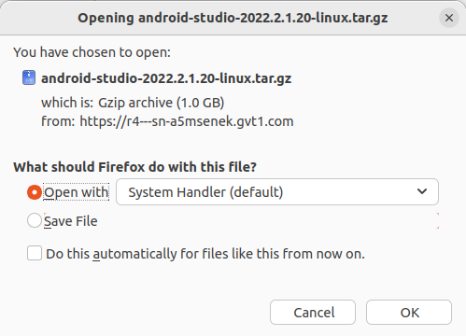

Open the Downloads folder in the terminal.

1. Extract the archive with the tar command.

tar -xzvf android-studio-2022.2.1.20-linux.tar.gz

1. Navigate to the android-studio/bin directory.

cd android-studio/bin

1. Run studio.sh

./studio.sh

1. Keep **Do not import settings** selected and click **OK** on the prompt.

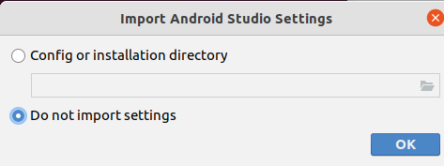

1. Choose whether or not to share usage data with Google.

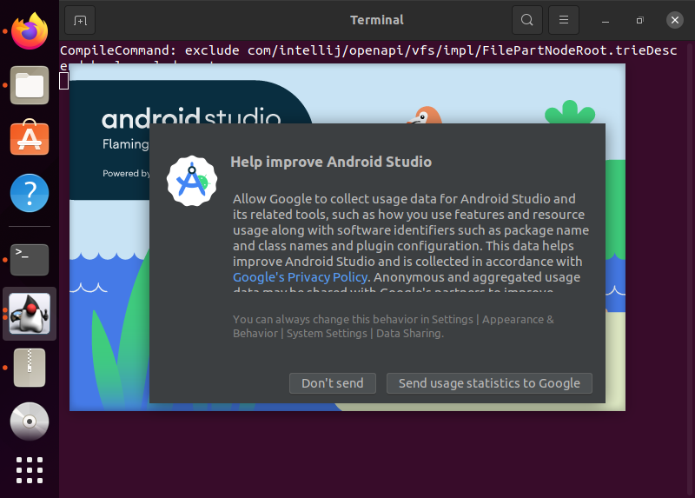

1. Keep **Standard** as the selected install type. Click **Next** to continue.

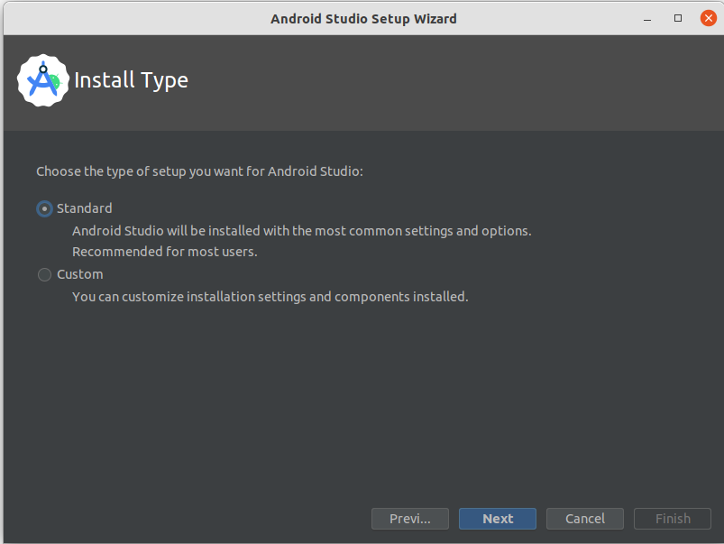

1. Choose your preference of light or dark theme. Screenshots in this course use the light theme, but choose whichever one you prefer. You can always change this later.

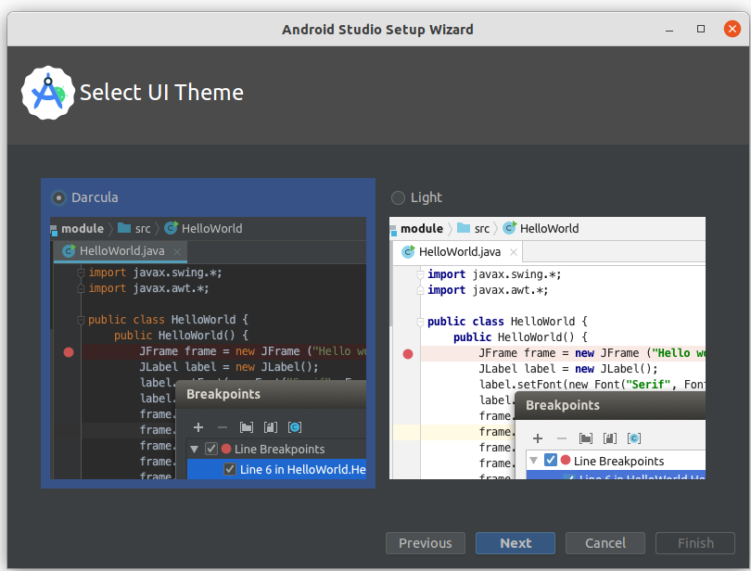

1. Accept all the default settings and click **Next**.

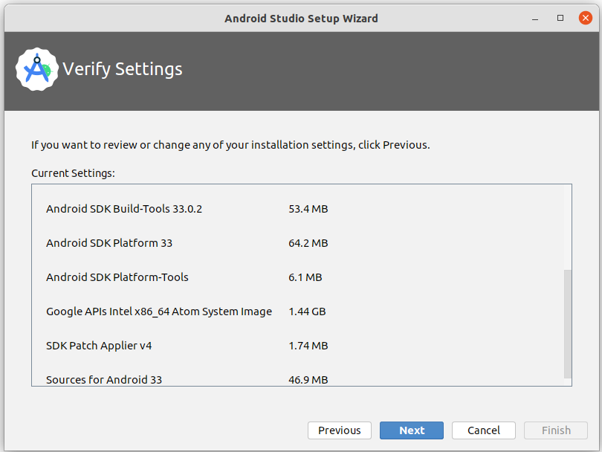

1. Read and agree to the **License Agreement** for the Android SDK and Android NDK, and click **Next**.

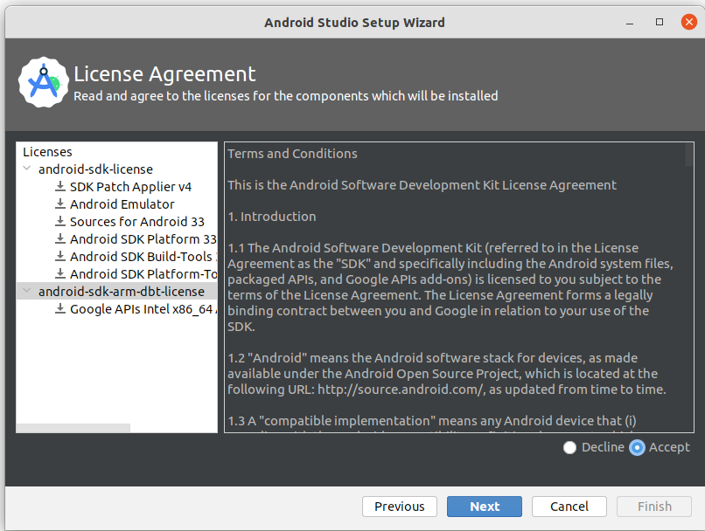

1. You may also see some additional information about hardware acceleration and the Android emulator. Click **Finish**.

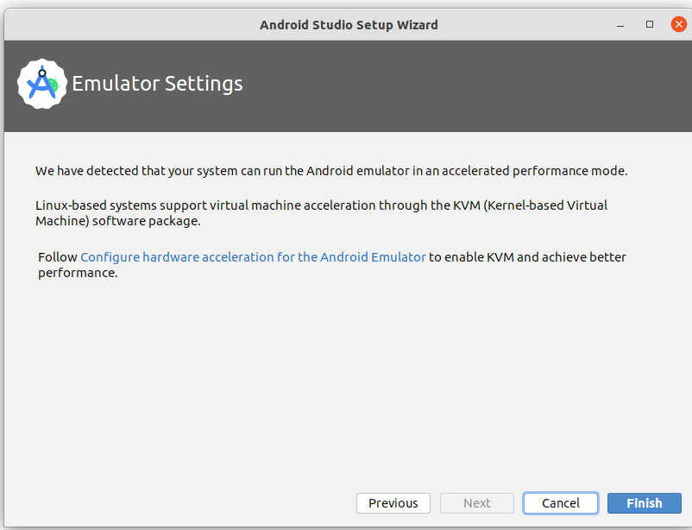

1. During the installation, the setup wizard downloads and installs additional components and tools needed for Android app development.

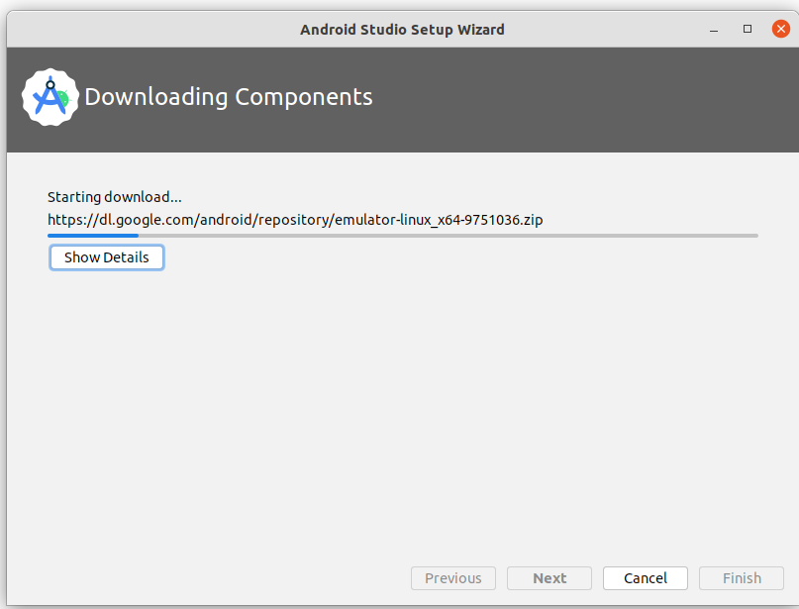

When the installation is complete, click **Finish**.

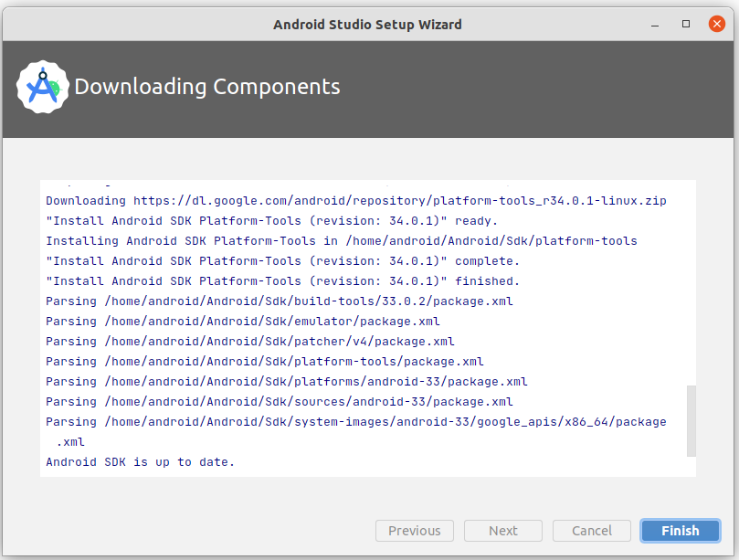

1. The **Welcome to Android Studio** dialog displays and you're ready to start creating apps!

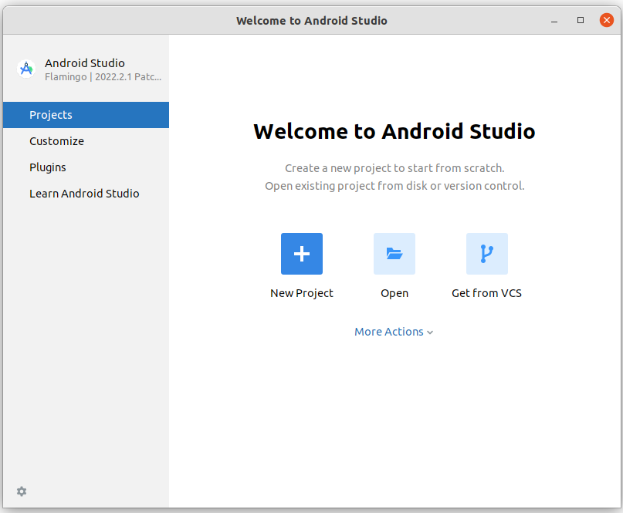

[8. Conclusion](https://developer.android.com/codelabs/basic-android-kotlin-compose-install-android-studio?continue=https%3A%2F%2Fdeveloper.android.com%2Fcourses%2Fpathways%2Fandroid-basics-compose-unit-1-pathway-2%23codelab-https%3A%2F%2Fdeveloper.android.com%2Fcodelabs%2Fbasic-android-kotlin-compose-install-android-studio#7)

Congratulations! You've successfully installed Android Studio. Now you're ready for the next step!

If you ran into any technical difficulties with the installation steps, refer to the [troubleshooting guide](https://developer.android.com/studio/troubleshoot).

Summary

* An Integrated Development Environment, or IDE, is a collection of tools for developing software.
* Android Studio is the IDE based on IntelliJ IDEA used for Android development.

Learn more

* [Vocabulary for Android Basics in Kotlin](https://developer.android.com/courses/android-basics-kotlin/android-basics-kotlin-vocab)
* [Download Android Studio](https://developer.android.com/studio/)
* [Install Android Studio](https://developer.android.com/studio/install)
* [Meet Android Studio](https://developer.android.com/studio/intro)

# Create your first Android app

bookmark\_border

ABOUT THIS CODELAB

schedule0 minutes

subjectLast updated September 29, 2023

account\_circleWritten by Google Developers Training team

## 1. Before you begin

Install [Android Studio](https://developer.android.com/studio) on your computer if you haven't done so already. Check that your computer meets the system requirements required for running Android Studio (located at the bottom of the download page). If you need more detailed instructions on the setup process, refer to the [Download and install Android Studio](https://developer.android.com/codelabs/basic-android-kotlin-training-install-android-studio) codelab.

In this codelab, you create your first Android app with a project template provided by Android Studio. You use Kotlin and Jetpack Compose to customize your app. Note that Android Studio gets updated and sometimes the UI changes so it is okay if your Android Studio looks a little different than the screenshots in this codelab.

## Prerequisites

* Basic Kotlin knowledge

## What you'll need

* The latest version of Android Studio

## What you'll learn

* How to create an Android App with Android Studio
* How to run apps with the Preview tool in Android Studio
* How to update text with Kotlin
* How to update a User Interface (UI) with Jetpack Compose
* How to see a preview of your app with Preview in Jetpack Compose

## What you'll build

* An app that lets you customize your introduction!

Here's what the app looks like when you complete this codelab (except it will be customized with your name!):

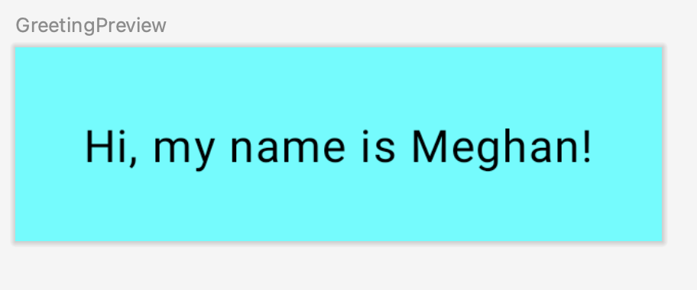

## What you'll need

* A computer with [Android Studio](https://developer.android.com/studio) installed.

## 2. Create a project using the template

In this codelab, you create an Android app with the **Empty Activity** project template provided by Android Studio.

To create a project in Android Studio:

1. Double click the Android Studio icon to launch Android Studio.

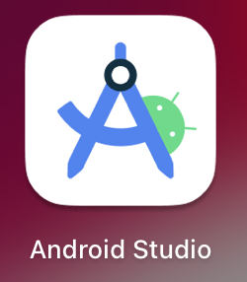

1. In the **Welcome to Android Studio** dialog, click **New Project**.

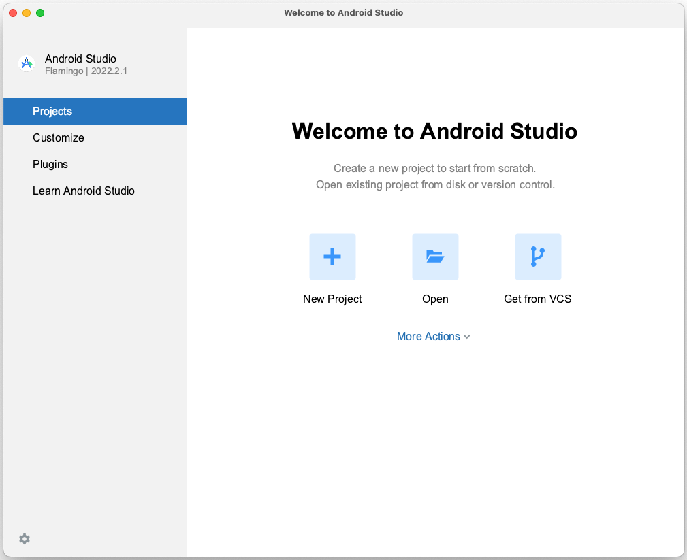

The **New Project** window opens with a list of templates provided by Android Studio.

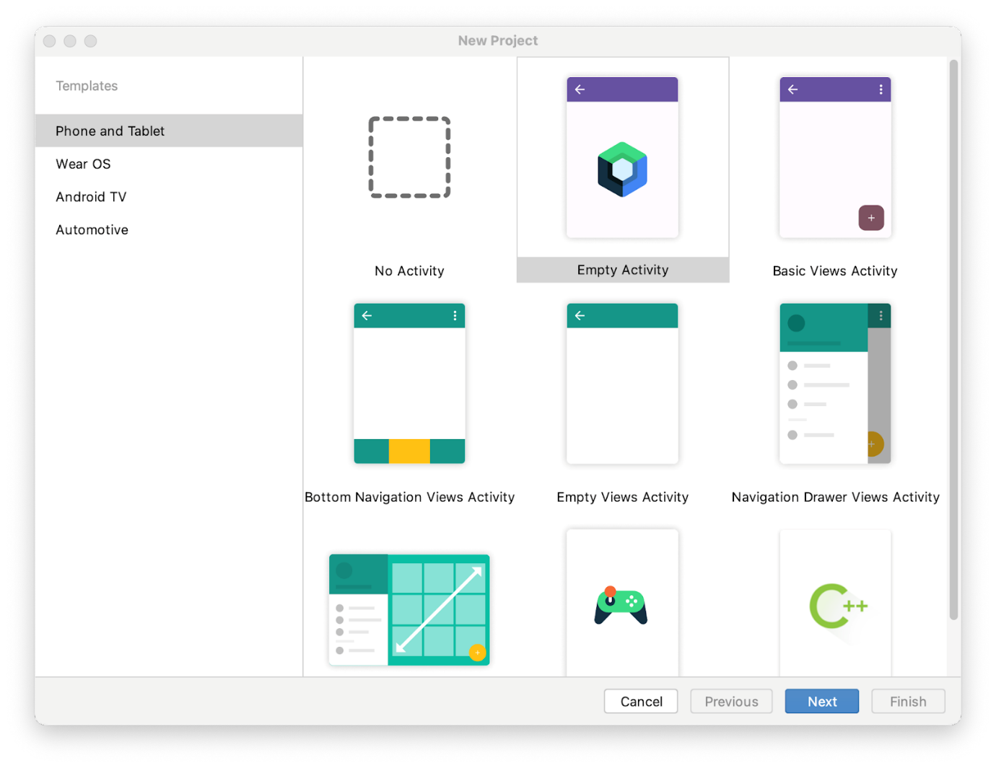

In Android Studio, a project template is an Android project that provides the blueprint for a certain type of app. Templates create the structure of the project and the files needed for Android Studio to build your project. The template that you choose provides starter code to get you going faster.

1. Make sure the **Phone and Tablet** tab is selected.
2. Click the **Empty Activity** template to select it as the template for your project. The **Empty Activity** template is the template to create a simple project that you can use to build a Compose app. It has a single screen and displays the text "Hello Android!".
3. Click **Next**. The **New Project** dialog opens. This has some fields to configure your project.
4. Configure your project as follows:

The **Name** field is used to enter the name of your project, for this codelab type "Greeting Card".

Leave the **Package name** field as is. This is how your files will be organized in the file structure. In this case, the package name will be com.example.greetingcard.

Leave the **Save location** field as is. It contains the location where all the files related to your project are saved. Take a note of where that is on your computer so that you can find your files.

Select **API 24: Android 7.0 (Nougat)** from the menu in the **Minimum SDK** field. [Minimum SDK](https://developer.android.com/guide/topics/manifest/uses-sdk-element) indicates the minimum version of Android that your app can run on.

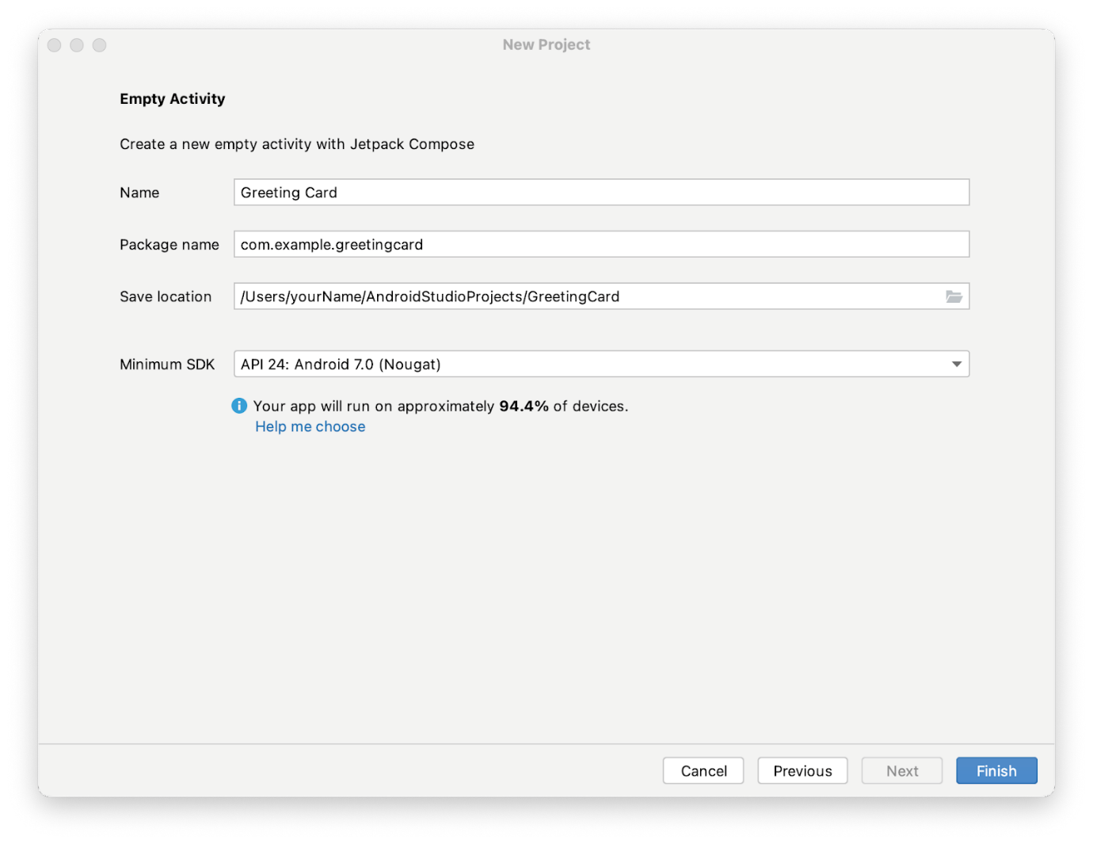

1. Click **Finish**. This may take a while - this is a great time to get a cup of tea! While Android Studio is setting up, a progress bar and message indicates whether Android Studio is still setting up your project. It may look like this:



A message that looks similar to this informs you when the project set up is created.

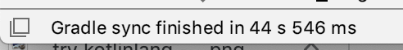

1. You may see a **What's New** pane which contains updates on new features in Android Studio. Close it for now.

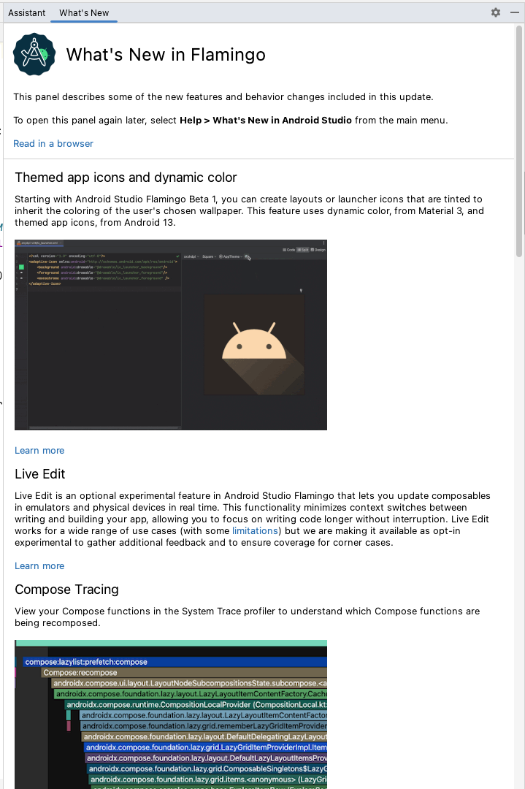

1. Click **Split** on the top right of Android Studio, this allows you to view both code and design. You can also click **Code** to view code only or click **Design** to view design only.



After pressing **Split** you should see three areas:

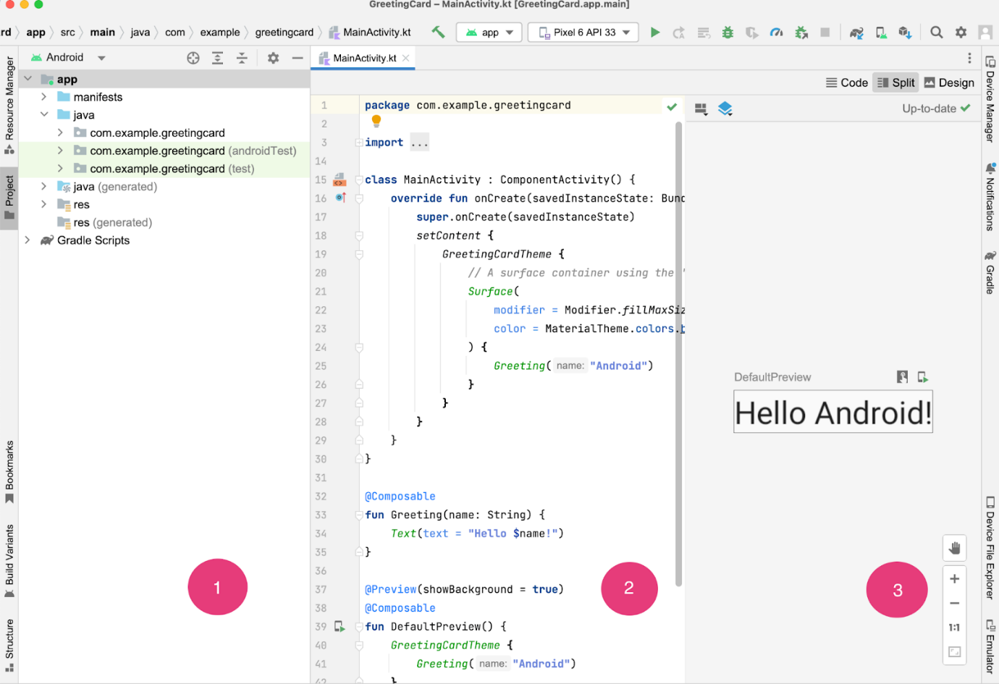

* The **Project** view (1) shows the files and folders of your project
* The **Code** view (2) is where you edit code
* The **Design** view (3) is where you preview what your app looks like

In the **Design** view, you will see a blank pane with this text:

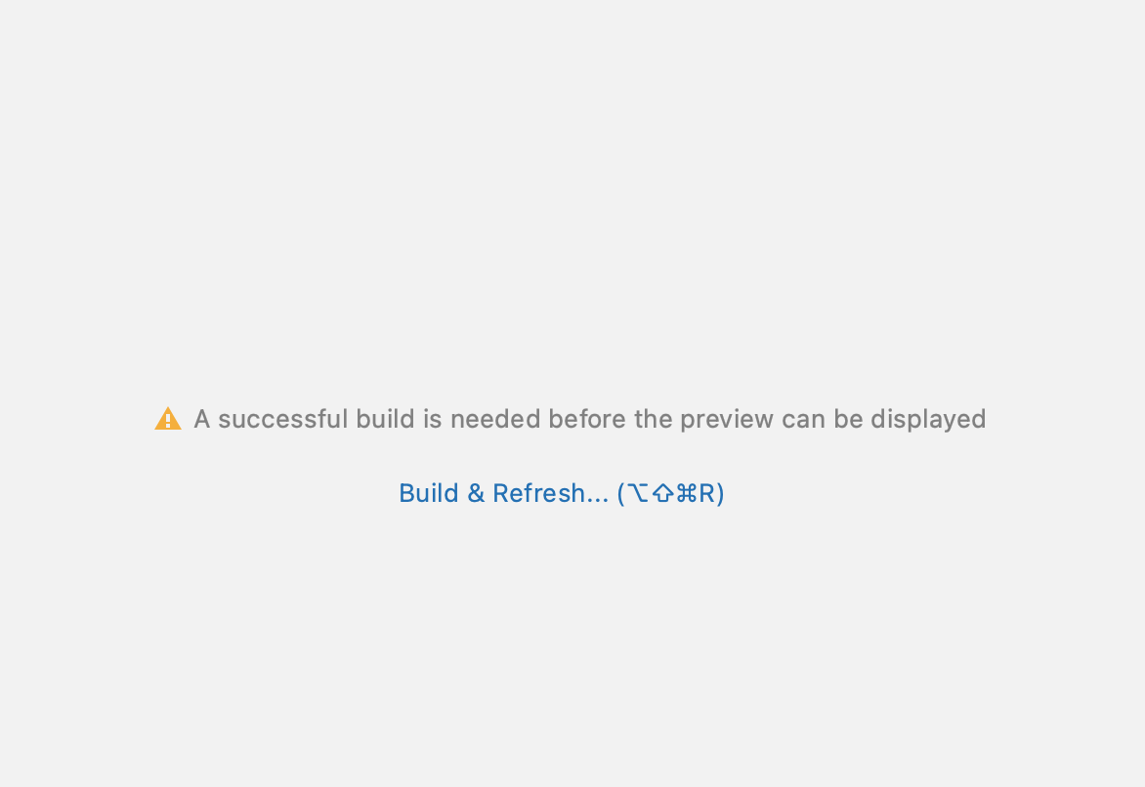

1. Click **Build & Refresh**. It may take a while to build but when it is done the preview shows a text box that says "**Hello Android!**". Empty Compose activity contains all the code necessary to create this app.

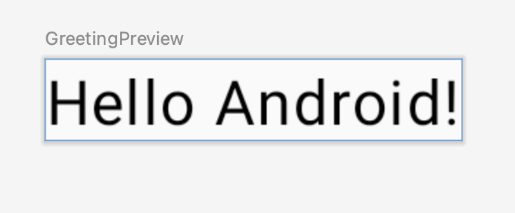

## 3. Find project files

In this section you will continue to explore Android Studio by becoming familiar with the file structure.

1. In Android Studio, take a look at the **Project** tab. The **Project** tab shows the files and folders of your project. When you were setting up your project the package name was **com.example.greetingcard**. You can see that package right here in the **Project** tab. A package is basically a folder where code is located. Android Studio organizes the project in a directory structure made up of set of packages.
2. If necessary, select **Android** from the drop-down menu in the **Project** tab.

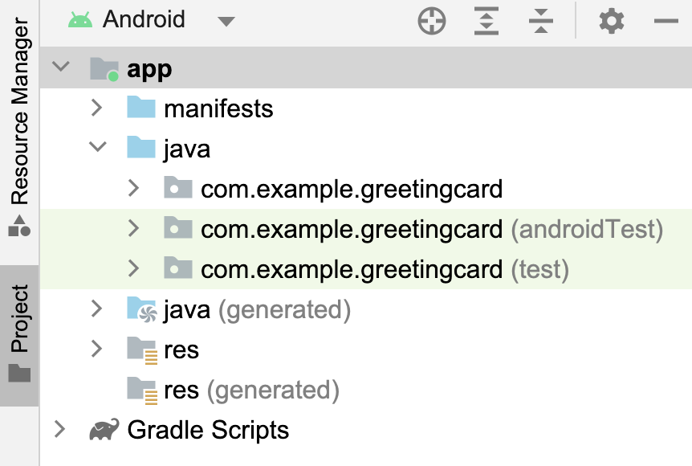

This is the standard view and organization of files that you use. It's useful when you write code for your project because you can easily access the files you will be working on in your app. However, if you look at the files in a file browser, such as Finder or Windows Explorer, the file hierarchy is organized very differently.

1. Select **Project Source Files** from the drop-down menu. You can now browse the files in the same way as in any file browser.

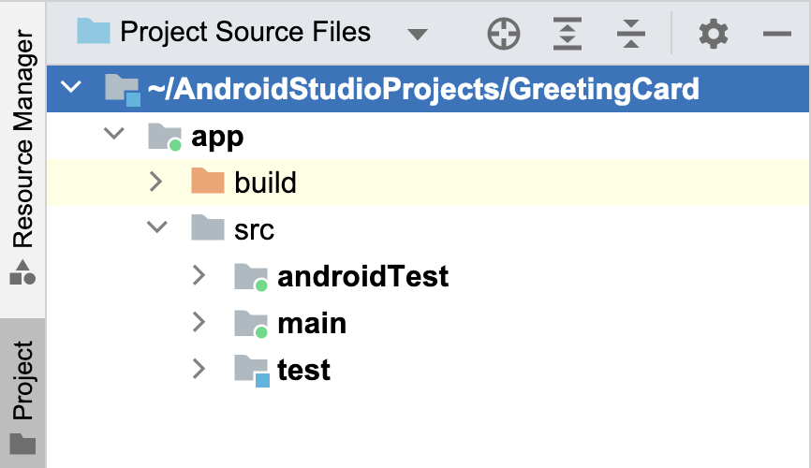

1. Select **Android** again to switch back to the previous view. You use the **Android** view for this course. If your file structure ever looks strange, check to make sure you're still in **Android** view.

## 4. Update the text

Now that you have gotten to know Android Studio, it's time to start making your greeting card!

Look at the **Code** view of the MainActivity.kt file. Notice there are some automatically generated functions in this code, specifically the onCreate() and the setContent() functions.

**Note:** Remember that a function is a segment of a program that performs a specific task.

class MainActivity : ComponentActivity() {  
   override fun onCreate(savedInstanceState: Bundle?) {  
       super.onCreate(savedInstanceState)  
       setContent {  
           GreetingCardTheme {  
               // A surface container using the 'background' color from the theme  
               Surface(  
                   modifier = Modifier.fillMaxSize(),  
                   color = MaterialTheme.colors.background  
               ) {  
                   Greeting("Android")  
               }  
           }  
       }  
   }  
}

The onCreate() function is the entry point to this Android app and calls other functions to build the user interface. In Kotlin programs, the main() function is the entry point/starting point of execution. In Android apps, the onCreate() function fills that role.

The [setContent()](https://developer.android.com/reference/kotlin/androidx/compose/ui/platform/ComposeView" \l "setContent(kotlin.Function0)" \t "_blank) function within the onCreate() function is used to define your layout through composable functions. All functions marked with the @Composable annotation can be called from the setContent() function or from other Composable functions. The annotation tells the Kotlin compiler that this function is used by Jetpack Compose to generate the UI.

**Note:** The compiler takes the Kotlin code you wrote, looks at it line by line, and translates it into something that the computer can understand. This process is called compiling your code.

Next, look at the Greeting() function. The Greeting() function is a Composable function, notice the @Composable annotation above it. This Composable function takes some input and generates what's shown on the screen.

@Composable  
fun Greeting(name: String, modifier: Modifier = Modifier) {  
    Text(text = "Hello $name!")  
}

You've learned about functions before (if you need a refresher, visit the [CreateandusefunctionsinKotlin](https://developer.android.com/codelabs/basic-android-kotlin-compose-functions" \t "_blank) codelab), but there are a few differences with composable functions.

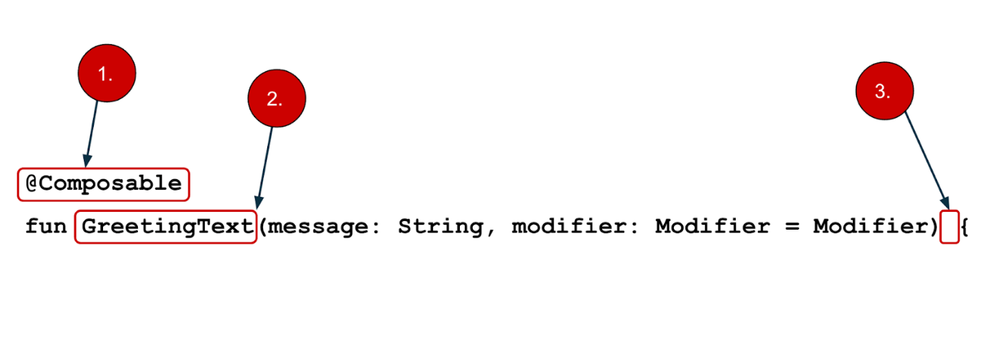

* You add the @Composable annotation before the function.
* @Composable function names are capitalized.
* @Composable functions can't return anything.

@Composable  
fun Greeting(name: String, modifier: Modifier = Modifier) {  
    Text(text = "Hello $name!")  
}

Right now the Greeting() function takes in a name and displays Hello to that person.

1. Update the Greeting() function to introduce yourself instead of saying "Hello":

@Composable  
fun Greeting(name: String, modifier: Modifier = Modifier) {  
    Text(text = "Hi, my name is $name!")  
}

1. Android should automatically update the preview.

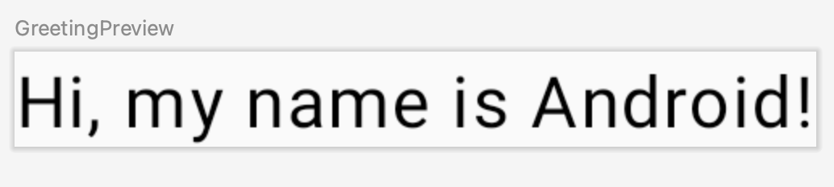

Great! You changed the text, but it introduces you as Android, which is probably not your name. Next, you will personalize it to introduce you with your name!

The GreetingPreview() function is a cool feature that lets you see what your composable looks like without having to build your entire app. To enable a preview of a composable, annotate it with @Composable and @Preview. The @Preview annotation tells Android Studio that this composable should be shown in the design view of this file.

As you can see, the @Preview annotation takes in a parameter called showBackground. If showBackground is set to **true**, it will add a background to your composable preview.

Since Android Studio by default uses a light theme for the editor, it can be hard to see the difference between showBackground = true and showBackground = false. However, this is an example of what the difference looks like. Notice the white background on the image set to true.

|  |
| --- |
| A close up of a box  Description automatically generatedshowBackground = true |
| A screenshot of a phone  Description automatically generatedshowBackground = false |

1. Update the GreetingPreview() function with your name. Then rebuild and check out your personalized greeting card!

@Preview(showBackground = true)  
@Composable  
fun GreetingPreview() {  
    GreetingCardTheme {  
        Greeting("Meghan")  
   }  
}

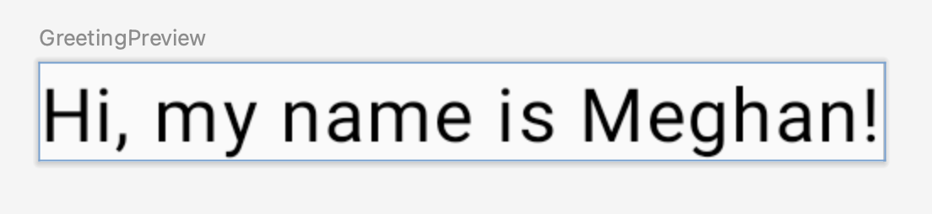

## 5. Change the background color

Now you have the introduction text, but it's a little boring! In this section, you learn to change the background color.

To set a different background color for your introduction, you'll need to surround your text with a [Surface](https://developer.android.com/reference/kotlin/androidx/compose/material/package-summary#Surface(androidx.compose.ui.Modifier,androidx.compose.ui.graphics.Shape,androidx.compose.ui.graphics.Color,androidx.compose.ui.graphics.Color,androidx.compose.foundation.BorderStroke,androidx.compose.ui.unit.Dp,kotlin.Function0)). A Surface is a container that represents a section of UI where you can alter the appearance, such as the background color or border.

1. To surround the text with a Surface, highlight the line of text, press (Alt+Enter for Windows or Option+Enter on Mac), and then select **Surround with widget**.

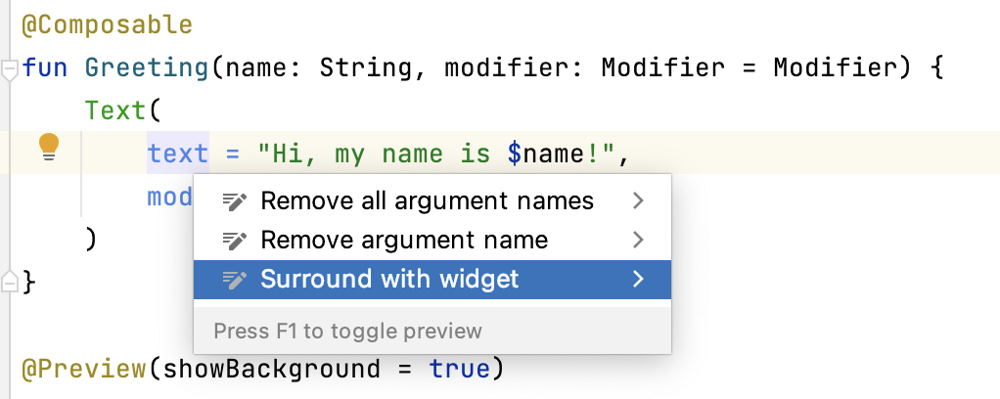

1. Choose **Surround with Container**.

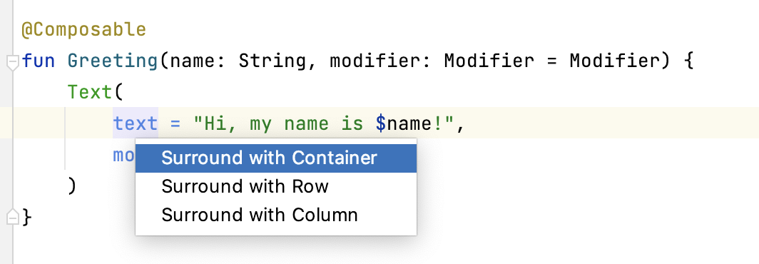

The default container it will give you is Box, but you can change this to another container type. You will learn about Box layout later in the course.

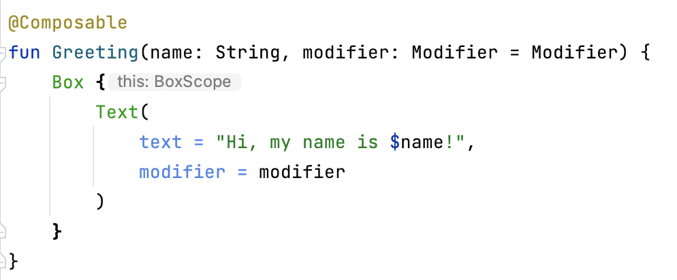

1. Delete Box and type Surface() instead.

@Composable  
fun Greeting(name: String, modifier: Modifier = Modifier) {  
   Surface() {  
       Text(  
           text = "Hi, my name is $name!",  
           modifier = modifier  
       )  
   }  
}

1. To the Surface container add a color parameter, set it to Color.

@Composable  
fun Greeting(name: String, modifier: Modifier = Modifier) {  
   Surface(color = Color) {  
       Text(  
           text = "Hi, my name is $name!",  
           modifier = modifier  
       )  
   }  
}

1. When you type Color you may notice that it is red, which means Android Studio is not able to resolve this. To solve this scroll to the top of the file where it says import and press the three buttons.



1. Add this statement to the bottom of the list of imports.

import androidx.compose.ui.graphics.Color

The full list of imports will look similar to this.

import android.os.Bundle  
import androidx.activity.ComponentActivity  
import androidx.activity.compose.setContent  
import androidx.compose.foundation.layout.Box  
import androidx.compose.foundation.layout.fillMaxSize  
import androidx.compose.material3.MaterialTheme  
import androidx.compose.material3.Surface  
import androidx.compose.material3.Text  
import androidx.compose.runtime.Composable  
import androidx.compose.ui.Modifier  
import androidx.compose.ui.tooling.preview.Preview  
import com.example.greetingcard.ui.theme.GreetingCardTheme  
import androidx.compose.ui.graphics.Color

1. In your code, the best practice is to keep your imports listed alphabetically and remove unused imports. To do this press **Help** on the top toolbar, type in **optimize imports**, and click on **Optimize Imports**.

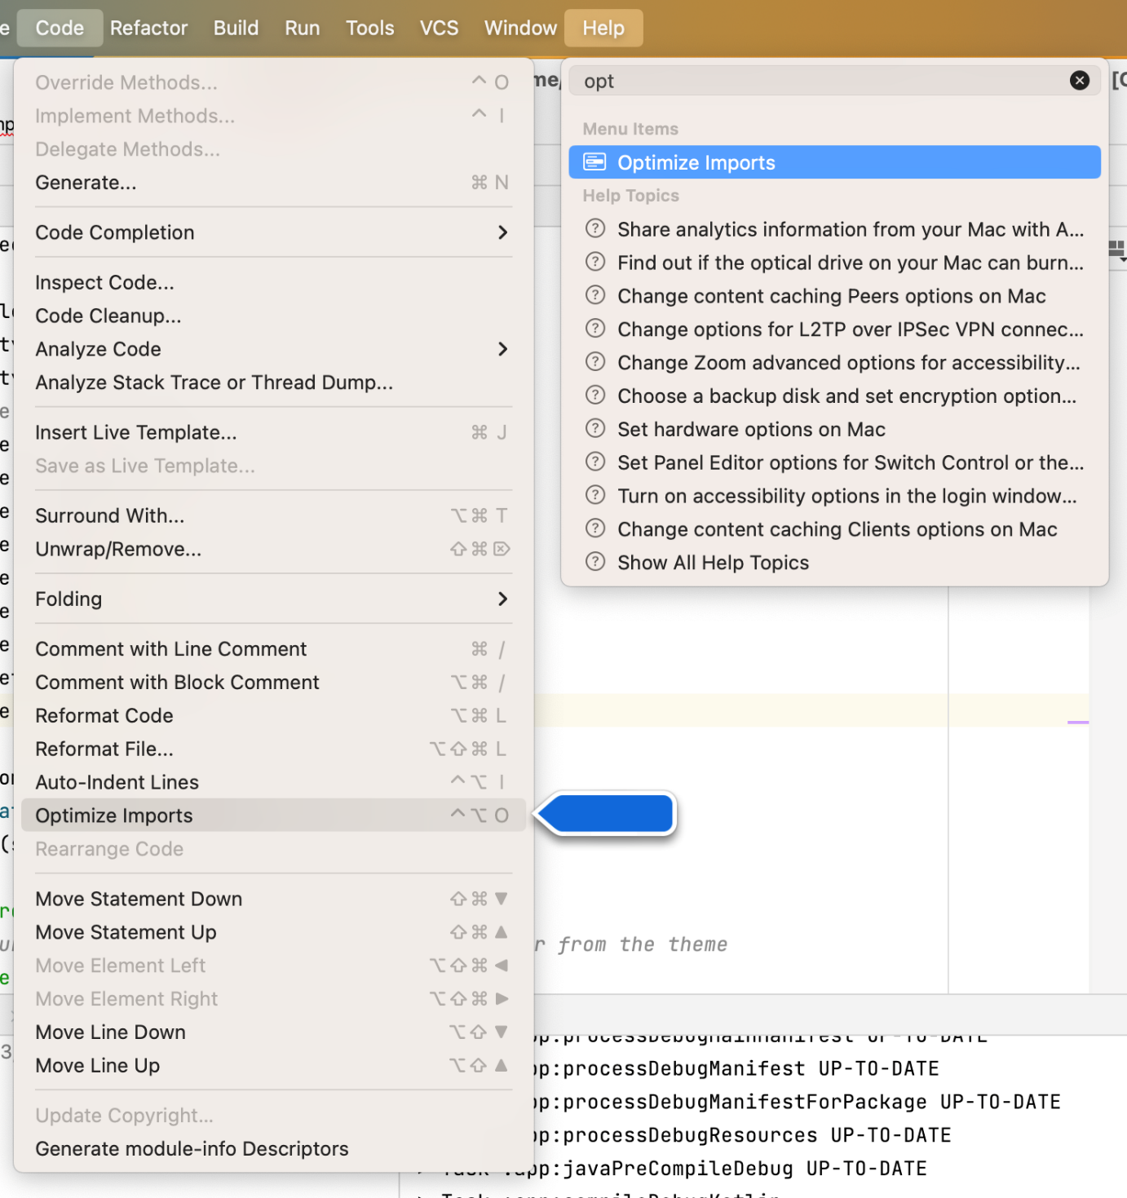

You could open the **Optimize Imports** directly from the menu: **Code** > **Optimize Imports.** Using Help's search option will help you locate a menu item if you don't remember where it is.

The full list of imports will now look like this:

import android.os.Bundle  
import androidx.activity.ComponentActivity  
import androidx.activity.compose.setContent  
import androidx.compose.foundation.layout.fillMaxSize  
import androidx.compose.material3.MaterialTheme  
import androidx.compose.material3.Surface  
import androidx.compose.material3.Text  
import androidx.compose.runtime.Composable  
import androidx.compose.ui.Modifier  
import androidx.compose.ui.graphics.Color  
import androidx.compose.ui.tooling.preview.Preview  
import com.example.greetingcard.ui.theme.GreetingCardTheme

1. Notice that the Color that you typed in the Surface parentheses has switched from being red to being underlined in red. To fix that, add a period after it. You will see a pop-up showing different color options.

This is one of the cool features in Android Studio, it is intelligent and will help you out when it can. In this case it knows you are wanting to specify a color so it will suggest different colors.

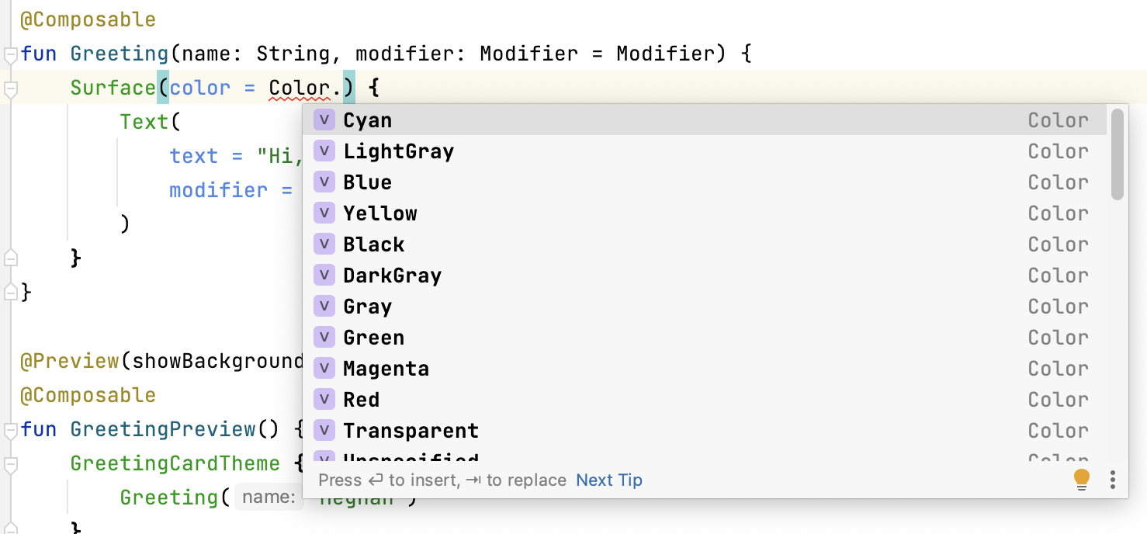

1. Choose a color for your surface. This codelab uses **Cyan**, but you can choose your favorite!

@Composable  
fun Greeting(name: String, modifier: Modifier = Modifier) {  
   Surface(color = Color.Cyan) {  
       Text(  
           text = "Hi, my name is $name!",  
           modifier = modifier  
       )  
   }  
}

1. Notice the updated preview.

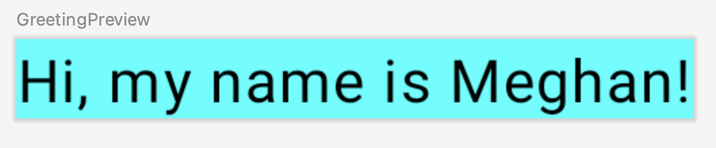

## 6. Add padding

Now your text has a background color, next you will add some space (padding) around the text.

A [Modifier](https://developer.android.com/reference/kotlin/androidx/compose/ui/Modifier) is used to augment or decorate a composable. One modifier you can use is the padding modifier, which adds space around the element (in this case, adding space around the text). This is accomplished by using the [Modifier.padding()](https://developer.android.com/reference/kotlin/androidx/compose/ui/Modifier" \l "(androidx.compose.ui.Modifier).padding(androidx.compose.ui.unit.Dp)" \t "_blank) function.

Every composable should have an optional parameter of the type Modifier. This should be the first optional parameter.

1. Add a padding to the modifier with a size of 24.dp.

**Note:** You learn more about density-independent pixels (**dp**) in the next pathway, but refer to [Layout – Material Design 3](https://m3.material.io/foundations/layout/understanding-layout/spacing#abccd6ce-1092-4ad0-9351-de75aeae0edf) article if you want to read more now.

@Composable  
fun Greeting(name: String, modifier: Modifier = Modifier) {  
   Surface(color = Color.Cyan) {  
       Text(  
           text = "Hi, my name is $name!",  
           modifier = modifier.padding(24.dp)  
       )  
   }  
}

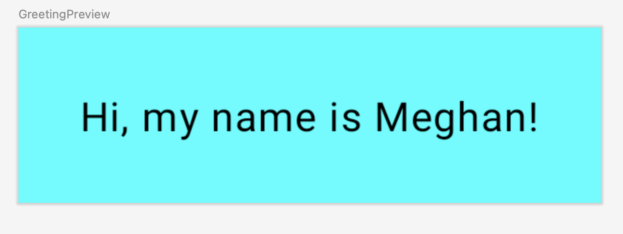

1. Add these imports to the import statement section.

Make sure to use **Optimize Imports** to alphabetize the new imports.

import androidx.compose.ui.unit.dp  
import androidx.compose.foundation.layout.padding

Well congratulations - you built your first Android app in Compose! This is a pretty huge accomplishment. Take some time to play around with different colors and text, make it your own!

## 7. Review the solution code

### Code snippet for review

package com.example.greetingcard  
  
import android.os.Bundle  
import androidx.activity.ComponentActivity  
import androidx.activity.compose.setContent  
import androidx.compose.ui.graphics.Color  
import androidx.compose.foundation.layout.fillMaxSize  
import androidx.compose.foundation.layout.padding  
import androidx.compose.material3.MaterialTheme  
import androidx.compose.material3.Surface  
import androidx.compose.material3.Text  
import androidx.compose.runtime.Composable  
import androidx.compose.ui.Modifier  
import androidx.compose.ui.tooling.preview.Preview  
import androidx.compose.ui.unit.dp  
import com.example.greetingcard.ui.theme.GreetingCardTheme  
  
class MainActivity : ComponentActivity() {  
    override fun onCreate(savedInstanceState: Bundle?) {  
        super.onCreate(savedInstanceState)  
        setContent {  
            GreetingCardTheme {  
                // A surface container using the 'background' color from the theme  
                Surface(  
                    modifier = Modifier.fillMaxSize(),  
                    color = MaterialTheme.colorScheme.background  
                ) {  
                    Greeting("Android")  
                }  
            }  
        }  
    }  
}  
  
@Composable  
fun Greeting(name: String, modifier: Modifier = Modifier) {  
    Surface(color = Color.Cyan) {  
        Text(text = "Hi, my name is $name!", modifier = modifier.padding(24.dp))  
    }  
}  
  
@Preview(showBackground = true)  
@Composable  
fun GreetingPreview() {  
    GreetingCardTheme {  
        Greeting("Meghan")  
    }  
}

## 8. Conclusion

You learned about Android Studio and built your first Android app with Compose, great job!

This codelab is part of the [Android Basics with Compose course](https://developer.android.com/courses/android-basics-compose/course). To learn how to run your app on the emulator or a physical device, check out the next codelabs in [this pathway](https://developer.android.com/courses/pathways/android-basics-compose-unit-1-pathway-2).

## Summary

* To create a new project: open Android Studio, click **New Project > Empty Activity > Next**, enter a name for your project and then configure its settings.
* To see how your app looks, use the **Preview** pane.
* Composable functions are like regular functions with a few differences: functions names are capitalized, you add the @Composable annotation before the function, @Composable functions can't return anything.
* A [Modifier](https://developer.android.com/reference/kotlin/androidx/compose/ui/Modifier) is used to augment or decorate your composable.

## Learn more

* [Vocabulary for Android Basics in Kotlin](https://developer.android.com/courses/android-basics-kotlin/android-basics-kotlin-vocab)
* [Meet Android Studio](https://developer.android.com/studio/intro)
* [Projects overview](https://developer.android.com/studio/projects)
* [Create a project](https://developer.android.com/studio/projects/create-project)
* [Add code from a template](https://developer.android.com/studio/projects/templates)
* [Jetpack Compose](https://developer.android.com/jetpack/compose)
* [Padding – Material Design 3](https://m3.material.io/foundations/layout/understanding-layout/spacing#64eb2223-f5e8-4d2a-9edc-9e3a7002220a)

Run your first app on the Android Emulator

[1. Before you begin](https://developer.android.com/codelabs/basic-android-kotlin-compose-emulator?continue=https%3A%2F%2Fdeveloper.android.com%2Fcourses%2Fpathways%2Fandroid-basics-compose-unit-1-pathway-2%23codelab-https%3A%2F%2Fdeveloper.android.com%2Fcodelabs%2Fbasic-android-kotlin-compose-emulator#0)

In this codelab, you'll take the Greeting Card app you built in the [Create your first Android app codelab](https://developer.android.com/codelabs/basic-android-kotlin-compose-first-app) , set up an Android Virtual Device (AVD), and see your code in action on an Android Emulator.

Prerequisites

* Knowledge of how to set up, configure, and use apps, such as a word processor or a spreadsheet.

What you'll learn

* How to create an AVD and run an app on the Android Emulator

What you'll build

* A basic Android app from a template

What you'll need

* A computer with Android Studio installed

## [2. Watch the code-along video (Optional)](https://developer.android.com/codelabs/basic-android-kotlin-compose-emulator?continue=https%3A%2F%2Fdeveloper.android.com%2Fcourses%2Fpathways%2Fandroid-basics-compose-unit-1-pathway-2%23codelab-https%3A%2F%2Fdeveloper.android.com%2Fcodelabs%2Fbasic-android-kotlin-compose-emulator#1)

If you'd like to watch one of the course instructors complete the codelab, play the below video.

It's recommended to expand the video to full screen. In the video player, click the **Full screen** icon  so you can see Android Studio and the code more clearly.

This step is optional. You can also skip the video and start the codelab instructions right away.

<https://youtu.be/HyOejjpVFtQ>

[3. Run your app on the Android Emulator](https://developer.android.com/codelabs/basic-android-kotlin-compose-emulator?continue=https%3A%2F%2Fdeveloper.android.com%2Fcourses%2Fpathways%2Fandroid-basics-compose-unit-1-pathway-2%23codelab-https%3A%2F%2Fdeveloper.android.com%2Fcodelabs%2Fbasic-android-kotlin-compose-emulator#2)

In this task, you'll use the [Device Manager](http://developer.android.com/tools/devices/managing-avds.html) to create an Android Virtual Device (AVD). An AVD is a software version, also called an emulator, of a mobile device that runs on your computer and mimics the configuration of a particular type of Android device. This could be any phone, tablet, TV, watch, or Android auto device. You'll use the AVD to run the Greeting Card app.

**Note:** The Android Emulator is an independent app used to set up a virtual device and it has its own system requirements. Virtual devices can use a lot of disk space. If you run into any issues, see [Run apps on the Android Emulator](https://developer.android.com/studio/run/emulator.html#Requirements).

Create an AVD

To run an Android app in an emulator on your computer, you first create a virtual device.

1. In Android Studio, select **Tools > Device Manager**.

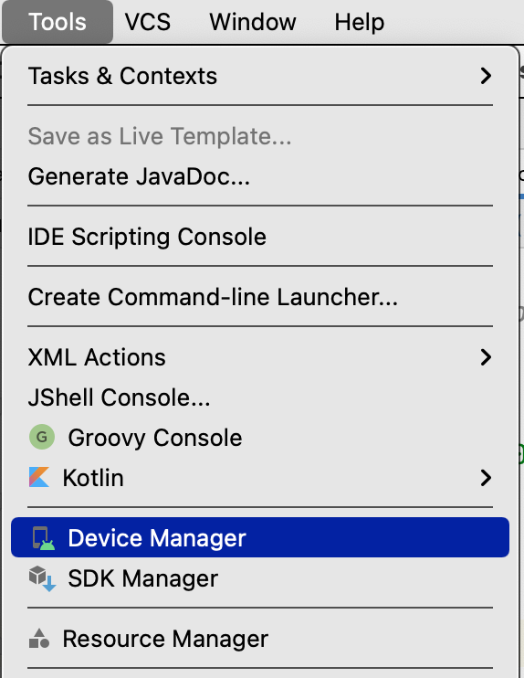

The **Device Manager** dialog opens. If you created a virtual device previously, it's listed in this dialog.

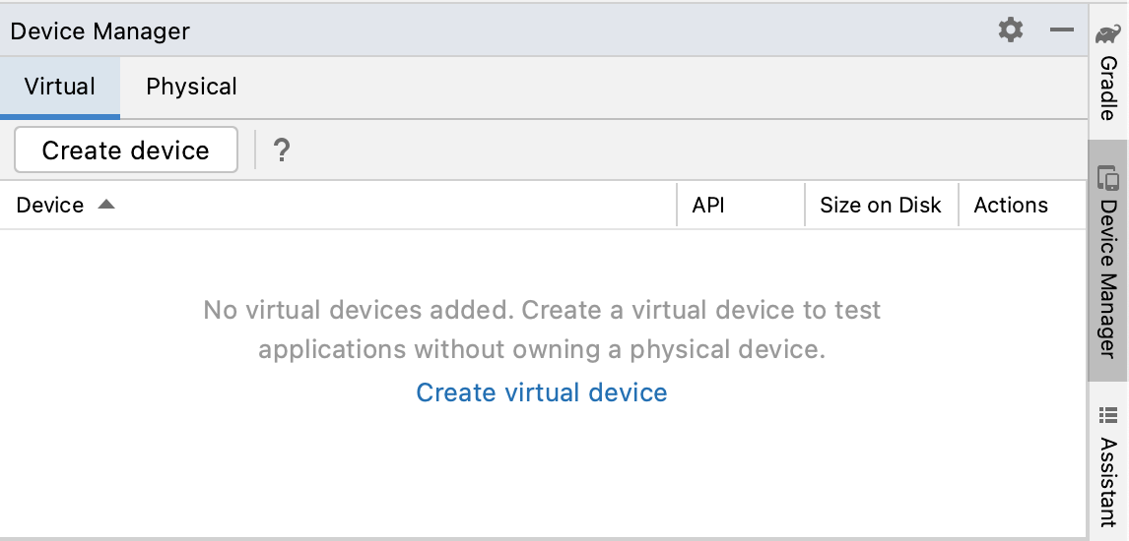

1. Click **Create virtual device**.

The **Virtual Device Configuration** dialog appears.

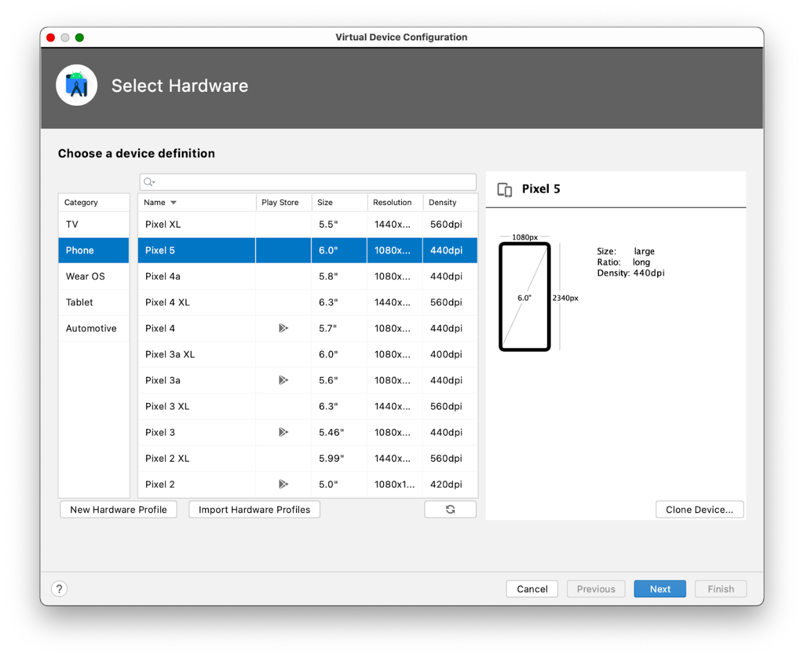

The dialog shows a list of pre-configured devices, organized by category, from which you can choose. For each device, the table provides a column for its display size (in inches), screen resolution (in pixels), and pixel density (number of pixels per inch).

1. Select **Phone** as the category.
2. Select a phone, such as the Pixel 5, and then click **Next**.

This step opens another screen where you can choose the version of Android to run on your virtual device. This lets you test your app on different versions of Android.

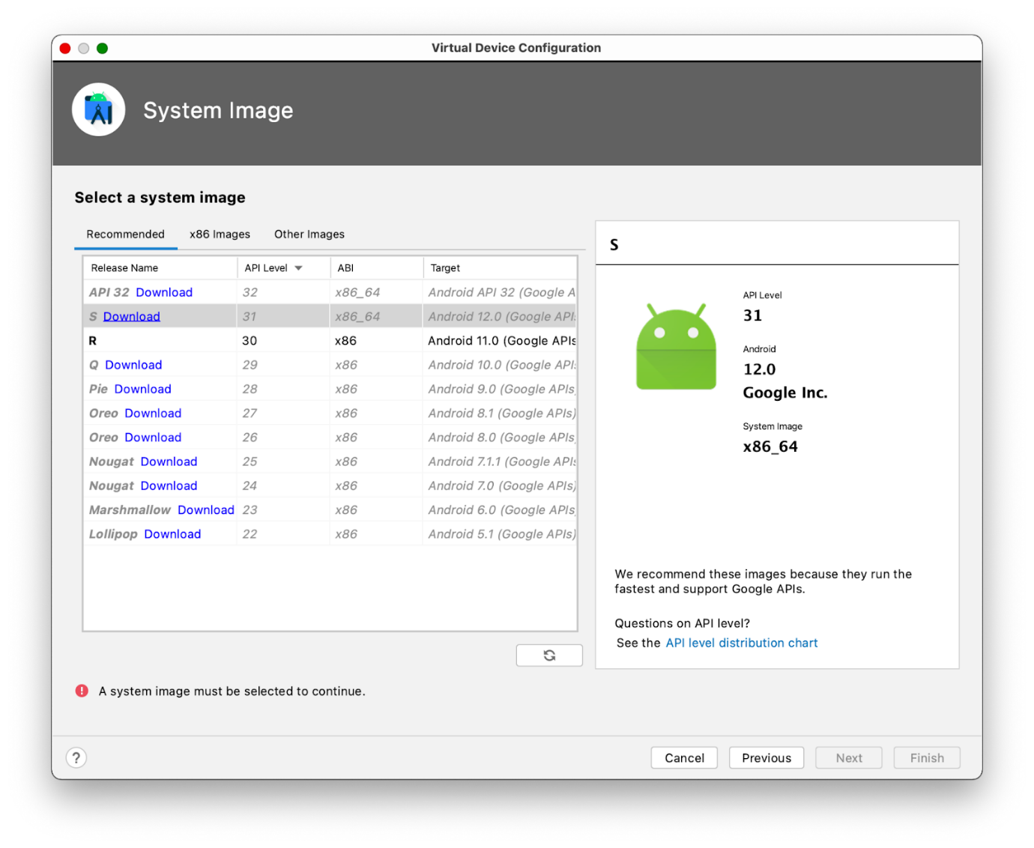

1. If there's a download link next to **S**, click **Download > Accept > Next > Finish**. The presence of the download link indicates that the image isn't installed on your computer, in which case you must install the image before you can configure the virtual device. Expect the download to take some time to complete.





1. In the **Recommended** tab, choose S as the version of Android to run on the virtual device.

Android S is the latest version of Android at the time of writing, but you can choose any later stable version. For a list of stable versions, see [Platform codenames, versions, API levels, and NDK releases](https://source.android.com/setup/start/build-numbers#platform-code-names-versions-api-levels-and-ndk-releases).

**Important:** These Android system images use a lot of disk space, so only a few are part of your original installation. Many more versions of the Android system are available than are shown in the **Recommended** tab. To see them, look under the **x86 Images** and **Other Images** tabs in the **Virtual Device Configuration** dialog.

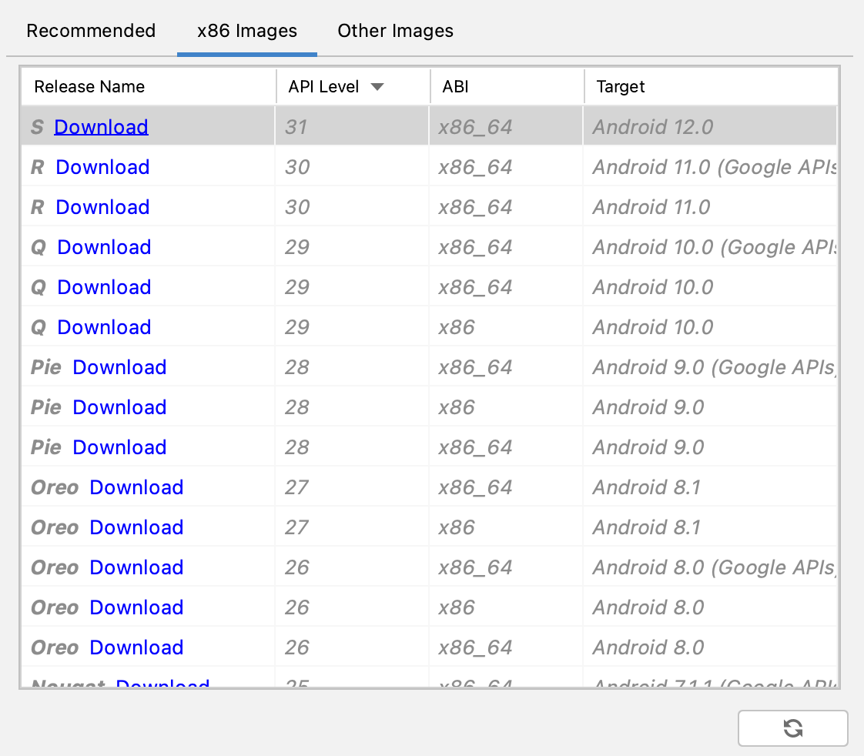

This action opens another screen, where you can choose additional configuration details for your device.

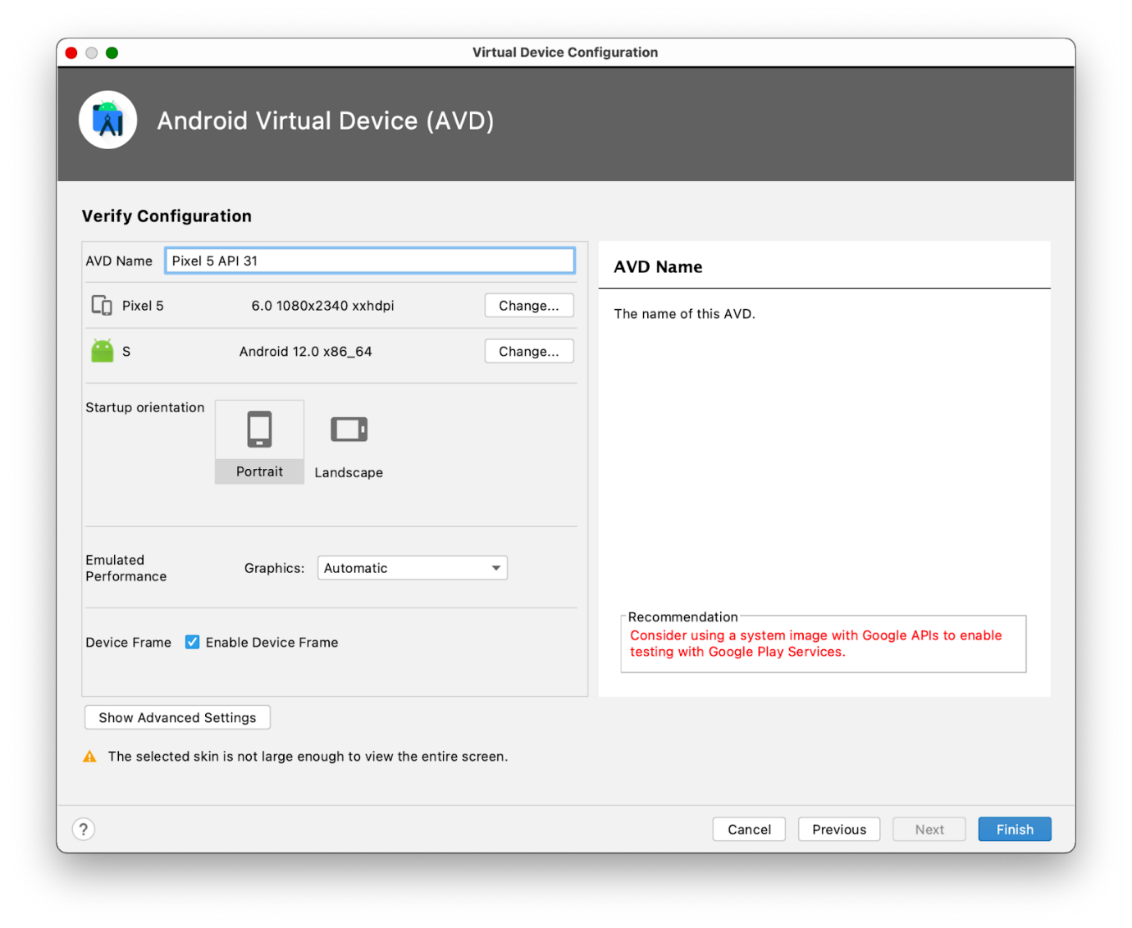

**Note:** If you see the red warning about using an image with Google APIs like in the screenshot above, you can disregard it for now.

1. In the **AVD Name** field, enter a name for your AVD or use the default. Leave the rest of the fields unchanged.
2. Click **Finish**.

This action returns to the **Android Virtual Device Manager** pane.

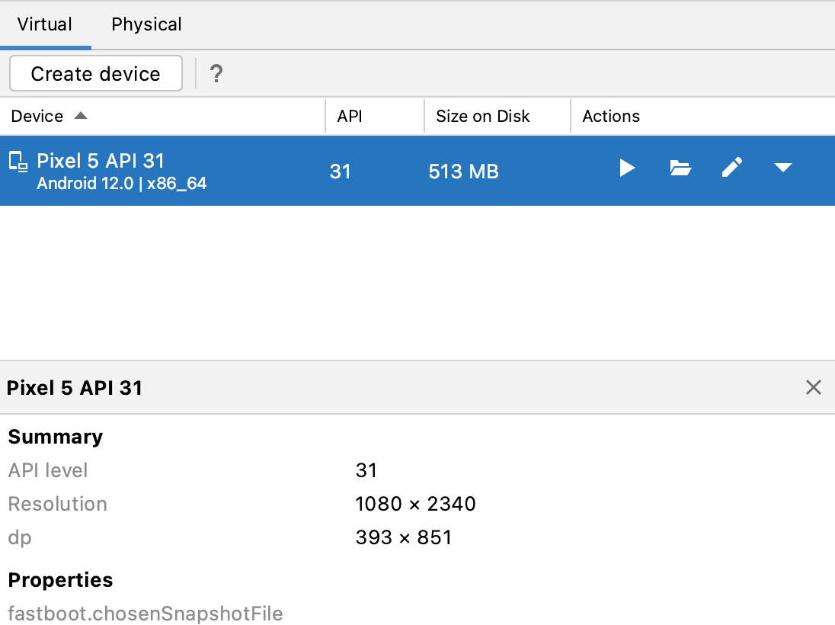

1. Close the **Device Manager** dialog.

Run your app on the Android Emulator

1. Select the virtual device that you created from the dropdown menu at the top of the Android Studio window.

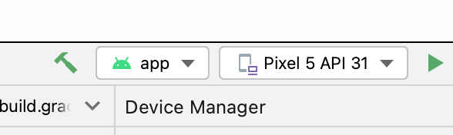

1. Click .

The virtual device starts just like a physical device. Expect this to take a while—potentially several minutes—for the emulator to start for the first time. The virtual device should open beside the code editor.

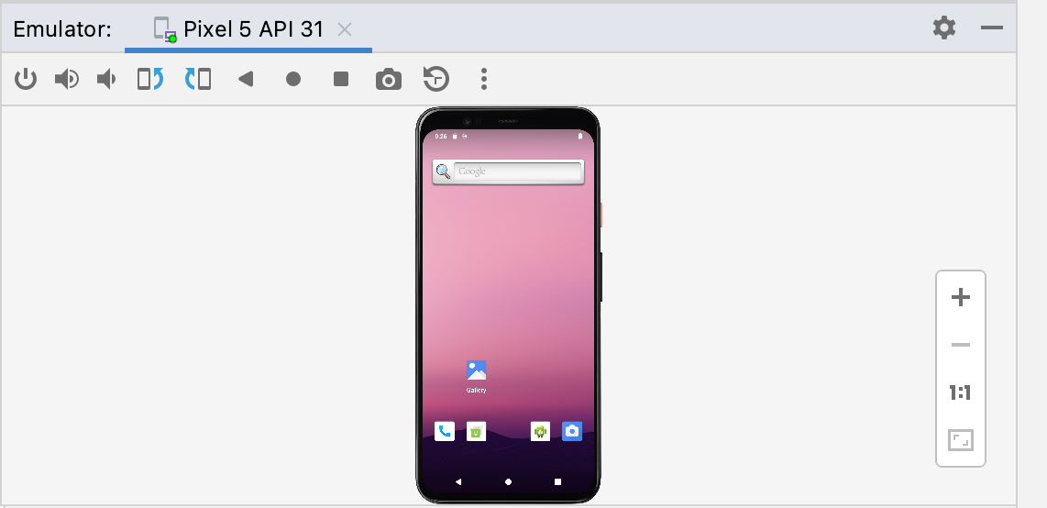

When your app is ready, it opens on the virtual device.

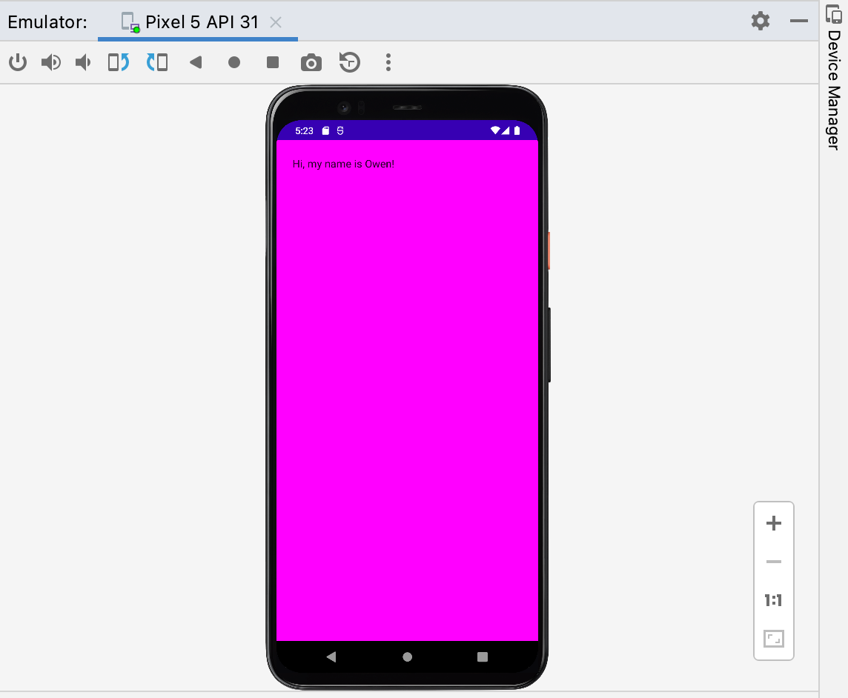

Great job! Your virtual device is now up and running. The app launches, and you can see the background color and greeting text on the screen.

[4. Conclusion](https://developer.android.com/codelabs/basic-android-kotlin-compose-emulator?continue=https%3A%2F%2Fdeveloper.android.com%2Fcourses%2Fpathways%2Fandroid-basics-compose-unit-1-pathway-2%23codelab-https%3A%2F%2Fdeveloper.android.com%2Fcodelabs%2Fbasic-android-kotlin-compose-emulator#3)

Congratulations! You ran your app on the Android Emulator!

Summary

* To create an AVD, open your project, click **Tools > Device Manager**, and use the [Device Manager](http://developer.android.com/tools/devices/managing-avds.html) to select a hardware device and system image.
* To run your app on a virtual device, ensure that you created a device, select the device from the toolbar menu, and click .

Learn more

* [Vocabulary for Android Basics in Kotlin](https://developer.android.com/courses/android-basics-kotlin/android-basics-kotlin-vocab)
* [Meet Android Studio](https://developer.android.com/studio/intro)
* [Projects overview](https://developer.android.com/studio/projects)
* [Create a project](https://developer.android.com/studio/projects/create-project)
* [Add code from a template](https://developer.android.com/studio/projects/templates)
* [Build and run your app](https://developer.android.com/studio/run)
* [Run apps on the Android Emulator](https://developer.android.com/studio/run/emulator)

How to connect your Android device

[1. Before you begin](https://developer.android.com/codelabs/basic-android-kotlin-compose-connect-device?continue=https%3A%2F%2Fdeveloper.android.com%2Fcourses%2Fpathways%2Fandroid-basics-compose-unit-1-pathway-2%23codelab-https%3A%2F%2Fdeveloper.android.com%2Fcodelabs%2Fbasic-android-kotlin-compose-connect-device#0)

In this codelab, you learn how to connect your app in Android Studio to your physical Android device. You can either connect your device with a cable or with Wi-Fi. This codelab will cover both cases. Note that Android Studio gets updated and sometimes the UI changes so it is okay if your Android Studio looks a little different than what is shown on the screen.

Prerequisites

* Basic knowledge of how to use Android Studio.
* Ability to open and adjust settings on your Android device.

What you'll learn

* How to enable your Android device to run apps from Android Studio.
* How to connect and run an app in Android Studio on a physical Android device.

What you'll need

* [Android Studio](https://developer.android.com/studio) downloaded and installed on your computer.
* An app project set up in Android Studio.
* An Android device, such as a phone or tablet running Lollipop or later.
* (Optional) A USB cable to connect your Android device to your computer through their USB ports.

**Note:** If you need help to determine which kind of USB ports your computer and Android device have, and the corresponding cable that you need, see [USB](https://en.wikipedia.org/wiki/USB).

## [2. Watch the code-along video (Optional)](https://developer.android.com/codelabs/basic-android-kotlin-compose-connect-device?continue=https%3A%2F%2Fdeveloper.android.com%2Fcourses%2Fpathways%2Fandroid-basics-compose-unit-1-pathway-2%23codelab-https%3A%2F%2Fdeveloper.android.com%2Fcodelabs%2Fbasic-android-kotlin-compose-connect-device#1)

If you'd like to watch one of the course instructors complete the codelab, play the below video.

It's recommended to expand the video to full screen (with this icon  in the lower right corner of the video) so you can see Android Studio and the code more clearly.

This step is optional. You can also skip the video and start the codelab instructions right away.

<https://youtu.be/kp692Pih_ks>

[3. Enable USB debugging](https://developer.android.com/codelabs/basic-android-kotlin-compose-connect-device?continue=https%3A%2F%2Fdeveloper.android.com%2Fcourses%2Fpathways%2Fandroid-basics-compose-unit-1-pathway-2%23codelab-https%3A%2F%2Fdeveloper.android.com%2Fcodelabs%2Fbasic-android-kotlin-compose-connect-device#2)

To let Android Studio communicate with your Android device, you must enable USB debugging in the Developer options settings of the device.

To show developer options and enable USB debugging:

1. On your Android device, tap **Settings** > **About phone**.
2. Tap **Build number** seven times.
3. If prompted, enter your device password or pin. You know you succeeded when you see a **You are now a developer!** message.

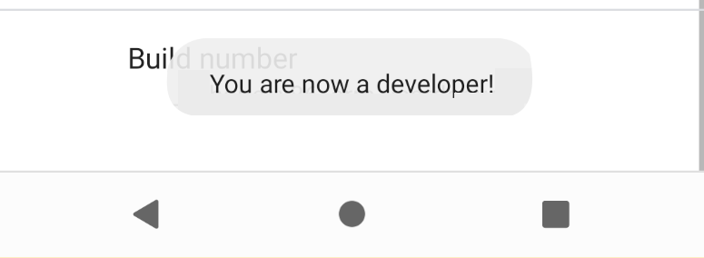

1. Return to **Settings** and then tap **System** > **Developer options**.
2. If you don't see **Developer options**, tap **Advanced options**.

|  |  |
| --- | --- |
| This image shows the System page with Developer options boxed in red. |  |

1. Tap **Developer options** and then tap the **USB debugging** toggle to turn it on.

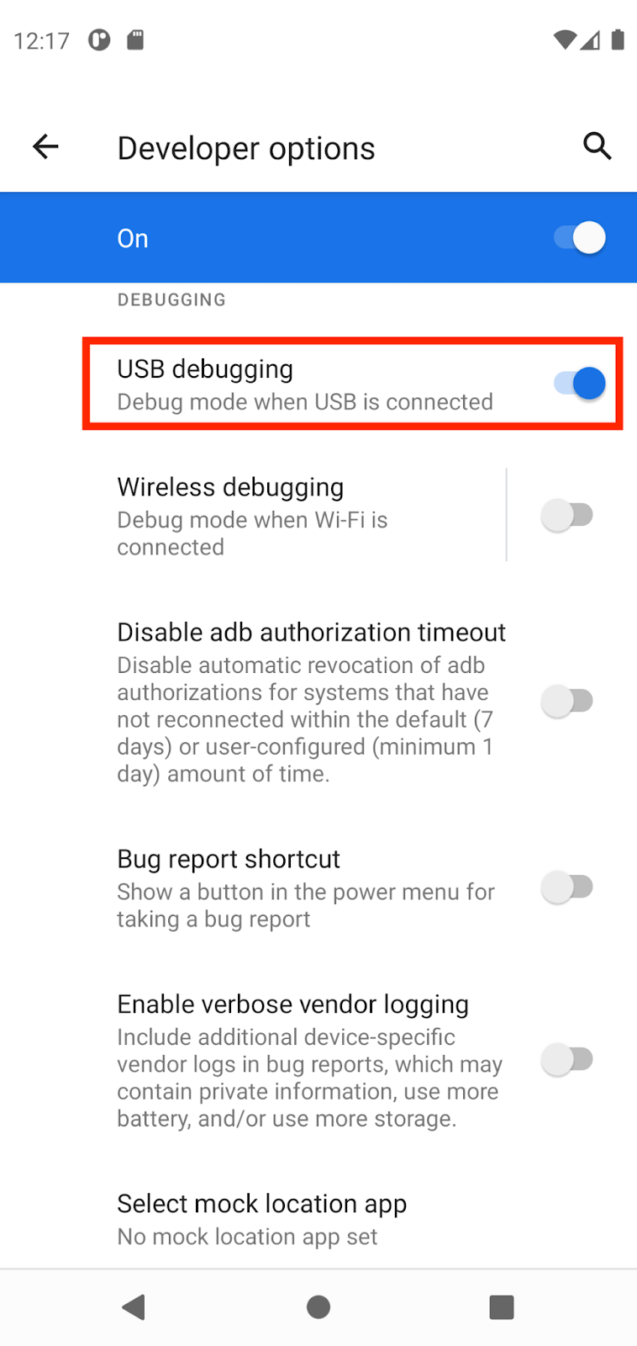

[Install the Google USB Driver (Windows only)](https://developer.android.com/codelabs/basic-android-kotlin-training-run-on-mobile-device?continue=https%3A%2F%2Fdeveloper.android.com%2Fcourses%2Fpathways%2Fandroid-basics-kotlin-two%23codelab-https%3A%2F%2Fdeveloper.android.com%2Fcodelabs%2Fbasic-android-kotlin-training-run-on-mobile-device#2)

If you installed Android Studio on Windows, you must install a USB device driver before you can run your app on a physical device.

**Note:** For Ubuntu Linux, follow the instructions in [Run Apps on a Hardware Device](http://developer.android.com/tools/device.html).

1. In Android Studio, click **Tools > SDK Manager**. The **Preferences > Appearance & Behavior > System Settings > Android SDK** dialog opens.
2. Click the **SDK Tools** tab.
3. Select **Google USB Driver** and then click **OK**.

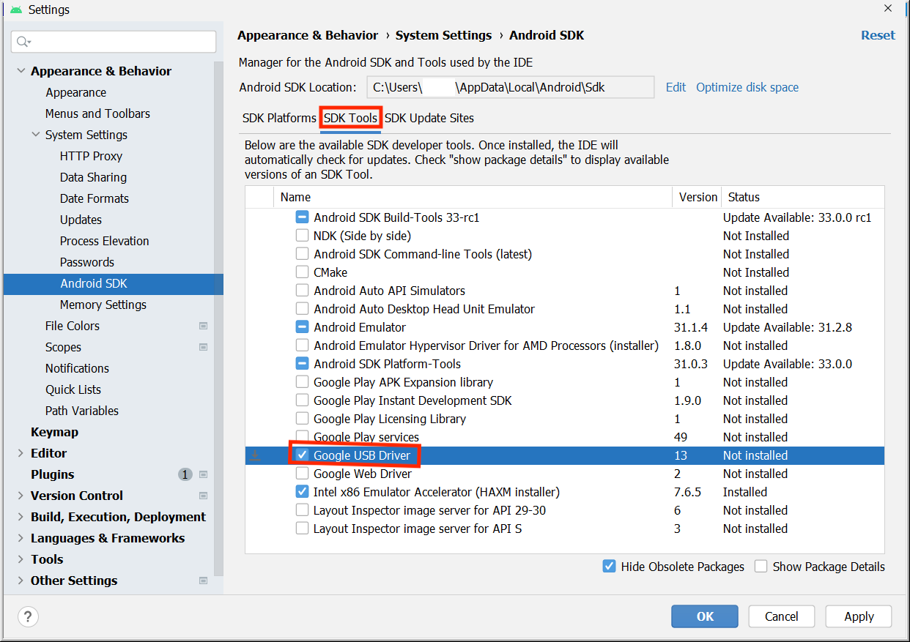

When done, the driver files are downloaded into the android\_sdk\extras\google\usb\_driver directory. Now you can connect and run your app from Android Studio.

[4. Run your app on the Android device with a cable](https://developer.android.com/codelabs/basic-android-kotlin-compose-connect-device?continue=https%3A%2F%2Fdeveloper.android.com%2Fcourses%2Fpathways%2Fandroid-basics-compose-unit-1-pathway-2%23codelab-https%3A%2F%2Fdeveloper.android.com%2Fcodelabs%2Fbasic-android-kotlin-compose-connect-device#3)

There are two ways to connect your device to Android Studio, through a cable or through Wi-Fi. You can choose whichever you like more.

To run your app from Android Studio on your Android device:

1. Connect your Android device to your computer with a USB cable. A dialog should appear on your device, which asks you to allow USB debugging.

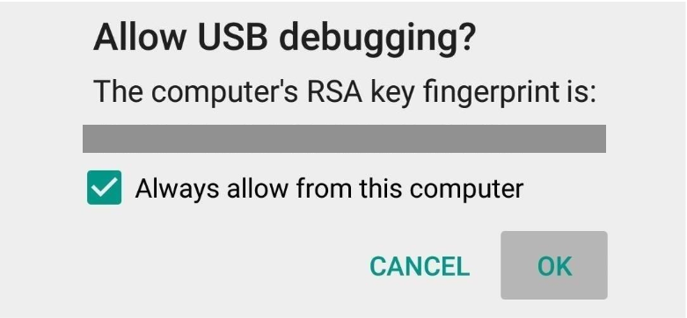

1. Select the **Always allow from this computer** checkbox and then tap **OK**.
2. In Android Studio on your computer, make sure your device is selected in the dropdown. Click .



1. Select your device and then click **OK**. Android Studio installs the app on your device and runs it.

**Note:** For Android Studio 3.6 and higher, the physical device is automatically selected when the device is connected with debugging turned on.

1. If your device runs an Android platform that isn't installed in Android Studio and you see a message that asks whether you want to install the needed platform, click **Install > Continue > Finish**. Android Studio installs the app on your device and runs it.

[5. Run your app on the Android device with Wi-Fi](https://developer.android.com/codelabs/basic-android-kotlin-compose-connect-device?continue=https%3A%2F%2Fdeveloper.android.com%2Fcourses%2Fpathways%2Fandroid-basics-compose-unit-1-pathway-2%23codelab-https%3A%2F%2Fdeveloper.android.com%2Fcodelabs%2Fbasic-android-kotlin-compose-connect-device#4)

If you don't have a cable, you can also connect and run your app on your device with Wi-Fi.

Get started

1. Ensure that your computer and device are connected to the same wireless network.
2. Ensure that your device runs Android 11 or higher. For more information, see [Check & update your Android version](https://support.google.com/android/answer/7680439).
3. Ensure that your computer has the latest version of Android Studio. To download it, see [Android Studio](https://developer.android.com/studio).
4. Ensure that your computer has the latest version of the [SDK Platform Tools](https://developer.android.com/studio/releases/platform-tools).

Pair your device

1. In Android Studio, select **Pair Devices Using Wi-Fi** from the run configurations drop-down menu.

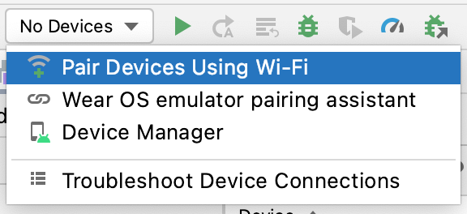

The **Pair devices over Wi-Fi** dialog opens.

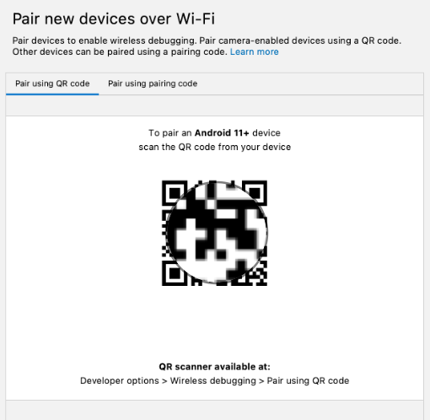

1. Go to **Developer options**, scroll down to the **Debugging** section and turn on **Wireless debugging**.

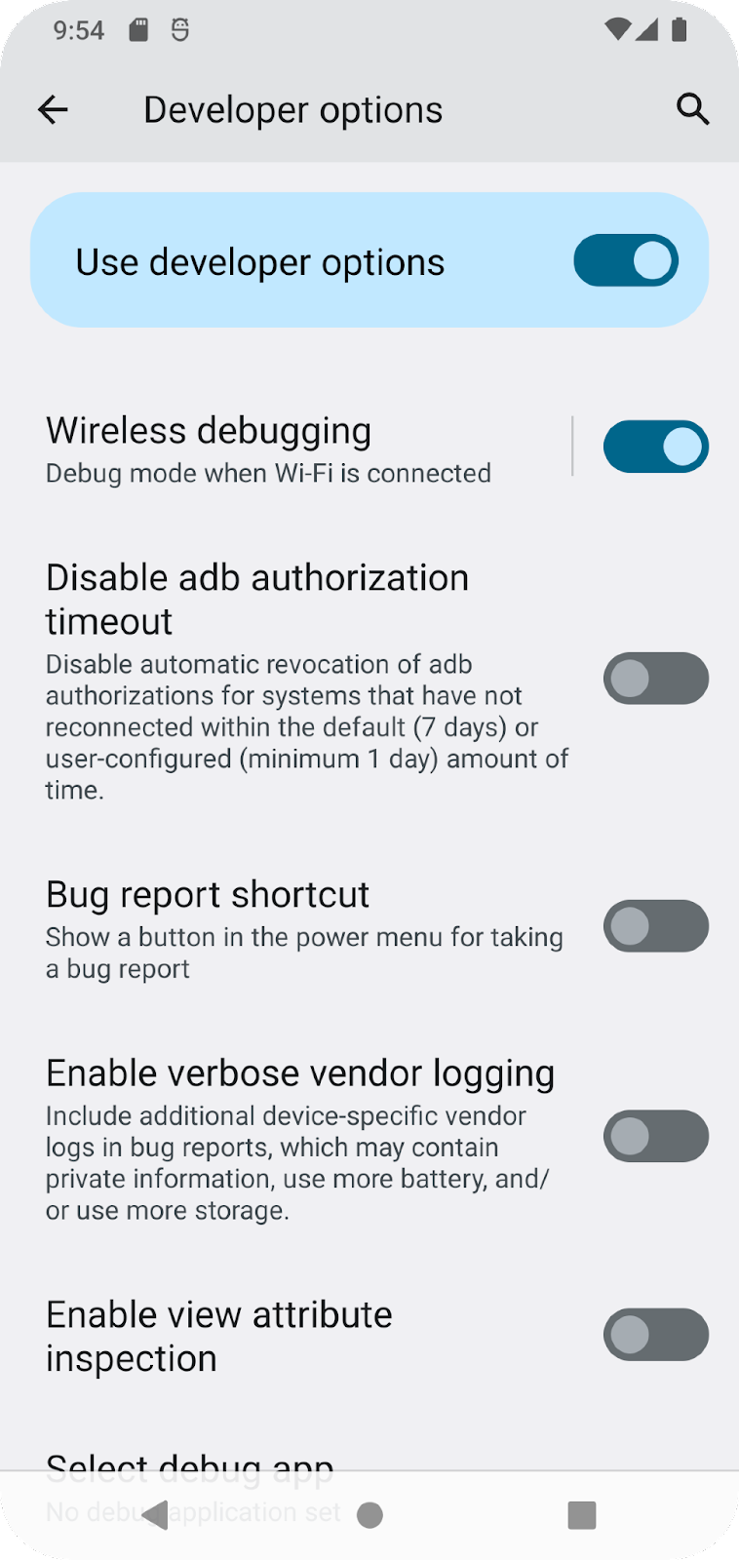

1. On the **Allow wireless debugging on this network?** popup, select **Allow**.

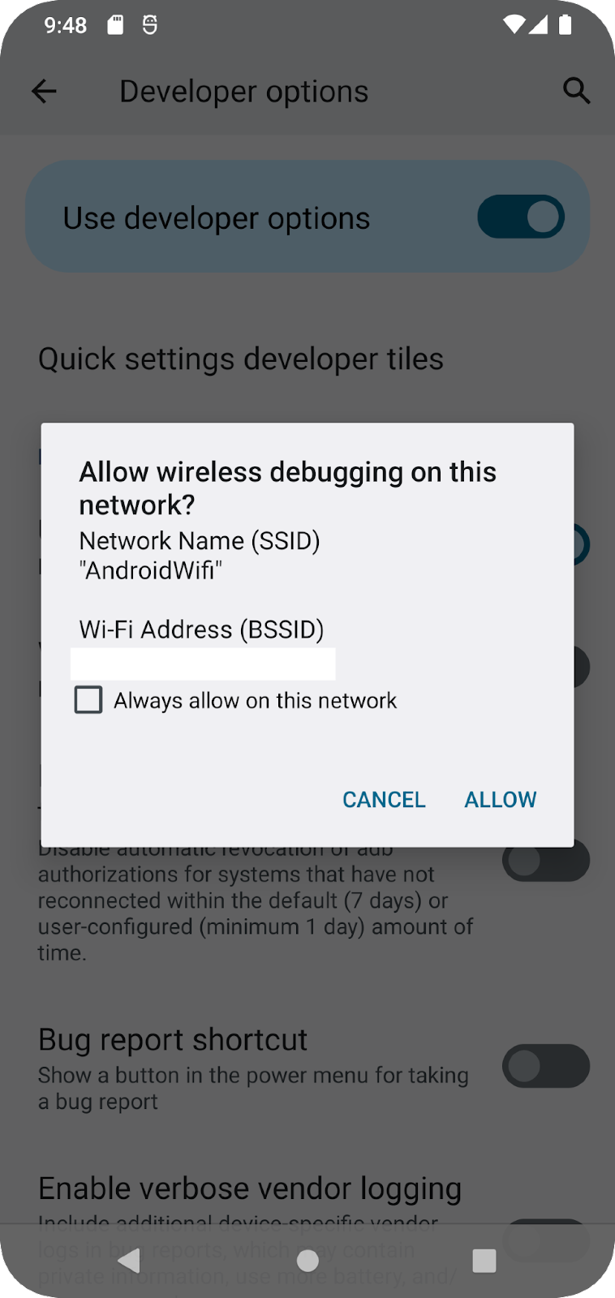

1. If you want to pair your device with a QR code, select **Pair device with QR code** and then scan the QR code on your computer. Alternatively, if you want to pair your device with a pairing code, select **Pair device with pairing code** and then enter the 6-digit code.
2. Click run and you can deploy your app to your device.

**Note:** If you want to pair a different device or forget this device on your computer, navigate to **Wireless debugging** on your device, tap on your workstation name under **Paired devices**, and select **Forget**.

[6. Troubleshooting](https://developer.android.com/codelabs/basic-android-kotlin-compose-connect-device?continue=https%3A%2F%2Fdeveloper.android.com%2Fcourses%2Fpathways%2Fandroid-basics-compose-unit-1-pathway-2%23codelab-https%3A%2F%2Fdeveloper.android.com%2Fcodelabs%2Fbasic-android-kotlin-compose-connect-device#5)

* If your computer runs Linux or Windows, and you can't run your app on a physical Android device, see [Run apps on a hardware device](http://developer.android.com/tools/device.html) for additional steps.
* If your computer runs Windows and the emulator installation doesn't work, see [Install OEM USB Drivers](http://developer.android.com/tools/extras/oem-usb.html) for the appropriate USB driver for your device.
* If Android Studio doesn't recognize your device: try unplugging the USB cable and plug it back in or restarting Android Studio.
* If your computer still doesn't find the device or declares it unauthorized: disconnect the USB cable. On the device, tap **Settings > Developer options > Revoke USB debugging authorizations**. Reconnect the device to your computer. When prompted, grant authorizations.

[7. Conclusion](https://developer.android.com/codelabs/basic-android-kotlin-compose-connect-device?continue=https%3A%2F%2Fdeveloper.android.com%2Fcourses%2Fpathways%2Fandroid-basics-compose-unit-1-pathway-2%23codelab-https%3A%2F%2Fdeveloper.android.com%2Fcodelabs%2Fbasic-android-kotlin-compose-connect-device#6)

You learned how to run an app in Android Studio on your physical Android device!

Summary

* You can run Android apps on your physical device through a cord or through Wi-Fi.
* Windows users need to install a USB debugging driver to run apps on their physical device.
* If you are running your app through Wi-Fi, you can pair using a QR code or a 6 digit code.

Learn more

* [Vocabulary for Android Basics in Kotlin](https://developer.android.com/courses/android-basics-kotlin/android-basics-kotlin-vocab)
* [Run apps on a hardware device](https://developer.android.com/studio/run/device)
* [Install OEM USB drivers](https://developer.android.com/studio/run/oem-usb#Drivers)
* [Get the Google USB Driver](https://developer.android.com/studio/run/win-usb)

Whats Next? <https://youtu.be/gleqCRTytuA>

**Build a basic layout**

## Intro to Jetpack Compose

<https://youtu.be/IuDkRDBy84k>

## Design a birthday card app

<https://youtu.be/LlF_2QXVZZ4>

Build a simple app with text composables

[1. Before you begin](https://developer.android.com/codelabs/basic-android-kotlin-compose-text-composables?continue=https%3A%2F%2Fdeveloper.android.com%2Fcourses%2Fpathways%2Fandroid-basics-compose-unit-1-pathway-3%23codelab-https%3A%2F%2Fdeveloper.android.com%2Fcodelabs%2Fbasic-android-kotlin-compose-text-composables#0)

In this codelab, you use Jetpack Compose to build a simple Android app that displays a birthday message on the screen.

Prerequisites

* How to create an app in Android Studio.
* How to run an app on an emulator or your Android device.

What you'll learn

* How to write composable functions, such as Text, Column and Row composable functions.
* How to display text in your app in a layout.
* How to format the text, such as changing text size.

What you'll build

* An Android app that displays a birthday greeting in text format, which looks like this screenshot when done:

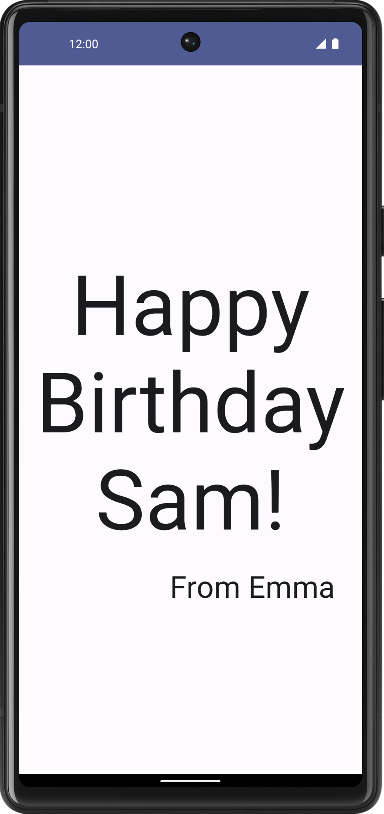

What you'll need

* A computer with Android Studio installed

[2. Set up a Happy Birthday app](https://developer.android.com/codelabs/basic-android-kotlin-compose-text-composables?continue=https%3A%2F%2Fdeveloper.android.com%2Fcourses%2Fpathways%2Fandroid-basics-compose-unit-1-pathway-3%23codelab-https%3A%2F%2Fdeveloper.android.com%2Fcodelabs%2Fbasic-android-kotlin-compose-text-composables#1)

In this task, you set up a project in Android Studio with the Empty Activity template and change the text message to a personalized birthday greeting.

Create an Empty Activity project

1. In the **Welcome to Android Studio** dialog, select **New Project**.
2. In the **New Project** dialog, select **Empty Activity** and then click **Next**.
3. In the **Name** field enter Happy Birthday and then select a minimum API level of 24 (Nougat) in the **Minimum SDK** field and click **Finish**.

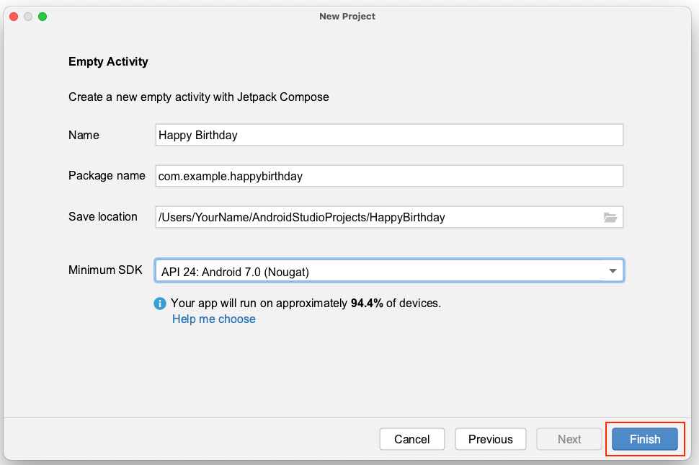

1. Wait for Android Studio to create the project files and build the project.
2. Click  **Run ‘app'**.

The app should look like this screenshot:

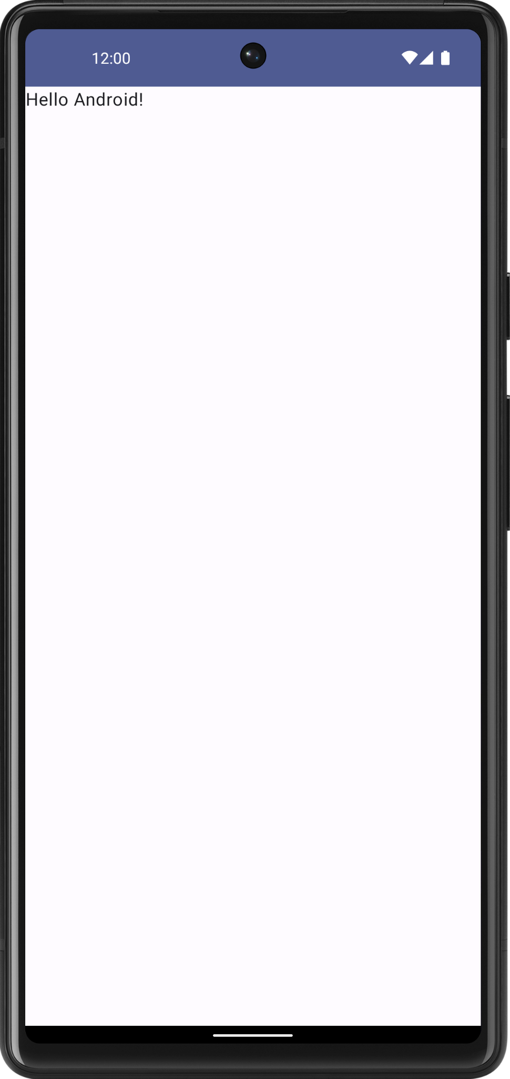

When you created this Happy Birthday app with the Empty Activity template, Android Studio set up resources for a basic Android app, including a **Hello Android!** message on the screen. In this codelab, you learn how that message gets there, how to change its text to a birthday greeting, and how to add and format additional messages.

What is a user interface (UI)?

The user interface (UI) of an app is what you see on the screen: text, images, buttons, and many other types of elements, and how it's laid out on the screen. It's how the app shows things to the user and how the user interacts with the app.

This image contains a clickable button, text message, and text-input field where users can enter data.

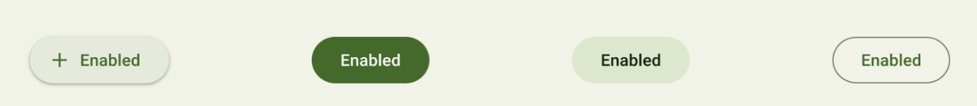

*Clickable button*

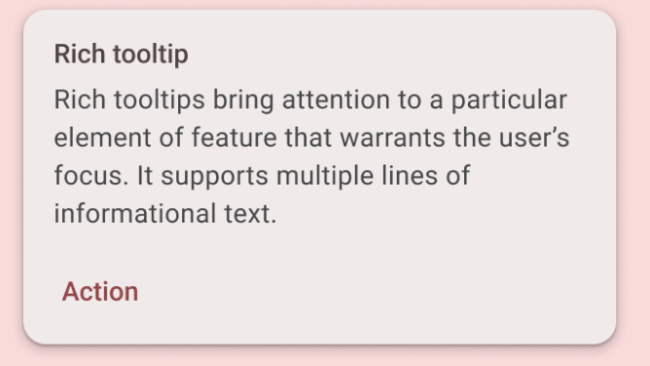

*Text message inside a Card*

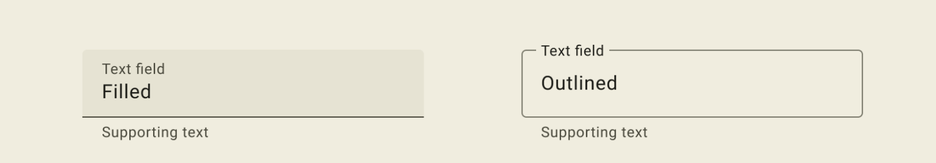

*Text-input field*

Each of these elements is called a UI component. Almost everything you see on the screen of your app is a UI element (also known as a UI component). They can be interactive, like a clickable button or an editable input field, or they can be decorative images.

In the following apps, try to find as many UI components as you can.

|  |  |
| --- | --- |
| showing recommended apps |  |

In this codelab, you work with a UI element that displays text called a Text element.

[3. What is Jetpack Compose?](https://developer.android.com/codelabs/basic-android-kotlin-compose-text-composables?continue=https%3A%2F%2Fdeveloper.android.com%2Fcourses%2Fpathways%2Fandroid-basics-compose-unit-1-pathway-3%23codelab-https%3A%2F%2Fdeveloper.android.com%2Fcodelabs%2Fbasic-android-kotlin-compose-text-composables#2)

Jetpack Compose is a modern toolkit for building Android UIs. Compose simplifies and accelerates UI development on Android with less code, powerful tools, and intuitive Kotlin capabilities. With Compose, you can build your UI by defining a set of functions, called composable functions, that take in data and describe UI elements.

Composable functions

Composable functions are the basic building block of a UI in Compose. A composable function:

* Describes some part of your UI.
* Doesn't return anything.
* Takes some input and generates what's shown on the screen.

Annotations

Annotations are means of attaching extra information to code. This information helps tools like the Jetpack Compose compiler, and other developers understand the app's code.

An annotation is applied by prefixing its name (the annotation) with the @ character at the beginning of the declaration you are annotating. Different code elements, including properties, functions, and classes, can be annotated. Later on in the course, you'll learn about classes.

The following diagram is an example of annotated function:

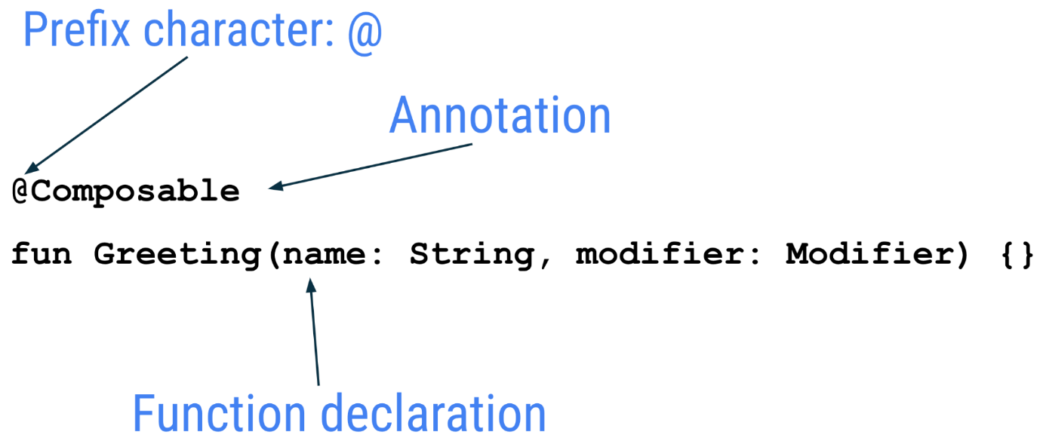

The following code snippet has examples of annotated properties. You will be using these in the coming codelabs.

// Example code, do not copy it over  
  
@Json  
val imgSrcUrl: String  
  
@Volatile  
private var INSTANCE: AppDatabase? = null

Annotations with parameters

Annotations can take parameters. Parameters provide extra information to the tools processing them. The following are some examples of the @Preview annotation with and without parameters.

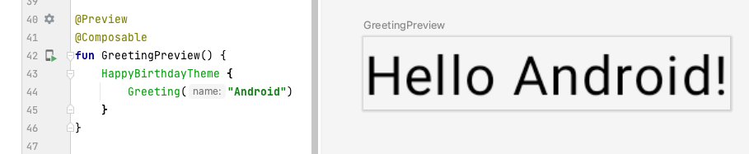

*Annotation without parameters*

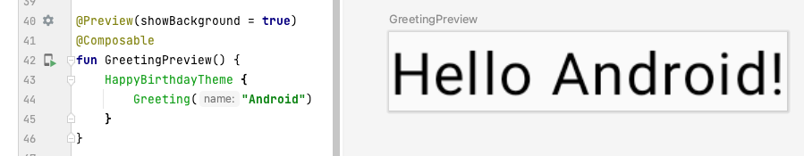

*Annotation previewing background*

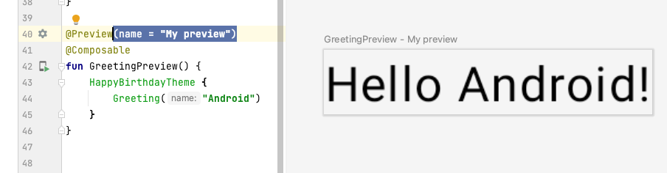

*Annotation with a preview title*

You can pass multiple parameters to the annotation, as shown here.

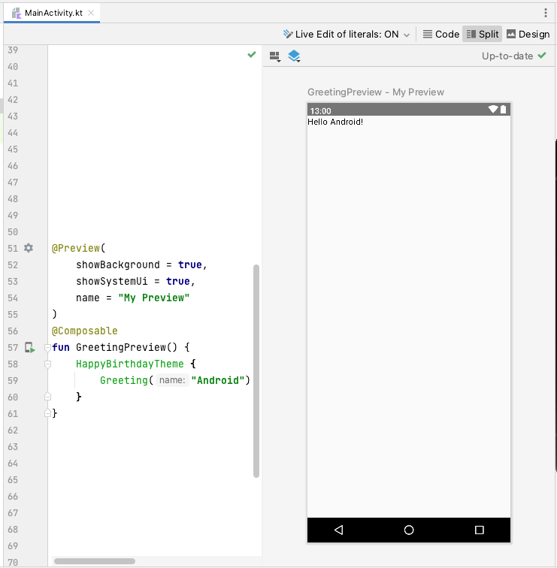

*Annotation with a preview title and the system UI (the phone screen)*

Jetpack Compose includes a wide range of built-in annotations, you have already seen @Composable and @Preview annotations so far in the course. You will learn more annotations and their usages in the latter part of the course.

Example of a composable function

The Composable function is annotated with the [@Composable](https://developer.android.com/reference/kotlin/androidx/compose/runtime/Composable) annotation. All composable functions must have this annotation. This annotation informs the Compose compiler that this function is intended to convert data into UI. As a reminder, a compiler is a special program that takes the code you wrote, looks at it line by line, and translates it into something the computer can understand (machine language).

This code snippet is an example of a simple composable function that is passed data (the name function parameter) and uses it to render a text element on the screen.

@Composable  
fun Greeting(name: String) {  
    Text(text = "Hello $name!")  
}

A few notes about the composable function:

* Jetpack Compose is built around composable functions. These functions let you define your app's UI programmatically by describing how it should look, rather than focusing on the process of the UI's construction. To create a composable function, just add the @Composable annotation to the function name.
* Composable functions can accept arguments, which let the app logic describe or modify the UI. In this case, your UI element accepts a String so that it can greet the user by name.

Notice the composable functions in code

1. In Android Studio, open the MainActivity.kt file.
2. Scroll to the GreetingPreview() function. This composable function helps preview the Greeting() function. As a good practice, functions should always be named or renamed to describe their functionality. Change the name of this function to BirthdayCardPreview().

@Preview(showBackground = true)  
@Composable  
fun BirthdayCardPreview() {  
   HappyBirthdayTheme {  
       Greeting("Android")  
   }  
}

Composable functions can call other composable functions. In this code snippet, the preview function is calling the Greeting() composable function.

Notice the previous function also has another annotation, a @Preview annotation, with a parameter before the @Composable annotation. You learn more about the arguments passed to the @Preview annotation later in the course.

Composable function names

The compose function that returns nothing and bears the @Composable annotation MUST be named using pascal case. Pascal case refers to a naming convention in which the first letter of each word in a compound word is capitalized. The difference between pascal case and camel case is that all words in pascal case are capitalized. In camel case, the first word is not capitalized.

The Compose function:

* *MUST* be a noun: DoneButton()
* *NOT* a verb or verb phrase: DrawTextField()
* *NOT* a nouned preposition: TextFieldWithLink()
* *NOT* an adjective: Bright()
* *NOT* an adverb: Outside()
* Nouns *MAY* be prefixed by descriptive adjectives: RoundIcon()

To learn more see [Naming Composable functions](https://github.com/androidx/androidx/blob/androidx-main/compose/docs/compose-api-guidelines.md#naming-unit-composable-functions-as-entities).

**Example code. Do not copy over**

// Do: This function is a descriptive PascalCased noun as a visual UI element  
@Composable  
fun FancyButton(text: String) {}  
  
  
// Do: This function is a descriptive PascalCased noun as a non-visual element  
// with presence in the composition  
@Composable  
fun BackButtonHandler() {}  
  
  
// Don't: This function is a noun but is not PascalCased!  
@Composable  
fun fancyButton(text: String) {}  
  
  
// Don't: This function is PascalCased but is not a noun!  
@Composable  
fun RenderFancyButton(text: String) {}  
  
  
// Don't: This function is neither PascalCased nor a noun!  
@Composable  
fun drawProfileImage(image: ImageAsset) {}

[4. Design pane in Android Studio](https://developer.android.com/codelabs/basic-android-kotlin-compose-text-composables?continue=https%3A%2F%2Fdeveloper.android.com%2Fcourses%2Fpathways%2Fandroid-basics-compose-unit-1-pathway-3%23codelab-https%3A%2F%2Fdeveloper.android.com%2Fcodelabs%2Fbasic-android-kotlin-compose-text-composables#3)

[Android Studio](https://developer.android.com/studio) lets you preview your composable functions within the IDE, instead of installing the app to an Android device or emulator. As you learned in the previous pathway, you can preview what your app looks like in the **Design** pane in Android Studio.

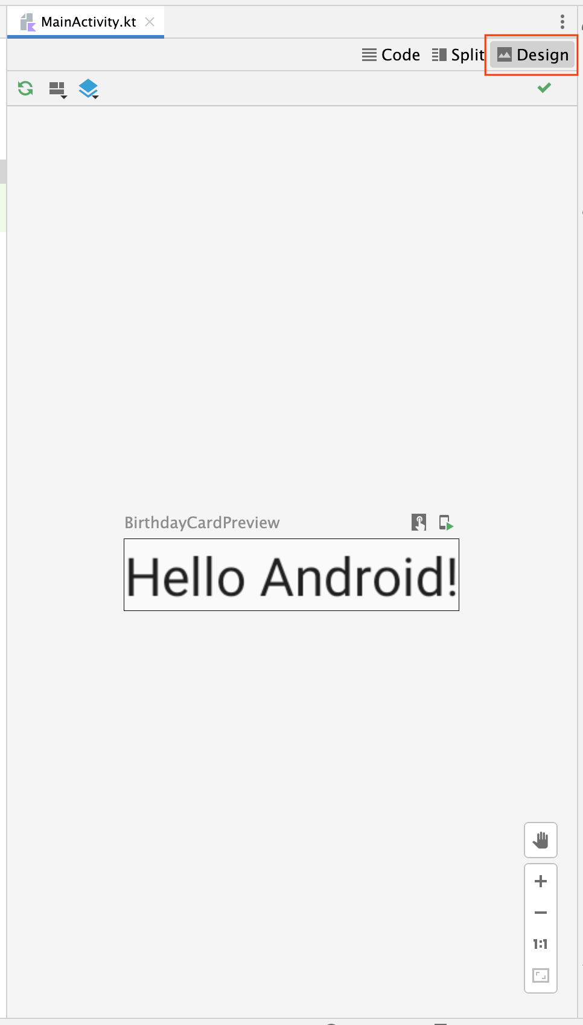

The composable function must provide default values for any parameters to preview it. For this reason, it is recommended not to preview the Greeting() function directly. Instead, you need to add another function, the BirthdayCardPreview() function in this case, that calls the Greeting() function with an appropriate parameter.

@Preview(showBackground = true)  
@Composable  
fun BirthdayCardPreview() {  
   HappyBirthdayTheme {  
       Greeting("Android")  
   }  
}

**Tip**: Click **Split** to view both your code and design preview.

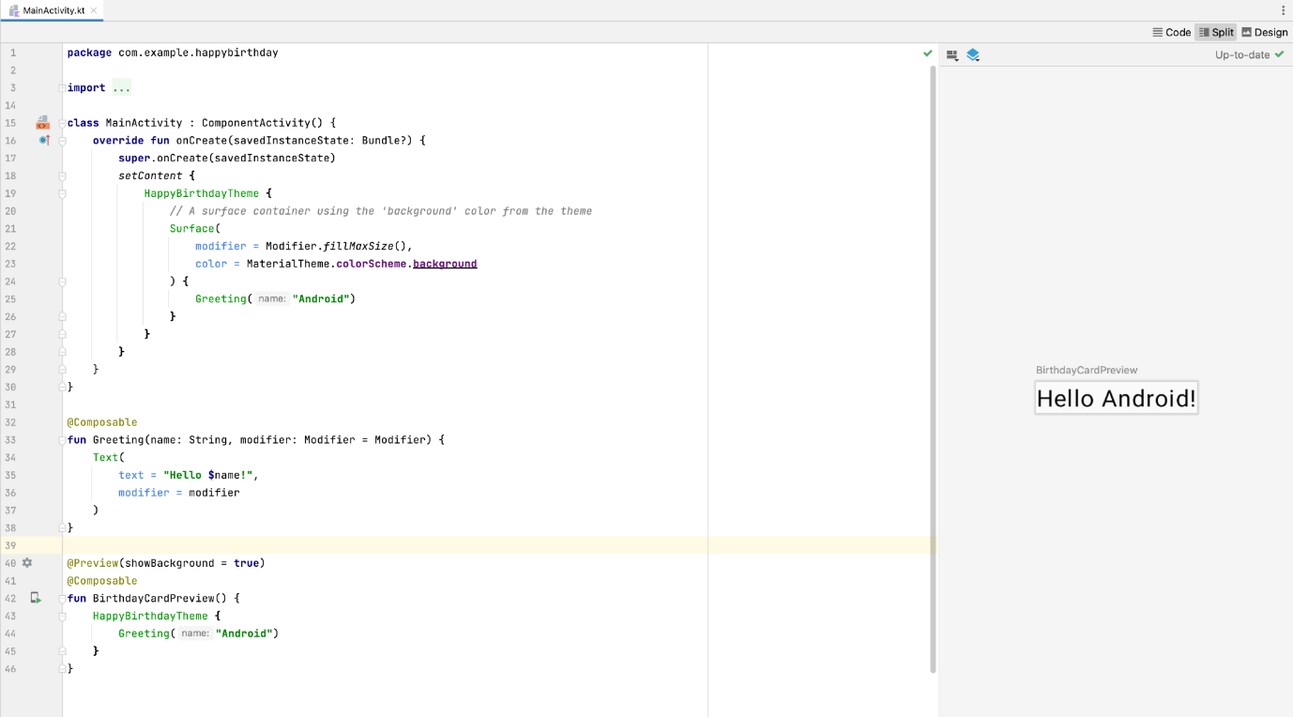

To view your preview:

1. In the BirthdayCardPreview() function, change the "Android" argument in the *Greeting()* function to your name.

@Preview(showBackground = true)  
@Composable  
fun BirthdayCardPreview() {  
   HappyBirthdayTheme {  
       Greeting("James")  
   }  
}

1. Build your code. The preview should automatically update.

You should see the updated preview.

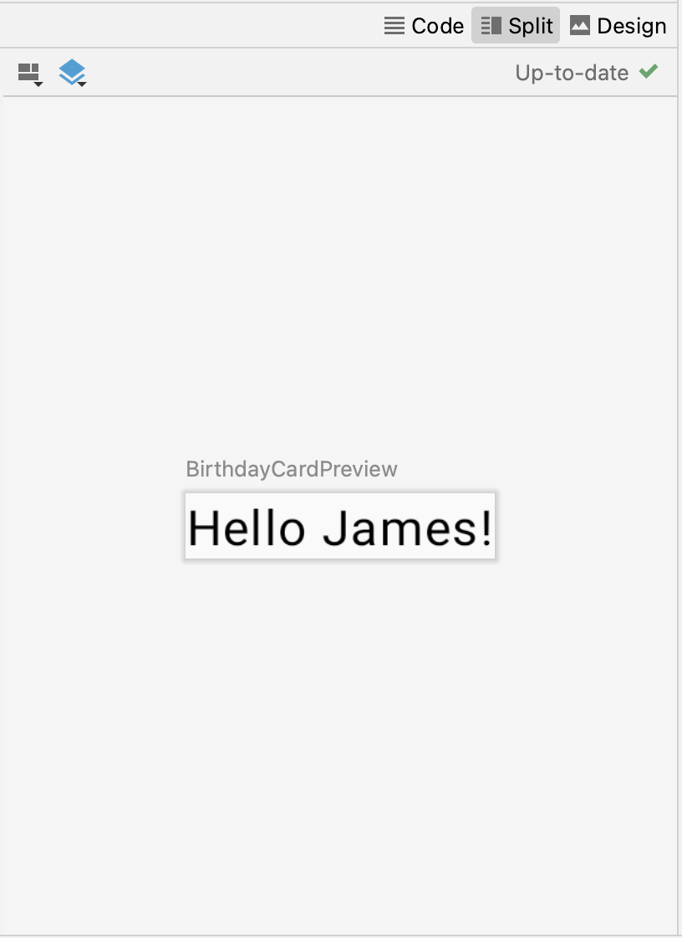

**Important**: The code you added to the BirthdayCardPreview() function with the @Preview annotation is only for previewing in the **Design** pane in Android Studio. These changes aren't reflected in the app. You learn how to make changes to the app later in this codelab.

[5. Add a new text element](https://developer.android.com/codelabs/basic-android-kotlin-compose-text-composables?continue=https%3A%2F%2Fdeveloper.android.com%2Fcourses%2Fpathways%2Fandroid-basics-compose-unit-1-pathway-3%23codelab-https%3A%2F%2Fdeveloper.android.com%2Fcodelabs%2Fbasic-android-kotlin-compose-text-composables#4)

In this task, you remove the Hello $name! greeting and add a birthday greeting.

Add a new composable function

1. In the MainActivity.kt file, delete the Greeting() function definition. You will add your own function to display the greeting in the codelab later.

**Remove the following code**

@Composable  
fun Greeting(name: String, modifier: Modifier = Modifier) {  
    Text(  
        text = "Hello $name!",  
        modifier = modifier  
    )  
}

1. Inside the onCreate() function, notice that the Greeting() function call is now colored red. This red coloring indicates an error. Hover over the cursor over this function call and Android Studio will display information regarding the error.

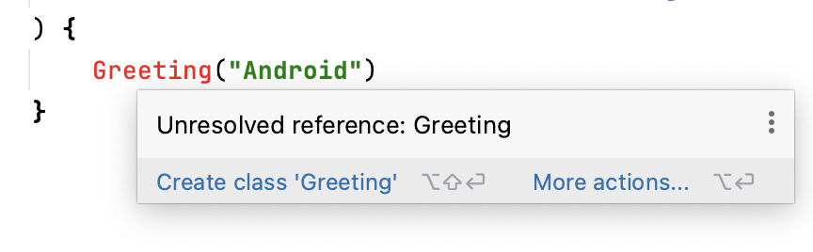

1. Delete the Greeting() function call along with its arguments from the onCreate()and BirthdayCardPreview() functions. Your MainActivity.kt file will look similar to this:

class MainActivity : ComponentActivity() {  
    override fun onCreate(savedInstanceState: Bundle?) {  
        super.onCreate(savedInstanceState)  
        setContent {  
            HappyBirthdayTheme {  
                // A surface container using the 'background' color from the theme  
                Surface(  
                    modifier = Modifier.fillMaxSize(),  
                    color = MaterialTheme.colorScheme.background  
                ) {  
                }  
            }  
        }  
    }  
}  
  
@Preview(showBackground = true)  
@Composable  
fun BirthdayCardPreview(){  
    HappyBirthdayTheme {  
    }  
}

1. Before the BirthdayCardPreview() function, add a new function called GreetingText(). Don't forget to add the @Composable annotation before the function because this will be a compose function describing a Text composable.

@Composable  
fun GreetingText() {  
}

1. It's a best practice to have your Composable accept a Modifier parameter, and pass that modifier to its first child. You will learn more about Modifier and child elements in the subsequent tasks and codelabs. For now, add a Modifier parameter to the GreetingText() function.

@Composable  
fun GreetingText(modifier: Modifier = Modifier) {  
}

1. Add a message parameter of type String to the GreetingText() composable function.

@Composable  
fun GreetingText(message: String, modifier: Modifier = Modifier) {  
}

1. In the GreetingText() function, add a [Text](https://developer.android.com/jetpack/compose/text) composable passing in the text message as a named argument.

@Composable  
fun GreetingText(message: String, modifier: Modifier = Modifier) {  
    Text(  
        text = message  
    )  
}

This GreetingText() function displays text in the UI. It does so by calling the Text() composable function.

Preview the function

In this task you will preview the GreetingText() function in the **Design** pane.

1. Call the GreetingText() function inside the BirthdayCardPreview() function.
2. Pass a String argument to the GreetingText() function, a birthday greeting to your friend. You can customize it with their name if you like, such as "Happy Birthday Sam!".

@Preview(showBackground = true)  
@Composable  
fun BirthdayCardPreview() {  
    HappyBirthdayTheme {  
        GreetingText(message = "Happy Birthday Sam!")  
    }  
}

1. In the **Design** pane updated automatically. Preview your changes.

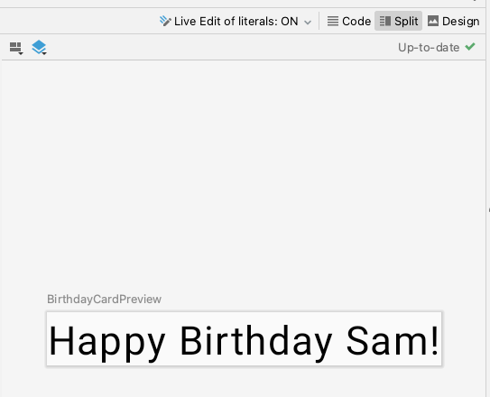

[6. Change font size](https://developer.android.com/codelabs/basic-android-kotlin-compose-text-composables?continue=https%3A%2F%2Fdeveloper.android.com%2Fcourses%2Fpathways%2Fandroid-basics-compose-unit-1-pathway-3%23codelab-https%3A%2F%2Fdeveloper.android.com%2Fcodelabs%2Fbasic-android-kotlin-compose-text-composables#5)

You added text to your user interface, but it doesn't look like the final app yet. In this task, you learn how to change the size, text color, and other attributes that affect the appearance of the text element. You can also experiment with different font sizes and colors.

Scalable pixels

The [*scalable pixels* (SP)](https://developer.android.com/reference/kotlin/androidx/compose/ui/unit/package-summary#(kotlin.Float).sp()) is a unit of measure for the font size. UI elements in Android apps use two different units of measurement: [*density-independent pixels* (DP)](https://developer.android.com/reference/kotlin/androidx/compose/ui/unit/package-summary#(kotlin.Int).dp()), which you use later for the layout, and scalable pixels (SP). By default, the SP unit is the same size as the DP unit, but it resizes based on the user's preferred text size under phone settings.

1. In the MainActivity.kt file, scroll to the Text() composable in the GreetingText() function.
2. Pass the Text() function a fontSize argument as a second named argument and set it to a value of 100.*sp*.

Text(  
   text = message,  
   fontSize = 100.sp  
)

Android Studio highlights the .sp code because you need to import some classes or properties to compile your app.

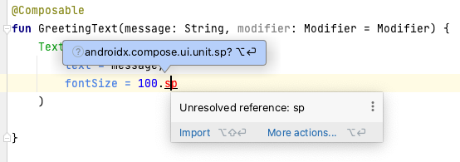

1. Click .sp, which is highlighted by Android Studio.
2. Click **Import** in the popup to import the androidx.compose.ui.unit.sp to use the .sp extension property.

**Note:** The AndroidX (Android Extension) library contains a set of libraries and classes that help accelerate your app development, by providing you the core functionality. You can access the classes, properties, and other artifacts using the androidx package.

1. Scroll to the top of the file and notice the import statements, where you should see an import androidx.compose.ui.unit.sp statement, which means that Android Studio adds the package to your file.

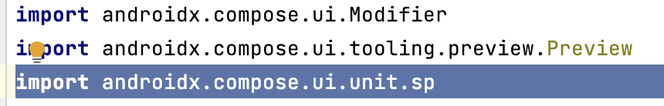

**Note:** If you encounter any problems with importing using Android Studio, you can manually add the imports at the top of the file.

1. Notice the updated preview of the font size. The reason for overlapping message is you need to specify the line height.

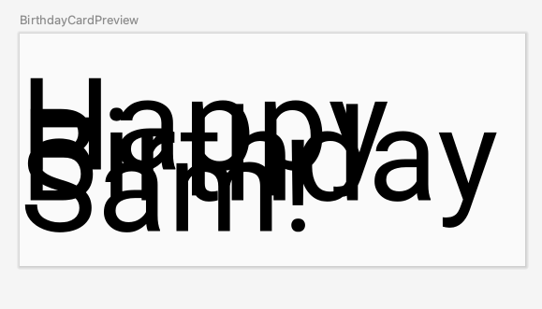

**Note:** The sp is an [extension property](https://kotlinlang.org/docs/extensions.html#extension-properties) for Int, which creates an sp unit. Similarly, you can use the .sp extension property in other data types, like Float and Double.

1. Update the Text composable to include the line height.

@Composable  
fun GreetingText(message: String, modifier: Modifier = Modifier) {  
    Text(  
        text = message,  
        fontSize = 100.sp,  
        lineHeight = 116.sp,  
    )  
}



Now you can experiment with different font sizes.

[7. Add another text element](https://developer.android.com/codelabs/basic-android-kotlin-compose-text-composables?continue=https%3A%2F%2Fdeveloper.android.com%2Fcourses%2Fpathways%2Fandroid-basics-compose-unit-1-pathway-3%23codelab-https%3A%2F%2Fdeveloper.android.com%2Fcodelabs%2Fbasic-android-kotlin-compose-text-composables#6)

In your previous tasks, you added a birthday-greeting message to your friend. In this task, you sign your card with your name.

1. In the MainActivity.kt file, scroll to the GreetingText() function.
2. Pass the function a from parameter of type String for your signature.

fun GreetingText(message: String, from: String, modifier: Modifier = Modifier)

**Note**: The order of the function parameters doesn't matter if you use the named arguments in the function call.

1. After the birthday message Text composable, add another Text composable that accepts a text argument set to the from value.

@Composable  
fun GreetingText(message: String, from: String, modifier: Modifier = Modifier) {  
    Text(  
        // ...  
    )  
    Text(  
        text = from  
    )  
}

1. Add a fontSize named argument set to a value of 36.sp.

Text(  
    text = from,  
    fontSize = 36.sp  
)

1. Scroll to the BirthdayCardPreview() function.
2. Add another String argument to sign your card, such as "From Emma".

GreetingText(message = "Happy Birthday Sam!", from ="From Emma")

1. Notice the preview.

[8. Arrange the text elements in a row and column](https://developer.android.com/codelabs/basic-android-kotlin-compose-text-composables?continue=https%3A%2F%2Fdeveloper.android.com%2Fcourses%2Fpathways%2Fandroid-basics-compose-unit-1-pathway-3%23codelab-https%3A%2F%2Fdeveloper.android.com%2Fcodelabs%2Fbasic-android-kotlin-compose-text-composables#7)

UI Hierarchy

The UI hierarchy is based on containment, meaning one component can contain one or more components, and the terms parent and child are sometimes used. The context here is that the parent UI elements contain children UI elements, which in turn can contain children UI elements. In this section, you will learn about Column, Row, and Box composables, which can act as parent UI elements.

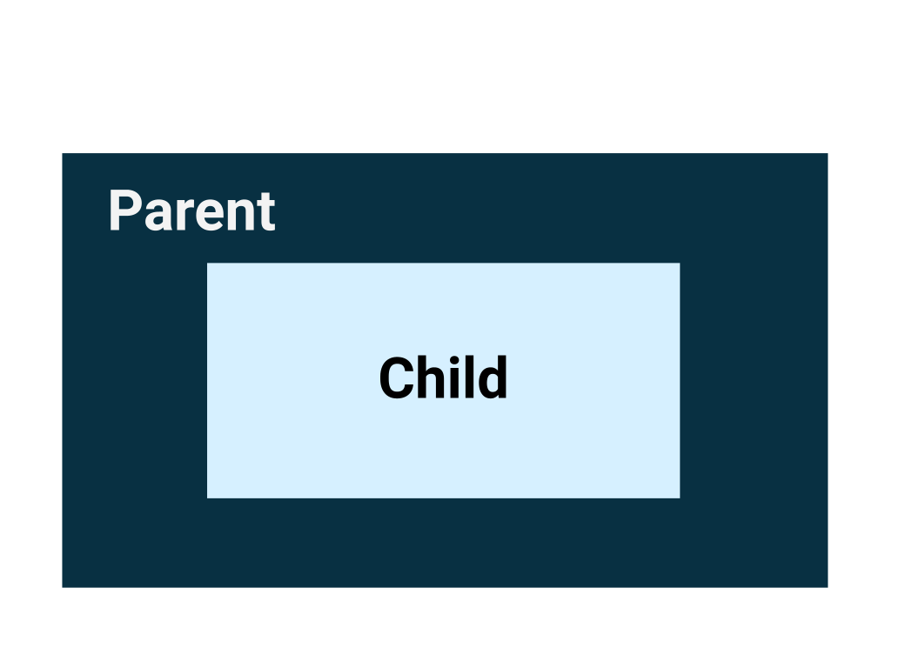

The three basic, standard layout elements in Compose are [Column](https://developer.android.com/reference/kotlin/androidx/compose/foundation/layout/package-summary#Column(androidx.compose.ui.Modifier,androidx.compose.foundation.layout.Arrangement.Vertical,androidx.compose.ui.Alignment.Horizontal,kotlin.Function1)), [Row](https://developer.android.com/reference/kotlin/androidx/compose/foundation/layout/package-summary#Row(androidx.compose.ui.Modifier,androidx.compose.foundation.layout.Arrangement.Horizontal,androidx.compose.ui.Alignment.Vertical,kotlin.Function1)), and [Box](https://developer.android.com/reference/kotlin/androidx/compose/foundation/layout/package-summary#Box(androidx.compose.ui.Modifier,androidx.compose.ui.Alignment,kotlin.Boolean,kotlin.Function1)) composables. You learn more about the Box composable in the next codelab.

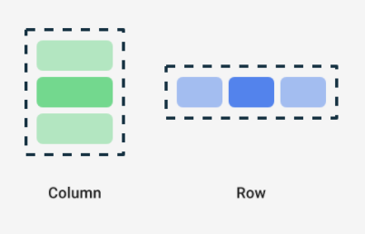

Column, Row, and Box are composable functions that take composable content as arguments, so you can place items inside these layout elements. For example, each child element inside a Row composable is placed horizontally next to each other in a row.

// Don't copy.  
Row {  
    Text("First Column")  
    Text("Second Column")  
}

These text elements display next to each other on the screen as seen in this image.

The blue borders are only for demonstration purposes and don't display.

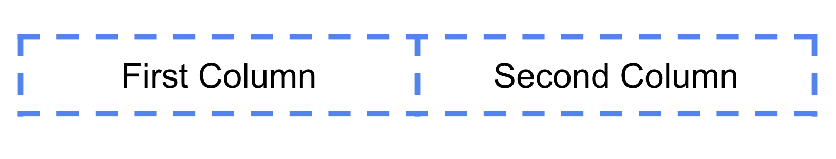

Trailing lambda syntax

Notice in the previous code snippet that curly braces are used instead of parentheses in the Row composable function. This is called *Trailing Lambda Syntax*. You learn about *lambdas* and trailing lambda syntax in detail later in the course. For now, get familiar with this commonly used Compose syntax.

Kotlin offers a special syntax for passing functions as parameters to functions, when the last parameter is a function.

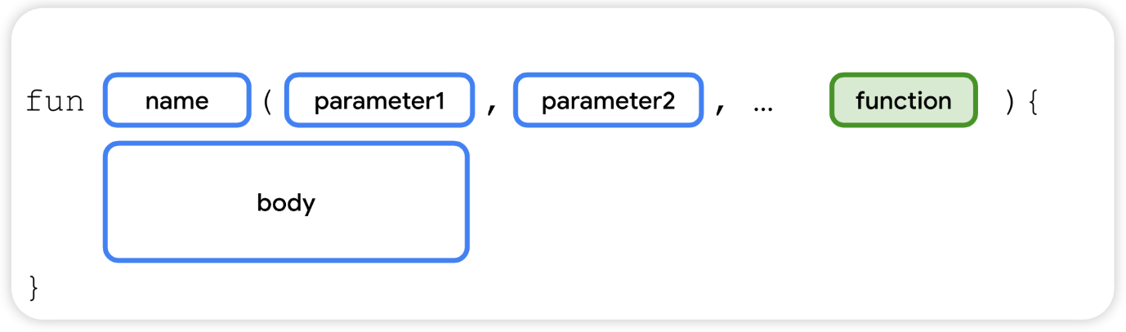

When you pass a function as that parameter, you can use trailing lambda syntax. Instead of putting the function body along with the function name within the parentheses({}), you put the parentheses along with the function body after the function name. This is a recommended and common practice in Compose, so you need to be familiar with how the code looks.

For example, the last parameter in the Row() composable function is the content parameter, a function that describes the child UI elements. Suppose you wanted to create a row that contains three text elements. This code would work, but it's very cumbersome to use named parameter for the trailing lambda:

Row(  
    content = {  
        Text("Some text")  
        Text("Some more text")  
        Text("Last text")  
    }  
)

Because the content parameter is the last one in the function signature and you pass its value as a lambda expression (for now, it's okay if you don't know what a lambda is, just familiarize yourself with the syntax), you can remove the content parameter and the parentheses as follows:

Row {  
    Text("Some text")  
    Text("Some more text")  
    Text("Last text")  
}

Arrange the text elements in a row

In this task, you arrange the text elements in your app in a row to avoid overlap.

1. In the MainActivity.kt file, scroll to the GreetingText() function.
2. Add the Row composable around the text elements so that it shows a row with two text elements. Select the two Text composables, click on the light bulb. Select **Surround with widget** > **Surround with Row**.

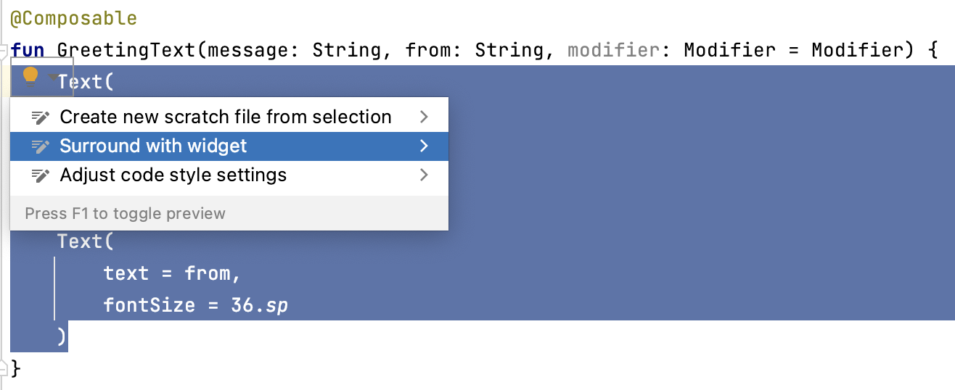

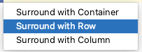

Now the function should look like this code snippet:

@Composable  
fun GreetingText(message: String, from: String, modifier: Modifier = Modifier) {  
    Row {  
        Text(  
            text = message,  
            fontSize = 100.sp,  
            lineHeight = 116.sp,  
        )  
        Text(  
            text = from,  
            fontSize = 36.sp  
        )  
    }  
}

1. Android Studio auto imports Row function for you. Scroll to the top and notice the import section. The import androidx.compose.foundation.layout.Row should have been added.
2. Observe the updated preview in the **Design** pane. Temporarily change the font size for the birthday message to 30.sp.

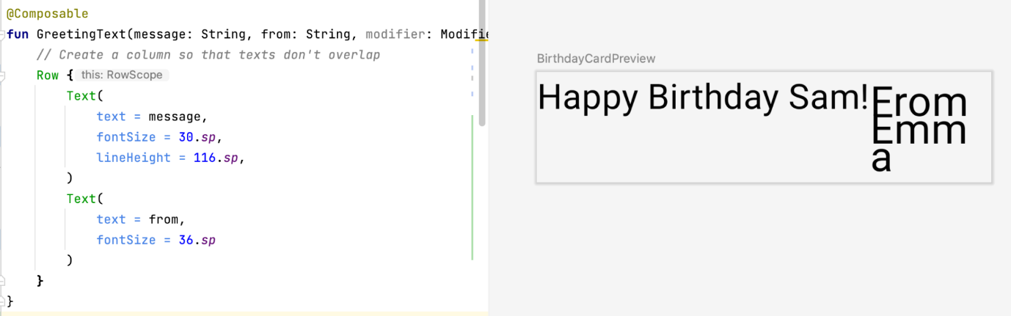

The preview looks much better now that there's no overlap. However, this isn't what you want because there's not enough room for your signature. In your next task, you arrange the text elements in a column to resolve this issue.

Arrange the text elements in a column

In this task, it is your turn to change the GreetingText() function to arrange the text elements in a column. The preview should look like this screenshot:

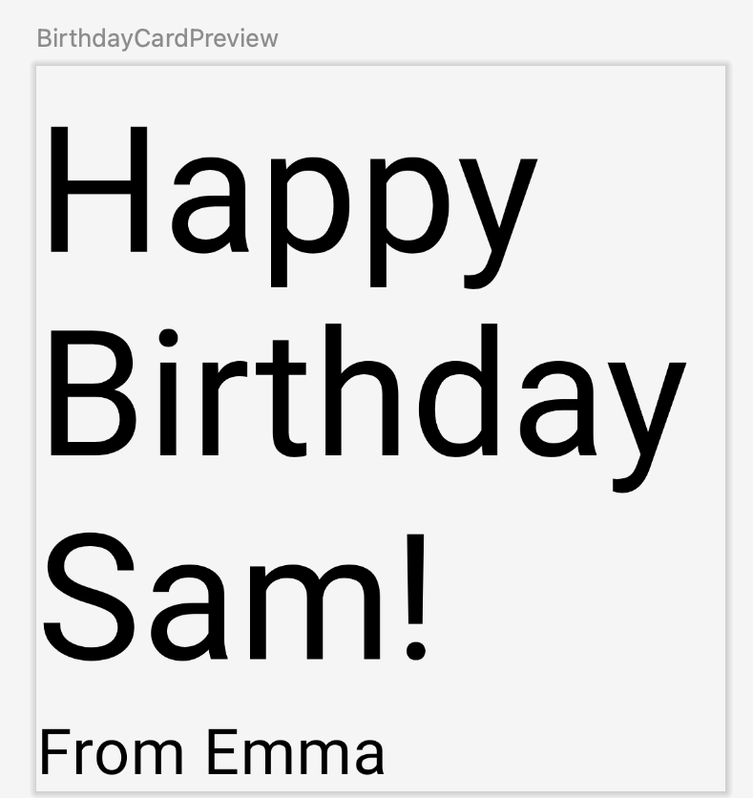

Now that you've tried doing this on your own, feel free to check your code against the solution code in this snippet:

@Composable  
fun GreetingText(message: String, from: String, modifier: Modifier = Modifier) {  
   Column {  
       Text(  
           text = message,  
           fontSize = 100.sp,  
           lineHeight = 116.sp  
       )  
       Text(  
           text = from,  
           fontSize = 36.sp  
       )  
   }  
}

Notice the auto imported package by Android Studio:

import androidx.compose.foundation.layout.Column

Recollect that you need to pass the modifier parameter to the child element in the composables.That means you need to pass the modifier parameter to the Column composable.

@Composable  
fun GreetingText(message: String, from: String, modifier: Modifier = Modifier) {  
    Column(modifier = modifier) {  
        Text(  
            text = message,  
            fontSize = 100.sp,  
            lineHeight = 116.sp  
        )  
        Text(  
            text = from,  
            fontSize = 36.sp  
        )  
    }  
}

[9. Add greeting to the app](https://developer.android.com/codelabs/basic-android-kotlin-compose-text-composables?continue=https%3A%2F%2Fdeveloper.android.com%2Fcourses%2Fpathways%2Fandroid-basics-compose-unit-1-pathway-3%23codelab-https%3A%2F%2Fdeveloper.android.com%2Fcodelabs%2Fbasic-android-kotlin-compose-text-composables#8)

Once you're happy with the preview, it's time to add the composable to your app on your device or emulator.

1. In the MainActivity.kt file, scroll to the onCreate() function.
2. Call the GreetingText() function from the Surface block.
3. Pass the GreetingText() function, your birthday greeting and signature.

The completed onCreate() function should look like this code snippet:

class MainActivity : ComponentActivity() {  
    override fun onCreate(savedInstanceState: Bundle?) {  
        super.onCreate(savedInstanceState)  
        setContent {  
            HappyBirthdayTheme {  
                // A surface container using the 'background' color from the theme  
                Surface(  
                    modifier = Modifier.fillMaxSize(),  
                    color = MaterialTheme.colorScheme.background  
                ) {  
                    GreetingText(message = "Happy Birthday Sam!", from = "From Emma")  
                }  
            }  
        }  
    }  
}

1. Build and run your app on the emulator.

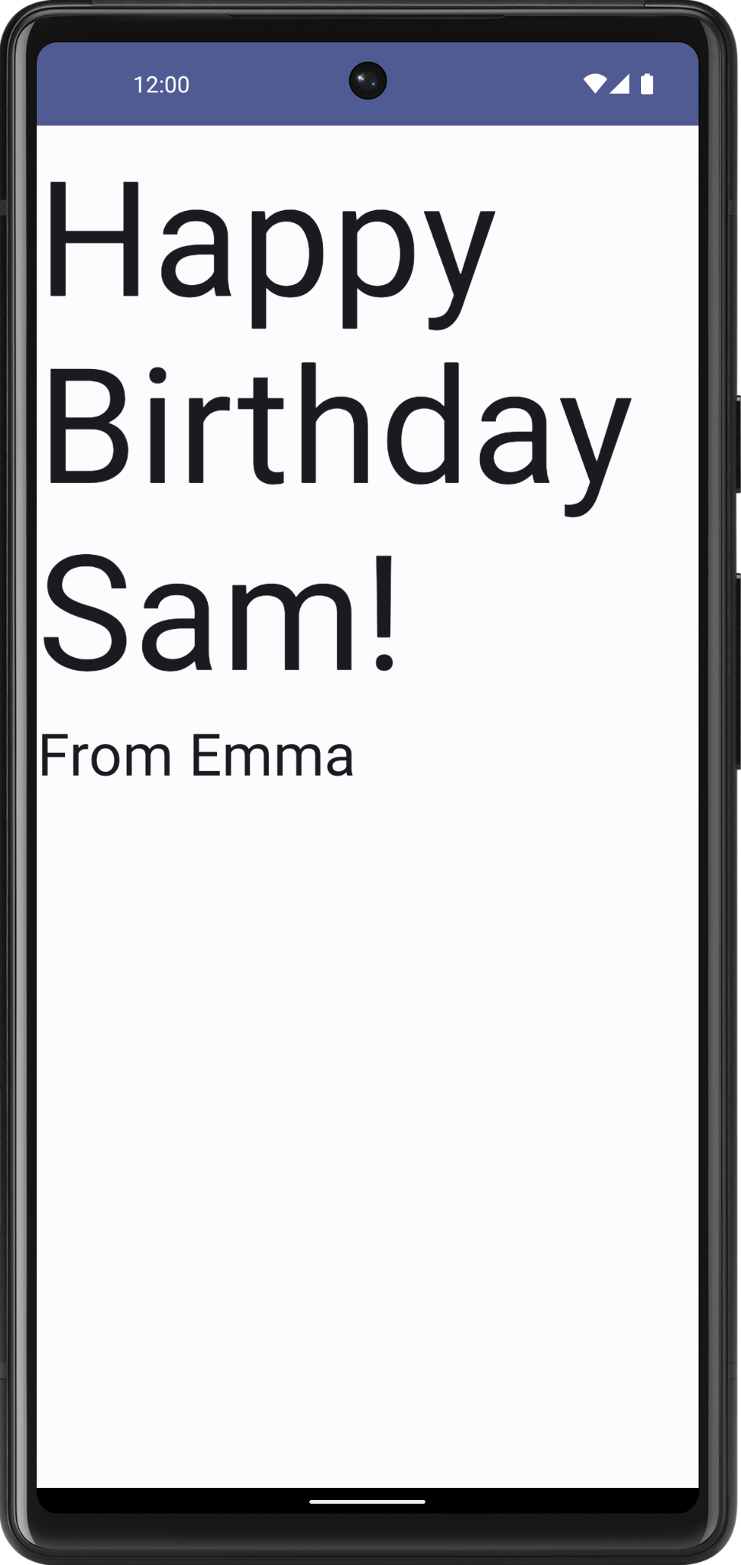

Align greeting to the center

1. To align the greeting in the center of the screen add a parameter called verticalArrangement set it to Arrangement.Center. You will learn more on the verticalArrangement in a later codelab.

@Composable  
fun GreetingText(message: String, from: String, modifier: Modifier = Modifier) {  
    Column(  
        verticalArrangement = Arrangement.Center,  
        modifier = modifier  
    ) {  
        // ...  
    }  
}

1. Add 8.dp padding around the column. It is a good practice to use padding values in increments of 4.dp.

@Composable  
fun GreetingText(message: String, from: String, modifier: Modifier = Modifier) {  
    Column(  
        verticalArrangement = Arrangement.Center,  
        modifier = modifier.padding(8.dp)  
    ) {  
        // ...  
    }  
}

1. To further beautify your app, align the greeting text to the center using textAlign.

Text(  
    text = message,  
    fontSize = 100.sp,  
    lineHeight = 116.sp,  
    textAlign = TextAlign.Center  
)



In the above screenshot, only the greeting is center aligned because of the textAlign parameter. The signature, **From Emma** has the default alignment which is left.

1. Add padding to the signature and align it to the right.

Text(  
    text = from,  
    fontSize = 36.sp,  
    modifier = Modifier  
        .padding(16.dp)  
        .align(alignment = Alignment.End)  
)

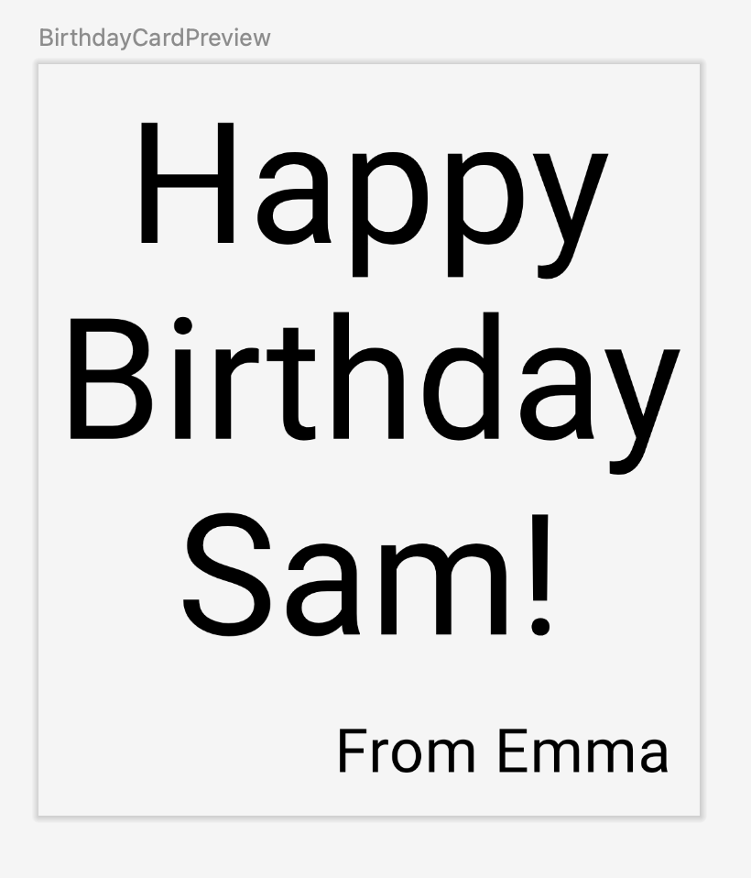

Adopt good practice

It is a good practice to pass the modifier attribute(s) along with the modifier from the parent composable. Update the modifier parameter in the GreetingText() as follows:

**onCreate()**

Surface(  
    //...  
) {  
    GreetingText(message = "Happy Birthday Sam!", from = "From Emma")  
}

**GreetingText()**

@Composable  
fun GreetingText(message: String, from: String, modifier: Modifier = Modifier) {  
   Column(  
       verticalArrangement = Arrangement.Center,  
       modifier = modifier  
   ) {  
       //...  
   }  
}

Build and run your app on the emulator to see the final result.

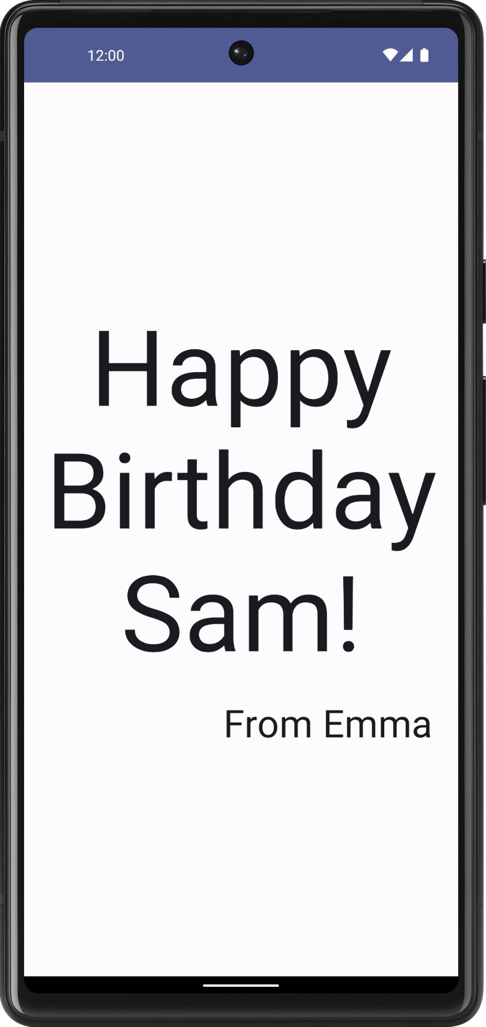

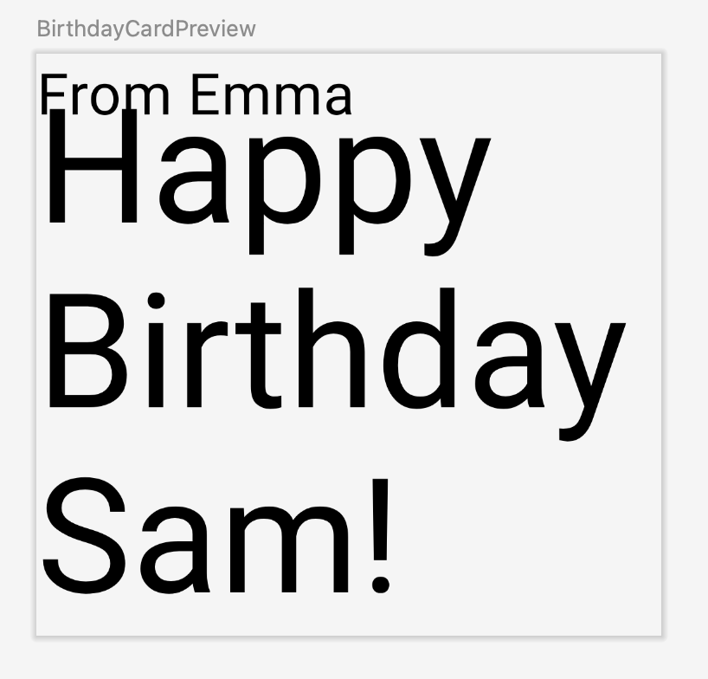

A composable function might describe several UI elements. However, if you don't provide guidance on how to arrange them, Compose might arrange the elements in a way that you don't like. For example, the previous code generates two text elements that overlap each other because there's no guidance on how to arrange the two composables.

In your next task, you will learn how to arrange the composables in a row and in a column.

## [10. Get the solution code](https://developer.android.com/codelabs/basic-android-kotlin-compose-text-composables?continue=https%3A%2F%2Fdeveloper.android.com%2Fcourses%2Fpathways%2Fandroid-basics-compose-unit-1-pathway-3%23codelab-https%3A%2F%2Fdeveloper.android.com%2Fcodelabs%2Fbasic-android-kotlin-compose-text-composables#9)

The completed MainActivity.kt:

package com.example.happybirthday  
  
import android.os.Bundle  
import androidx.activity.ComponentActivity  
import androidx.activity.compose.setContent  
import androidx.compose.foundation.layout.Arrangement  
import androidx.compose.foundation.layout.Column  
import androidx.compose.foundation.layout.fillMaxSize  
import androidx.compose.foundation.layout.padding  
import androidx.compose.material3.MaterialTheme  
import androidx.compose.material3.Surface  
import androidx.compose.material3.Text  
import androidx.compose.runtime.Composable  
import androidx.compose.ui.Alignment  
import androidx.compose.ui.Modifier  
import androidx.compose.ui.res.stringResource  
import androidx.compose.ui.text.style.TextAlign  
import androidx.compose.ui.tooling.preview.Preview  
import androidx.compose.ui.unit.dp  
import androidx.compose.ui.unit.sp  
import com.example.happybirthday.ui.theme.HappyBirthdayTheme  
  
class MainActivity : ComponentActivity() {  
   override fun onCreate(savedInstanceState: Bundle?) {  
       super.onCreate(savedInstanceState)  
       setContent {  
           HappyBirthdayTheme {  
               // A surface container using the 'background' color from the theme  
               Surface(  
                   modifier = Modifier.fillMaxSize(),  
                   color = MaterialTheme.colorScheme.background  
               ) {  
                   GreetingText(message = "Happy Birthday Sam!", from = "From Emma")  
               }  
           }  
       }  
   }  
}  
  
@Composable  
fun GreetingText(message: String, from: String, modifier: Modifier = Modifier) {  
   // Create a column so that texts don't overlap  
   Column(  
       verticalArrangement = Arrangement.Center,  
       modifier = modifier  
   ) {  
       Text(  
           text = message,  
           fontSize = 100.sp,  
           lineHeight = 116.sp,  
           textAlign = TextAlign.Center  
       )  
       Text(  
           text = from,  
           fontSize = 36.sp,  
           modifier = Modifier  
               .padding(16.dp)  
               .align(alignment = Alignment.End)  
       )  
   }  
}  
  
@Preview(showBackground = true)  
@Composable  
fun BirthdayCardPreview() {  
    HappyBirthdayTheme {  
        GreetingText(message = "Happy Birthday Sam!", from ="From Emma")  
    }  
}

[11. Conclusion](https://developer.android.com/codelabs/basic-android-kotlin-compose-text-composables?continue=https%3A%2F%2Fdeveloper.android.com%2Fcourses%2Fpathways%2Fandroid-basics-compose-unit-1-pathway-3%23codelab-https%3A%2F%2Fdeveloper.android.com%2Fcodelabs%2Fbasic-android-kotlin-compose-text-composables#10)

You created your Happy Birthday app.

In the next codelab, you add a picture to your app, and change the alignment of the text elements to beautify it.

Summary

* Jetpack Compose is a modern toolkit for building Android UI. Jetpack Compose simplifies and accelerates UI development on Android with less code, powerful tools, and intuitive Kotlin APIs.
* The user interface (UI) of an app is what you see on the screen: text, images, buttons, and many other types of elements.
* Composable functions are the basic building block of Compose. A composable function is a function that describes some part of your UI.
* The Composable function is annotated with the @Composable annotation; this annotation informs the Compose compiler that this function is intended to convert data into UI.
* The three basic standard layout elements in Compose are Column, Row, and Box. They are Composable functions that take Composable content, so you can place items inside. For example, each child within a Row will be placed horizontally next to each other.

Learn more

* [Composable](https://developer.android.com/reference/kotlin/androidx/compose/runtime/Composable)
* [Compose layout basics](https://developer.android.com/jetpack/compose/layouts/basics)
* [Pixel density](https://m3.material.io/design/layout/pixel-density.html#pixel-density)
* [Text in Compose](https://developer.android.com/jetpack/compose/text)
* [Kotlin for Jetpack Compose](https://developer.android.com/jetpack/compose/kotlin)

Add images to your Android app

[1. Before you begin](https://developer.android.com/codelabs/basic-android-kotlin-compose-add-images?continue=https%3A%2F%2Fdeveloper.android.com%2Fcourses%2Fpathways%2Fandroid-basics-compose-unit-1-pathway-3%23codelab-https%3A%2F%2Fdeveloper.android.com%2Fcodelabs%2Fbasic-android-kotlin-compose-add-images#0)

In this codelab, you learn how to add images to your app using an Image composable.

Prerequisites

* Basic knowledge of how to create and run an app in Android Studio.
* Basic knowledge of how to add UI elements, such as text composables.

What you'll learn

* How to add an image or photo to your Android app.
* How to display an image in your app with an Image composable.
* Best practices using String resources.

What you'll build

* Enhance the **Happy Birthday** app to include an image.

What you'll need

* A computer with Android Studio installed.
* The app from the [Build a simple app with text composables](https://developer.android.com/codelabs/basic-android-kotlin-compose-text-composables) codelab.

[2. Set up your app](https://developer.android.com/codelabs/basic-android-kotlin-compose-add-images?continue=https%3A%2F%2Fdeveloper.android.com%2Fcourses%2Fpathways%2Fandroid-basics-compose-unit-1-pathway-3%23codelab-https%3A%2F%2Fdeveloper.android.com%2Fcodelabs%2Fbasic-android-kotlin-compose-add-images#1)

Open your Happy Birthday project from the previous codelab in Android Studio.

When you run the app, it should look like this screenshot.

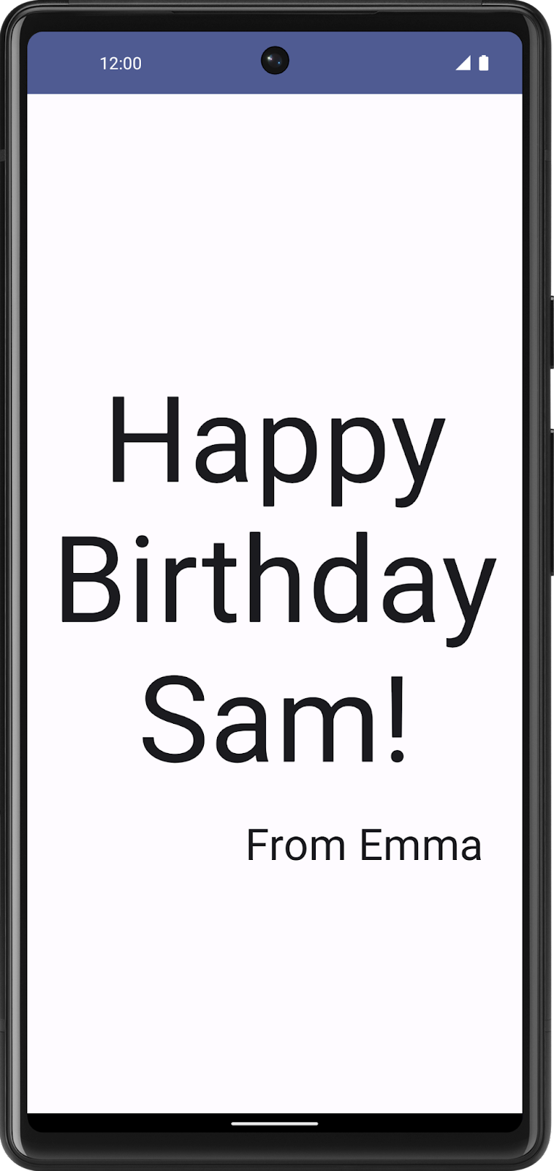

Add an image to your project

In this task, you'll download an image from the internet and add it to your **Happy Birthday** app.

1. Open the image for your birthday card app from this [link](https://github.com/google-developer-training/basic-android-kotlin-compose-birthday-card-app/blob/main/app/src/main/res/drawable-nodpi/androidparty.png).
2. Click **Download**.

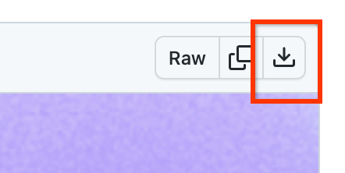

1. Right-click the image and then save the file to your computer as androidparty.png.
2. Make note of where you saved the image.

For example, you may have saved it in your **Downloads** folder.

1. In Android Studio, click **View > Tool Windows > Resource Manager** or click the **Resource Manager** tab next to the **Project** window.

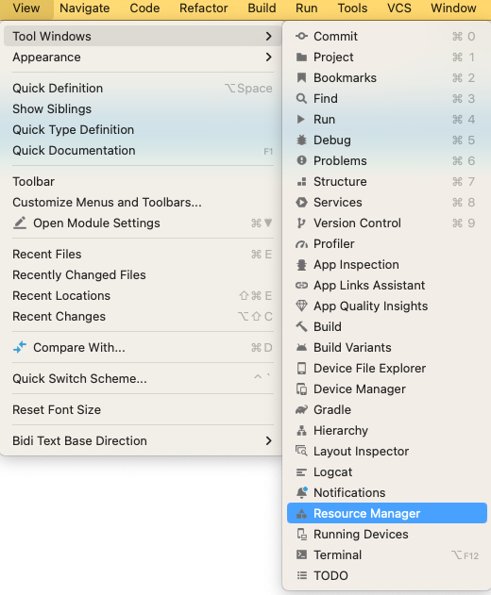

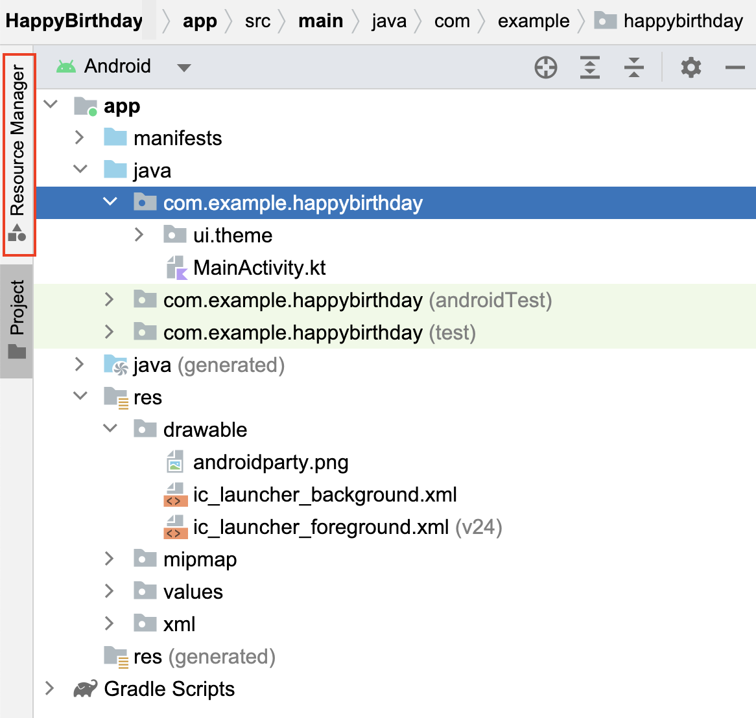

**Note**: Resource Manager is a tool window that lets you import, create, manage, and use resources in your app.

1. Click **+ (Add resources to the module) > Import Drawables**.

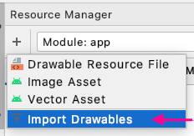

1. In the file browser, select the image file that you downloaded and then click **Open**.

This action opens the **Import drawables** dialog.

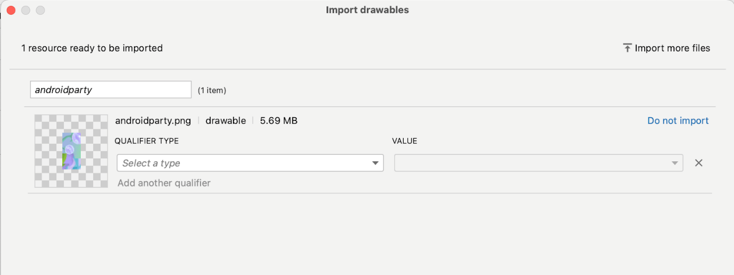

1. Android Studio shows you a preview of the image. Select **Density** from the **QUALIFIER TYPE** drop-down list. You'll learn why you're doing this, in a later section.

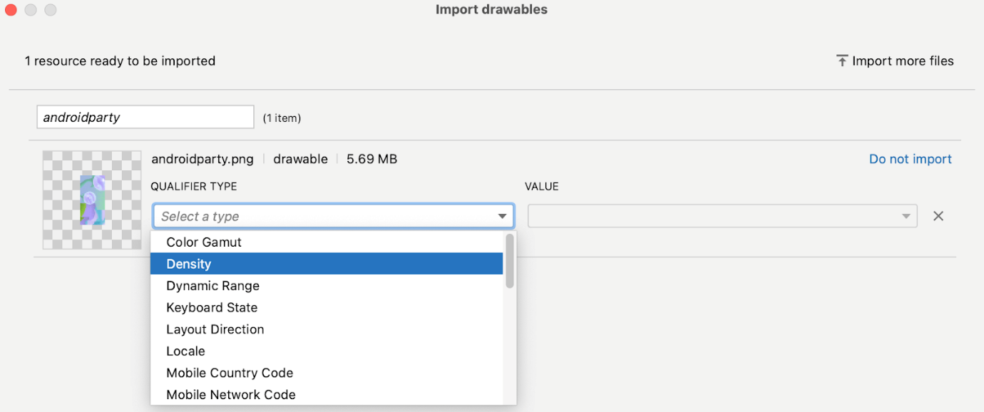

1. Select **No Density** from the **VALUE** list.

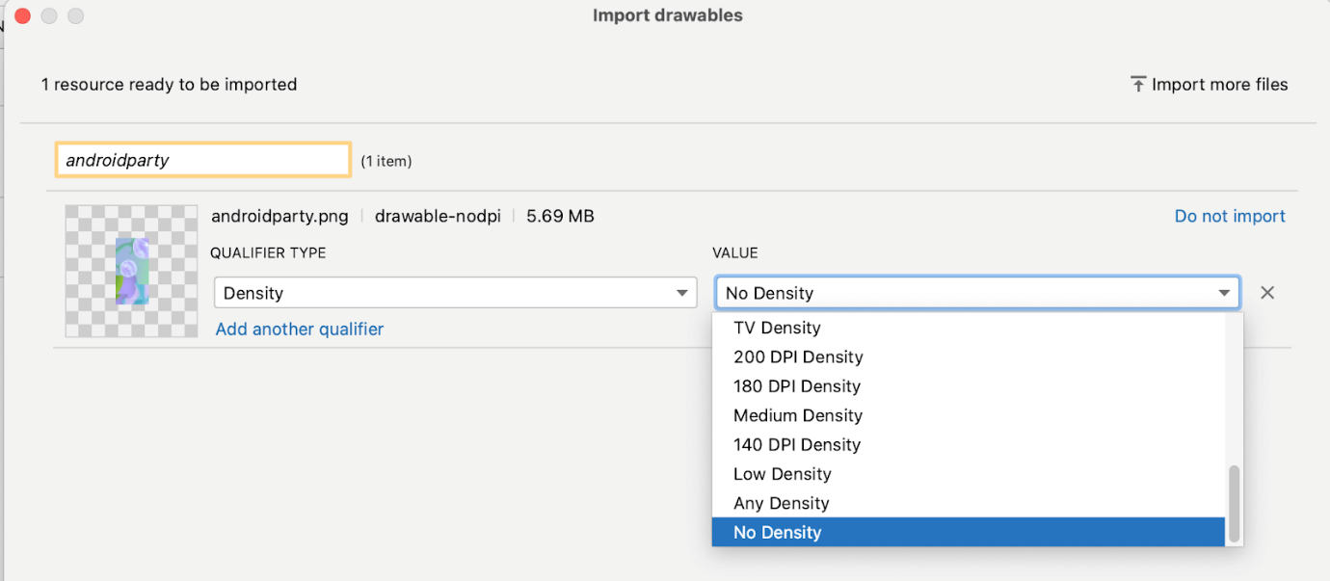

Android devices come in different screen sizes (phones, tablets, and TVs to name a few), and their screens also have different pixel sizes. That is, while one device has 160 pixels per square inch, another device fits 480 pixels in the same space. If you don't consider these variations in pixel density, the system might scale your images, which could result in blurry images, or large images that consume too much memory, or images that are sized improperly.

When you resize images that are larger than the Android system can handle, an out-of-memory error is thrown. For photographs and background images, such as the current image, the androidparty.png, you should place them in the drawable-nodpi folder, which stops the resizing behavior.

For more information about pixel densities, see [Support different pixel densities](https://developer.android.com/training/multiscreen/screendensities).

1. Click **Next**.
2. Android Studio shows you the folder structure in which your image will be placed. Notice the drawable-nodpi folder.
3. Click **Import(C)**.

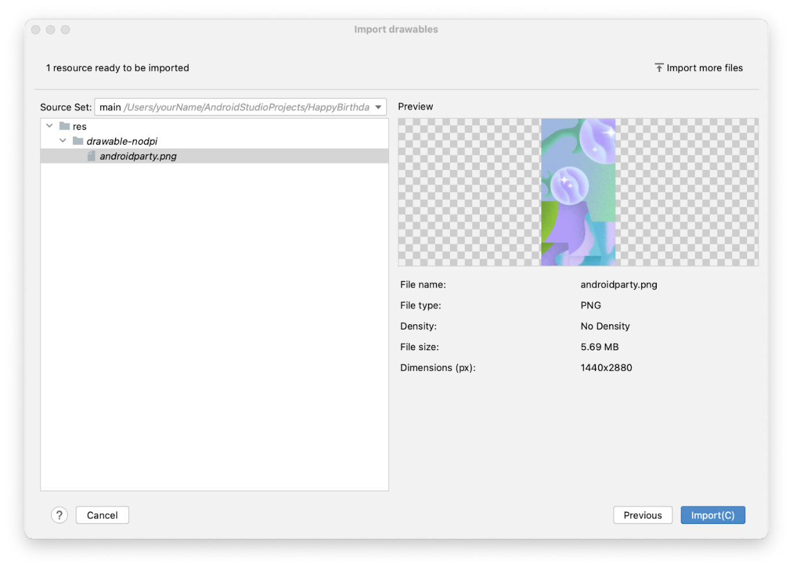

Android Studio creates a drawable-nodpi folder and places your image in it. In the Android Studio project view, the resource name is displayed as androidparty.png (nodpi). In the computer file system, Android Studio would have created a folder called drawable-nodpi.

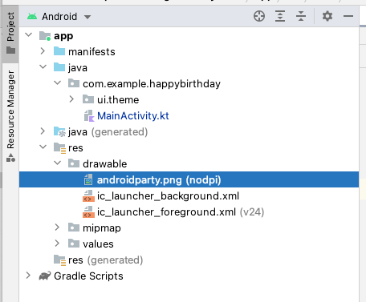

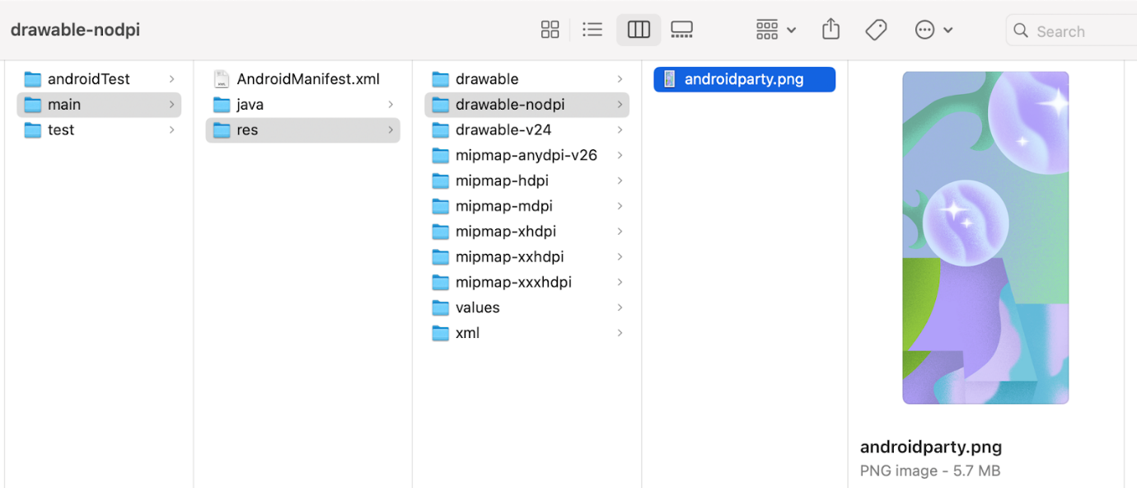

If the image is imported successfully, Android Studio adds the image to the list under the **Drawable** tab. This list includes all your images and icons for the app. You can now use this image in your app.

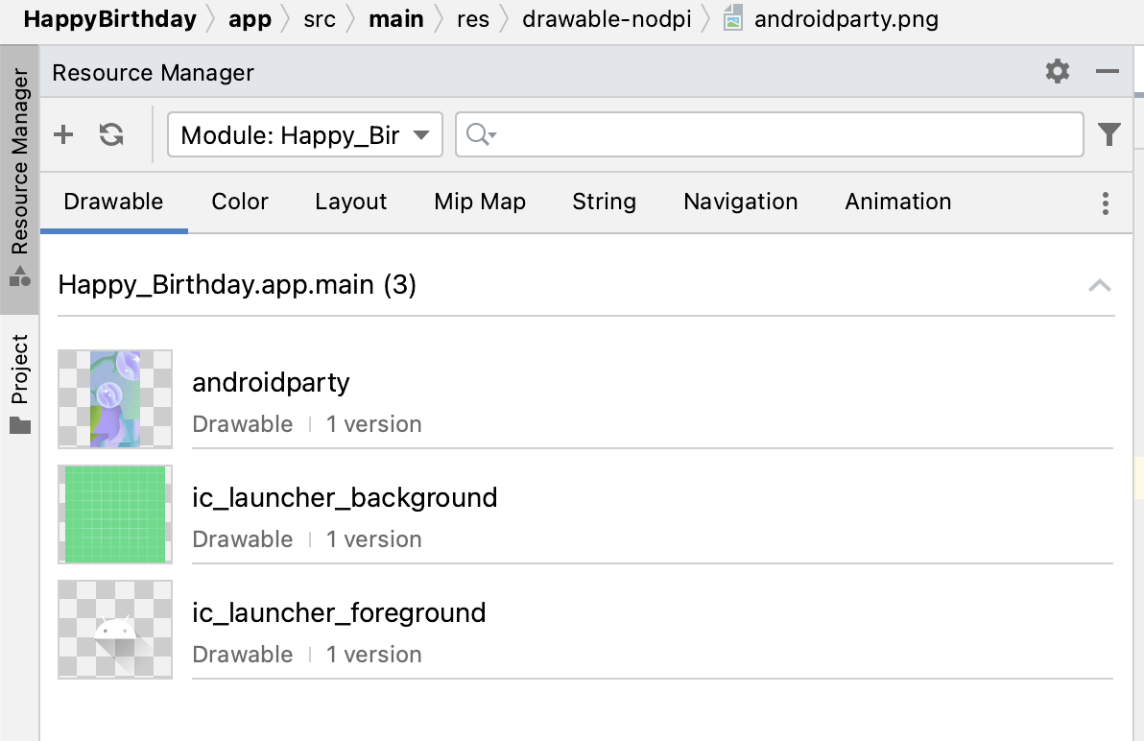

1. Switch back to the project view, click **View > Tool Windows > Project** or click the **Project** tab on the far left.
2. Click **app > res > drawable** to confirm that the image is in the drawable folder.

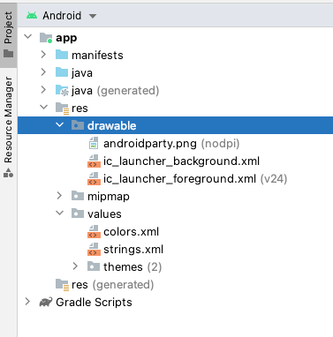

[3. Add an Image composable](https://developer.android.com/codelabs/basic-android-kotlin-compose-add-images?continue=https%3A%2F%2Fdeveloper.android.com%2Fcourses%2Fpathways%2Fandroid-basics-compose-unit-1-pathway-3%23codelab-https%3A%2F%2Fdeveloper.android.com%2Fcodelabs%2Fbasic-android-kotlin-compose-add-images#2)

To display an image in your app, it needs a place to be displayed. Just like you use a Text composable to display text, you can use an Image composable to display an image.

In this task, you add an Image composable to your app, set its image to the image that you downloaded, position it and adjust its size so that it fills the screen.

Add a composable function to add an image

1. In the MainActivity.kt file, add a GreetingImage() composable function after the GreetingText() function.
2. Pass the GreetingImage() function two String parameters: one called message for the birthday greeting and the other called from for your signature.

@Composable  
fun GreetingImage(message: String, from: String) {  
}

1. Every composable function should accept an optional Modifier parameter. Modifiers tell a UI element how to lay out, display, or behave within its parent layout. Add another parameter at the GreetingImage() composable.

@Composable  
fun GreetingImage(message: String, from: String, modifier: Modifier = Modifier) {  
}

Resources in Jetpack Compose

Resources are the additional files and static content that your code uses, such as bitmaps, user-interface strings, animation instructions, and more. For more information about resources in Android, see [App resources overview](https://developer.android.com/guide/topics/resources/providing-resources).

You should always separate app resources, such as images and strings, from your code so that you can maintain them independently. At runtime, Android uses the appropriate resource based on the current configuration. For example, you might want to provide a different UI layout based on the screen size or different strings based on the language setting.

Grouping resources

You should always place each type of resource in a specific subdirectory of your project's res/ directory. For example, here's the file hierarchy for a simple project:

MyProject/  
    src/  
        MyActivity.kt  
    res/  
        drawable/  
            graphic.png  
        mipmap/  
            icon.png  
        values/  
            strings.xml

As you can see in this example, the res/ directory contains all the resources in subdirectories, which includes a drawable/ directory for an image resource, a mipmap/ directory for launcher icons, and a values/ directory for string resources. To learn more about the usage, format, and syntax for app resources, see [Resource types overview](https://developer.android.com/guide/topics/resources/available-resources).

Accessing resources

Jetpack Compose can access the resources defined in your Android project. Resources can be accessed with resource IDs that are generated in your project's R class.

An R class is an automatically generated class by Android that contains the IDs of all resources in the project. In most cases, the resource ID is the same as the filename. For example, the image in the previous file hierarchy can be accessed with this code:

R.drawable.graphic

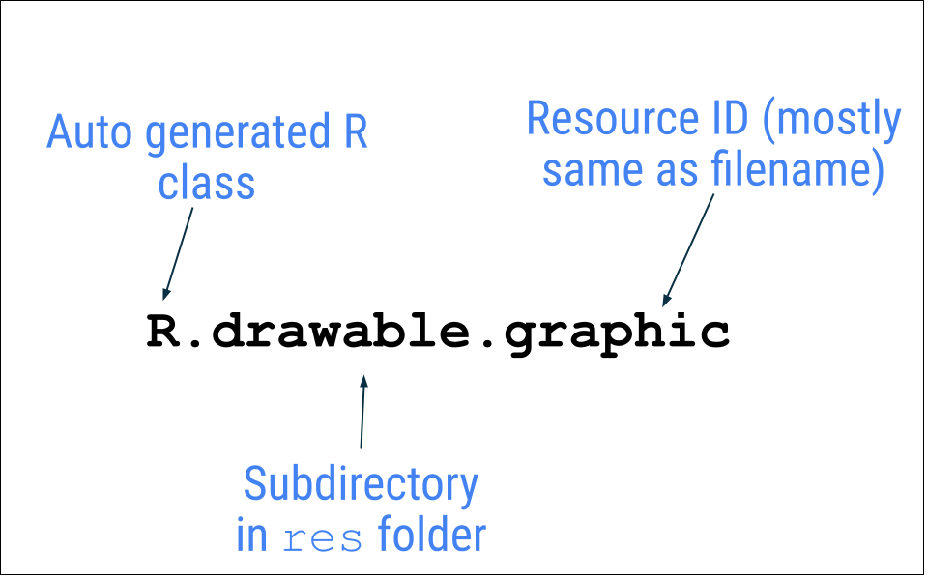

In the next task, you use the image, androidparty.png file, which you added in the previous task.

1. In the GreetingImage() function, declare a val property and name it image.
2. Make a call to [painterResource()](https://developer.android.com/reference/kotlin/androidx/compose/ui/res/package-summary" \l "painterResource(kotlin.Int)" \t "_blank) function by passing in the androidparty resource. Assign the returned value to the image variable.

val image = painterResource(R.drawable.androidparty)

The [painterResource()](https://developer.android.com/reference/kotlin/androidx/compose/ui/res/package-summary" \l "painterResource(kotlin.Int)" \t "_blank) function loads a drawable image resource, and takes resource ID (R.drawable.androidparty in this case) as an argument.

1. After the call to the [painterResource()](https://developer.android.com/reference/kotlin/androidx/compose/ui/res/package-summary" \l "painterResource(kotlin.Int)" \t "_blank) function, add an Image composable and then pass in the image as a named argument for the painter.

Image(  
   painter = image  
)

Android Studio displays an error that says that, "None of the following functions can be called with the arguments supplied." the arguments don't match the function signature. You can see the error when you hover over the Image composable. The reason for this error is that the arguments you are passing in the Image() composable function are not sufficient and do not match the function signature.

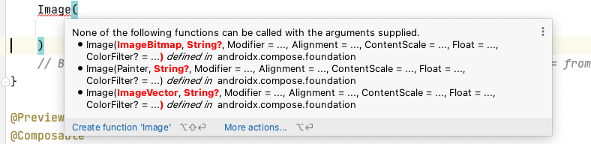

To fix the error, please include the following import, at the top of your MainActivity.kt file:

import androidx.compose.foundation.Image

Check your app for accessibility

When you follow coding practices for accessibility, you let all of your users, including those with [disabilities](https://developer.android.com/guide/topics/ui/accessibility), more easily navigate, and interact with, your app.

**Note:** Android provides many tools for users. For example, [TalkBack](https://support.google.com/accessibility/android/answer/6283677" \t "_blank) is the Google screen reader included on Android devices. TalkBack gives users spoken feedback so that users can use their device without looking at the screen. To learn more about accessibility, see [Build accessible apps](https://developer.android.com/guide/topics/ui/accessibility/).

Android Studio provides hints and warnings to help you make your app more accessible. A content description defines the purpose of a UI element, which makes your app more usable with TalkBack.

However, the image in this app is only included for decorative purposes. The addition of a content description for the image would make it harder to use with TalkBack in this particular case. Instead of setting the content description that's announced to the user, you can set the image's contentDescription argument to null so that TalkBack skips the Image composable.

* In the Image composable, add another named argument called contentDescription and set its value to null.

Image(  
   painter = image,  
   contentDescription = null  
)

Preview the Image composable

In this task, you preview the image composable and run the app on an emulator or device.

1. In the BirthdayCardPreview() function, replace the GreetingText() function call with a GreetingImage() function call.

Your function should look like this code snippet:

@Preview(showBackground = false)  
@Composable  
fun BirthdayCardPreview() {  
    HappyBirthdayTheme {  
        GreetingImage("Happy Birthday Sam!", "From Emma")  
    }  
}

1. The **Design** pane should auto update, if it doesn't, click  to build.

Notice that you can't see the text anymore because the new function only has an Image composable, but not a Text composable.

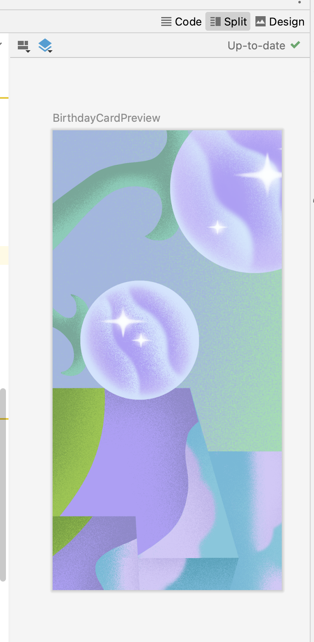

[4. Add Box layout](https://developer.android.com/codelabs/basic-android-kotlin-compose-add-images?continue=https%3A%2F%2Fdeveloper.android.com%2Fcourses%2Fpathways%2Fandroid-basics-compose-unit-1-pathway-3%23codelab-https%3A%2F%2Fdeveloper.android.com%2Fcodelabs%2Fbasic-android-kotlin-compose-add-images#3)

The three basic, standard layout elements in Compose are [Column](https://developer.android.com/reference/kotlin/androidx/compose/foundation/layout/package-summary#Column(androidx.compose.ui.Modifier,androidx.compose.foundation.layout.Arrangement.Vertical,androidx.compose.ui.Alignment.Horizontal,kotlin.Function1)), [Row](https://developer.android.com/reference/kotlin/androidx/compose/foundation/layout/package-summary#Row(androidx.compose.ui.Modifier,androidx.compose.foundation.layout.Arrangement.Horizontal,androidx.compose.ui.Alignment.Vertical,kotlin.Function1)), and [Box](https://developer.android.com/reference/kotlin/androidx/compose/foundation/layout/package-summary#Box(androidx.compose.ui.Modifier,androidx.compose.ui.Alignment,kotlin.Boolean,kotlin.Function1)) composables. You have learned about [Column](https://developer.android.com/reference/kotlin/androidx/compose/foundation/layout/package-summary#Column(androidx.compose.ui.Modifier,androidx.compose.foundation.layout.Arrangement.Vertical,androidx.compose.ui.Alignment.Horizontal,kotlin.Function1)) and [Row](https://developer.android.com/reference/kotlin/androidx/compose/foundation/layout/package-summary#Row(androidx.compose.ui.Modifier,androidx.compose.foundation.layout.Arrangement.Horizontal,androidx.compose.ui.Alignment.Vertical,kotlin.Function1)) composables in the previous codelabs, now you will explore more about the Box composable.

[Box](https://developer.android.com/reference/kotlin/androidx/compose/foundation/layout/package-summary#Box(androidx.compose.ui.Modifier,androidx.compose.ui.Alignment,kotlin.Boolean,kotlin.Function1)) layout is one of the standard layout elements in Compose. Use Box layout to stack elements on top of one another. Box layout also lets you configure the specific alignment of the elements that it contains.

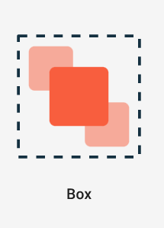

1. In the GreetingImage() function, add a Box composable around the Image composable as shown:

@Composable  
fun GreetingImage(message: String, from: String, modifier: Modifier = Modifier) {  
    val image = painterResource(R.drawable.androidparty)  
    //Step 3 create a box to overlap image and texts  
    Box {  
        Image(  
            painter = image,  
            contentDescription = null  
        )  
    }  
}

1. At the end of the Box composable, call the GreetingText() function, and pass it the birthday message, signature and the modifier as shown:

@Composable  
fun GreetingImage(message: String, from: String, modifier: Modifier = Modifier) {  
    val image = painterResource(R.drawable.androidparty)  
    //Step 3 create a box to overlap image and texts  
    Box {  
        Image(  
            painter = image,  
            contentDescription = null  
        )  
        GreetingText(  
            message = message,  
            from = from,  
            modifier = Modifier  
                .fillMaxSize()  
                .padding(8.dp)  
        )  
    }  
}

1. Notice the updated preview in the **Design** pane.

You should see the text and image.

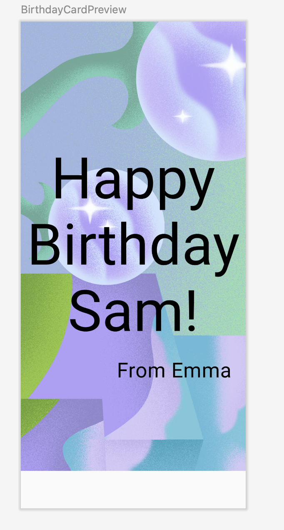

1. To make the above changes reflect in the emulator or a device, in the onCreate() function, replace the GreetingText() function call with a GreetingImage() function call.

Your setContent block should look like this code snippet:

setContent {  
    HappyBirthdayTheme {  
       // A surface container using the 'background' color from the theme  
        Surface(color = MaterialTheme.colors.background) {  
            GreetingImage("Happy Birthday Sam!", "From Emma")  
        }  
    }  
}

Notice that the image is as wide as the screen, but the image is anchored to the top of the screen. There's a whitespace at the bottom of the screen that doesn't look very attractive. In your next task, you will fill the width and height of the screen, and scale the image to fill the entire screen.

[5. Change opacity and scale the image](https://developer.android.com/codelabs/basic-android-kotlin-compose-add-images?continue=https%3A%2F%2Fdeveloper.android.com%2Fcourses%2Fpathways%2Fandroid-basics-compose-unit-1-pathway-3%23codelab-https%3A%2F%2Fdeveloper.android.com%2Fcodelabs%2Fbasic-android-kotlin-compose-add-images#4)

In this task, you make the image full screen to beautify your app. To achieve this you use the ContentScale parameters.

Scale content

You have added the image to your app and positioned the image. Now, you need to adjust the scale type of the image, which says how to size the image, to make it fullscreen.

There are quite a few [ContentScale](https://developer.android.com/reference/kotlin/androidx/compose/ui/layout/ContentScale" \t "_blank) [types](https://developer.android.com/jetpack/compose/graphics/images/customize#content-scale) available. You use the ContentScale.Crop parameter scaling, which scales the image uniformly to maintain the aspect ratio so that the width and height of the image are equal to, or larger than, the corresponding dimension of the screen.

1. Add a ContentScale named argument to the image.

Image(  
    painter = image,  
    contentDescription = null,  
    contentScale = ContentScale.Crop  
)

1. Import the androidx.compose.ui.layout.ContentScale interface when prompted by Android Studio.
2. Check out the **Design** pane.

The image should now fill the entire preview screen as you can see in this screenshot:

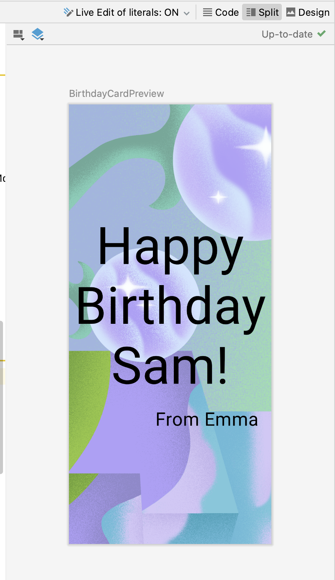

Change opacity

To improve the app's contrast, change the opacity of the background image.

Add alpha parameter to the Image composable and set it to 0.5F.

Image(  
   painter = image,  
   contentDescription = null,  
   contentScale = ContentScale.Crop,  
   alpha = 0.5F  
)

Notice the change in image opacity.

|  |  |
| --- | --- |
|  |  |

That's a lot of code! It's time to preview all your hard work.

Run the app

Run the app on a device or emulator.

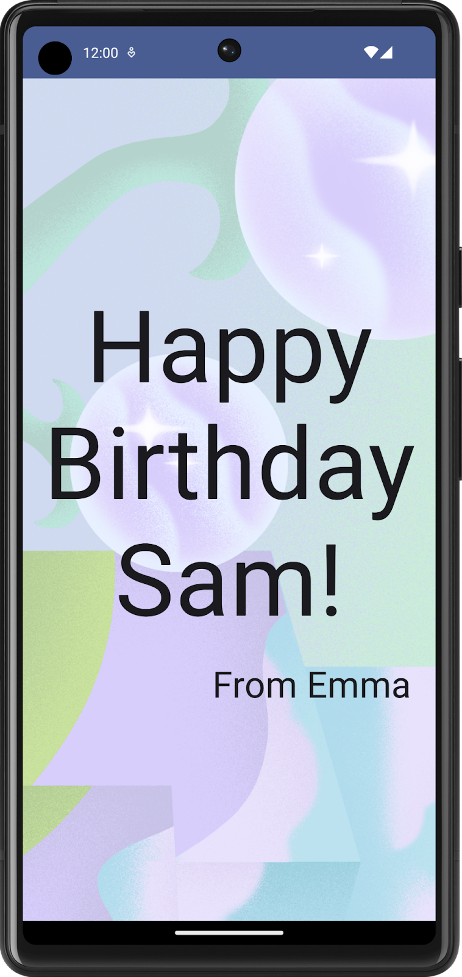

Good job with the full-screen image and text message. You have also changed the opacity of the image.

Layout Modifiers

Modifiers are used to decorate or add behavior to Jetpack Compose UI elements. For example, you can add backgrounds, padding or behavior to rows, text, or buttons. To set them, a composable or a layout needs to accept a modifier as a parameter.

In a previous codelab, you learned about modifiers and used the padding modifier (Modifier.padding) to add space around Text composable. Modifiers can do a lot and you will see that in this and upcoming pathways.

For example, this Text composable has a Modifier argument that changes the background color to green.

//Example  
Text(  
    text = "Hello, World!",  
    // Solid element background color  
    modifier = Modifier.background(color = Color.Green)   
)

Similar to the above example, you can add Modifiers to layouts to position the child elements using arrangement and alignment properties.

To set children's position within a [Row](https://developer.android.com/reference/kotlin/androidx/compose/foundation/layout/package-summary#Row(androidx.compose.ui.Modifier,androidx.compose.foundation.layout.Arrangement.Horizontal,androidx.compose.ui.Alignment.Vertical,kotlin.Function1)), set the horizontalArrangement and verticalAlignment arguments. For a [Column](https://developer.android.com/reference/kotlin/androidx/compose/foundation/layout/package-summary#Column(androidx.compose.ui.Modifier,androidx.compose.foundation.layout.Arrangement.Vertical,androidx.compose.ui.Alignment.Horizontal,kotlin.Function1)), set the verticalArrangement and horizontalAlignment arguments.

The arrangement property is used to arrange the child elements when the size of the layout is larger than the sum of its children.

For example: when the size of the [Column](https://developer.android.com/reference/kotlin/androidx/compose/foundation/layout/package-summary#Column(androidx.compose.ui.Modifier,androidx.compose.foundation.layout.Arrangement.Vertical,androidx.compose.ui.Alignment.Horizontal,kotlin.Function1)) is larger than the sum of its children sizes, a [verticalArrangement](https://developer.android.com/reference/kotlin/androidx/compose/foundation/layout/package-summary" \l "Column(androidx.compose.ui.Modifier,androidx.compose.foundation.layout.Arrangement.Vertical,androidx.compose.ui.Alignment.Horizontal,kotlin.Function1)" \t "_blank) can be specified to define the positioning of the children inside the Column. Below is an illustration of different vertical arrangements:



Similarly, when the size of the [Row](https://developer.android.com/reference/kotlin/androidx/compose/foundation/layout/package-summary#Row(androidx.compose.ui.Modifier,androidx.compose.foundation.layout.Arrangement.Horizontal,androidx.compose.ui.Alignment.Vertical,kotlin.Function1)) is larger than the sum of its children sizes, a horizontalArrangement can be specified to define the positioning of the children inside the Row. Below is an illustration of different horizontal arrangements:



The alignment property is used to align the child elements at the start, center, or end of layout.

[6. Align and arrange the text](https://developer.android.com/codelabs/basic-android-kotlin-compose-add-images?continue=https%3A%2F%2Fdeveloper.android.com%2Fcourses%2Fpathways%2Fandroid-basics-compose-unit-1-pathway-3%23codelab-https%3A%2F%2Fdeveloper.android.com%2Fcodelabs%2Fbasic-android-kotlin-compose-add-images#5)

In this task, you will observe the code that you have added in the previous codelab to arrange the text in the app.

1. In the MainActivity.kt file, scroll to the GreetingText() function. The verticalArrangement property in the column is set to Arrangement.Center. The text content will be centered on the screen thus.

@Composable  
fun GreetingText(message: String, from: String, modifier: Modifier = Modifier) {  
    // Create a column so that texts don't overlap  
    Column(  
        verticalArrangement = Arrangement.Center,  
        modifier = modifier  
    ) {  
        Text(  
            text = message,  
            fontSize = 100.sp,  
            lineHeight = 116.sp,  
            textAlign = TextAlign.Center  
        )  
        Text(  
            text = from,  
            fontSize = 36.sp,  
            modifier = Modifier  
                .padding(16.dp)  
                .align(alignment = Alignment.End)  
        )  
    }

Padding

A UI element wraps itself around its content. To prevent it from wrapping too tightly, you can specify the amount of *padding* on each side.

|  |  |
| --- | --- |
| Text composable without padding | Text composable with padding |

Padding is used as a modifier, which means that you can apply it to any composable. For each side of the composable, the padding modifier takes an optional argument that defines the amount of padding.

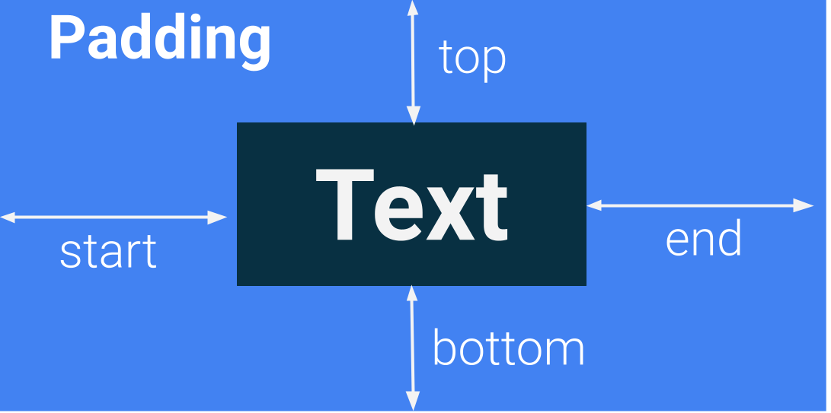

// This is an example.   
Modifier.padding(  
    start = 16.dp,  
    top = 16.dp,  
    end = 16.dp,  
    bottom = 16.dp  
)

1. Your turn! In the MainActivity.kt file, scroll to the GreetingText() function and notice the padding attribute.

modifier = Modifier  
    .fillMaxSize()  
    .padding(8.dp)

1. Similarly notice the padding set to signature.

modifier = Modifier  
   .padding(16.dp)  
   .align(alignment = Alignment.End)

[7. Adopt good code practices](https://developer.android.com/codelabs/basic-android-kotlin-compose-add-images?continue=https%3A%2F%2Fdeveloper.android.com%2Fcourses%2Fpathways%2Fandroid-basics-compose-unit-1-pathway-3%23codelab-https%3A%2F%2Fdeveloper.android.com%2Fcodelabs%2Fbasic-android-kotlin-compose-add-images#6)

Translation

When you write apps, it's important to remember that they may be translated into another language at some point. As you learned in an earlier codelab, a String data type is a sequence of characters, such as "Happy Birthday Sam!".

A *hardcoded* string is one that's written directly in the code of your app. Hardcoded strings make it more difficult to translate your app into other languages and harder to reuse strings in different places in your app. You can extract strings into a resource file to resolve these issues. Instead of hardcoding strings in your code, you put the strings into a file, name the string resources, and use the names whenever you want to use the strings. The name stays the same, even if you change the string or translate it to a different language.

1. In the MainActivity.kt file, scroll to the onCreate() function. Select the birthday greeting, Happy Birthday Sam! string without quotes.
2. Click the bulb on the left side of the screen.
3. Select **Extract string resource**.

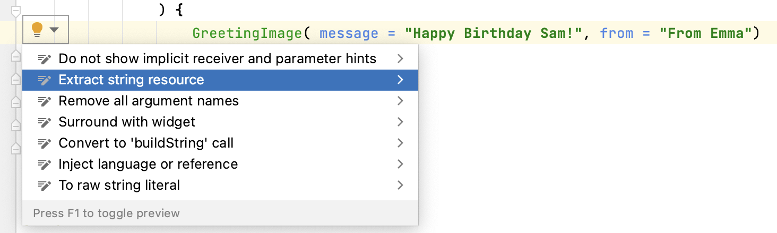

Android Studio opens the **Extract Resource** dialog. In this dialog, you can customize what your string resource is called and some details on how to store it. The **Resource name** field is where you enter what the string is going to be called. The **Resource value** field is where you enter the actual string itself.

1. In the **Extract Resource** dialog, change the **Resource name** to happy\_birthday\_text.

String resources should have lowercase names and multiple words should be separated with an underscore. Leave the other settings with the defaults.

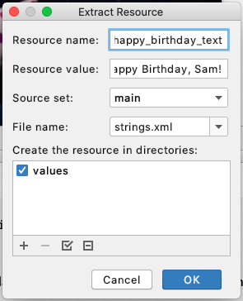

1. Click **OK**.
2. Notice the changes in code.

The hardcoded string is now replaced with a stringResource() function.

HappyBirthdayTheme {  
   // A surface container using the 'background' color from the theme  
   Surface(color = MaterialTheme.colors.background) {  
       GreetingImage( stringResource(R.string.happy\_birthday\_text), "From Emma")  
   }  
}

**Note:** Some Android Studio versions replace the hardcoded string with the getString() function. Please manually change the function to stringResource() in such cases.

1. In the **Project** pane, open the **strings.xml** file from the path app > res > values > strings.xml and notice that Android Studio created a string resource called happy\_birthday\_text.

<resources>  
    <string name="app\_name">Happy Birthday</string>  
    <string name="happy\_birthday\_text">Happy Birthday Sam!</string>  
</resources>

The strings.xml file has a list of strings that the user sees in your app. Note that the name of your app is also a string resource. By putting the strings all in one place, you can more easily translate all the text in your app and more easily reuse a string in different parts of your app.

1. Follow the same steps to extract the text for the signature Text composable, but this time enter signature\_text in the **Resource name** field.

Your finished file should look like this code snippet:

<resources>  
    <string name="app\_name">Happy Birthday</string>  
    <string name="happy\_birthday\_text">Happy Birthday Sam!</string>  
    <string name="signature\_text">From Emma</string>  
</resources>

1. Update the BirthdayCardPreview() to use stringResource() and the extracted strings.

@Preview(showBackground = false)  
@Composable  
private fun BirthdayCardPreview() {  
   HappyBirthdayTheme {  
       GreetingImage( stringResource(R.string.happy\_birthday\_text),  
           stringResource(R.string.signature\_text))  
   }  
}

1. Run your app again to make sure that it still works.

[8. Try this challenge](https://developer.android.com/codelabs/basic-android-kotlin-compose-add-images?continue=https%3A%2F%2Fdeveloper.android.com%2Fcourses%2Fpathways%2Fandroid-basics-compose-unit-1-pathway-3%23codelab-https%3A%2F%2Fdeveloper.android.com%2Fcodelabs%2Fbasic-android-kotlin-compose-add-images#7)

Good job on adding the image to your app. Here's a challenge for you:

1. Arrange or align the signature text composable so that it is aligned to the center of the screen.

Here's a hint: Compose offers the align modifier to position a child composable individually, defying the alignment layout rules enforced by the parent layout. Chain the .align(alignment = Alignment.CenterHorizontally) argument with the text composable Modifier.

Your app should look something like this:

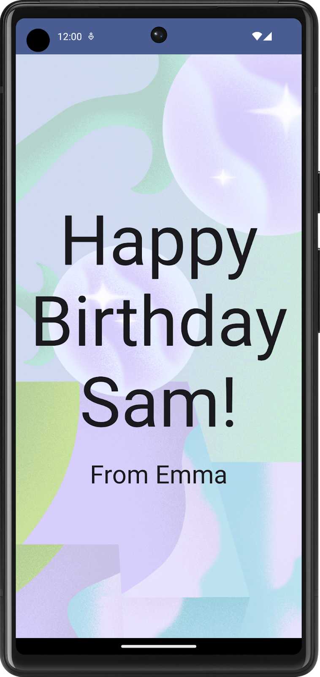

Here's the solution code for the GreetingText() function for your reference:

@Composable  
fun GreetingText(message: String, from: String, modifier: Modifier = Modifier) {  
   // Create a column so that texts don't overlap  
   Column(  
       verticalArrangement = Arrangement.Center,  
       modifier = modifier  
   ) {  
       Text(  
           text = message,  
           fontSize = 100.sp,  
           lineHeight = 116.sp,  
           textAlign = TextAlign.Center  
       )  
       Text(  
           text = from,  
           fontSize = 36.sp,  
           modifier = Modifier  
               .padding(16.dp)  
               .align(alignment = Alignment.CenterHorizontally)  
       )  
   }  
}

## [9. Get the solution code](https://developer.android.com/codelabs/basic-android-kotlin-compose-add-images?continue=https%3A%2F%2Fdeveloper.android.com%2Fcourses%2Fpathways%2Fandroid-basics-compose-unit-1-pathway-3%23codelab-https%3A%2F%2Fdeveloper.android.com%2Fcodelabs%2Fbasic-android-kotlin-compose-add-images#8)

The solution code for the **Happy Birthday** app is on GitHub.

GitHub is a service that lets developers manage code for their software projects. It uses Git, a version-control system that tracks changes made for each version of the code. If you've ever seen the version history of a document in [Google Docs](https://www.google.com/docs/about/), you can see what edits were made and when they were made. Similarly, you can track the version history of the code in a project. This is helpful when you work on a project as an individual or with a team.

GitHub also has a website that lets you view and manage your project. This GitHub link lets you browse the Happy Birthday project files online or download them on your computer.

To download the code for the finished codelab, you can use this git command:

$ git clone https://github.com/google-developer-training/basic-android-kotlin-compose-birthday-card-app.git

Alternatively, you can download the repository as a zip file, unzip it, and open it in Android Studio.

[file\_downloadDownload zip](https://github.com/google-developer-training/basic-android-kotlin-compose-birthday-card-app/archive/refs/heads/main.zip)

**Note:** The solution code is in the main branch of the downloaded repository.

If you want to see the solution code, [view it on GitHub](https://github.com/google-developer-training/basic-android-kotlin-compose-birthday-card-app).

## Branches in GitHub

Before you understand what a branch is, understand what a repository or repo is. A repository is your whole project (directories and files) that you clone (copy) on your computer. A branch is a version of your repository, or in other words, an independent line of development. As an example, in this course, the starter branch could be a version of your project that you used to build up on during codelab. The main or solution branch is the version of your project at the end of your codelab, containing the complete solution code.

A repository can contain multiple branches, which means there are multiple versions of the code in the repository.

[10. Conclusion](https://developer.android.com/codelabs/basic-android-kotlin-compose-add-images?continue=https%3A%2F%2Fdeveloper.android.com%2Fcourses%2Fpathways%2Fandroid-basics-compose-unit-1-pathway-3%23codelab-https%3A%2F%2Fdeveloper.android.com%2Fcodelabs%2Fbasic-android-kotlin-compose-add-images#9)

You added an image to your **Happy Birthday** app, aligned the text with modifiers, followed the accessibility guidelines, and made it easier to translate to other languages! More importantly, you finished creating your own **Happy Birthday** app! Share your work on social media, and use the hashtag **#AndroidBasics** so we can see it!

Summary

* The **Resource Manager** tab in Android Studio helps you add and organize your images and other resources.
* An Image composable is a UI element that displays images in your app.
* An Image composable should have a content description to make your app more accessible.
* Text that's shown to the user, such as the birthday greeting, should be extracted into a string resource to make it easier to translate your app into other languages.

Learn more

* [Vocabulary for Android Basics in Kotlin](https://developer.android.com/courses/android-basics-kotlin/android-basics-kotlin-vocab)
* [Manage your app's UI resources with Resource Manager](https://developer.android.com/studio/write/resource-manager)
* [Build more accessible apps](https://developer.android.com/guide/topics/ui/accessibility)
* [Support different languages and cultures](https://developer.android.com/training/basics/supporting-devices/languages)
* [Getting started with GitHub](https://help.github.com/en/github/getting-started-with-github)

Practice:

Compose Basics

[1. Before you begin](https://developer.android.com/codelabs/basic-android-kotlin-compose-composables-practice-problems?continue=https%3A%2F%2Fdeveloper.android.com%2Fcourses%2Fpathways%2Fandroid-basics-compose-unit-1-pathway-3%23codelab-https%3A%2F%2Fdeveloper.android.com%2Fcodelabs%2Fbasic-android-kotlin-compose-composables-practice-problems#0)

Congratulations! You built your first app and acquired knowledge of the basics of Jetpack Compose. Now you're ready to put what you learned into practice.

These exercises focus on how to build apps with the UI composables that you learned. The exercises are inspired by real-world use cases, some of which you probably encountered before.

These exercises provide you with resources that you need for implementation, such as images and strings. The string resources contain the text that's displayed in the UI. You add these strings to the strings.xml file and use them in your code.

Additionally, the exercises provide you with a set of specifications, such as font size, to use for the text content or padding around the UI components. These specifications help you build consistent UIs and often guide developers to visualize and build the screens. You might encounter similar specifications when you work with a team for an organization.

Some exercises might require you to use a Modifier. In such cases, see the **References** section available for each problem, where you can find links to documentation related to the modifiers or properties. You can read the documentation and determine how to incorporate the concepts in the app. The ability to comprehend documentation is one of the important skills that you should develop to grow your knowledge.

The solution code is available at the end, but try to solve the exercises before you check the answers. Consider the solutions as one way to implement the app. The solution code uses the basic composables and concepts that you learned so far. There's a lot of room for improvement, so feel free to experiment and try different things.

Work through the problems at a pace that's comfortable to you. You're encouraged to take as much time as you need to solve each problem thoughtfully.

Lastly, you should use Android Studio to create separate projects for these exercises.

Prerequisites

* Complete [Build a simple app with text composables codelab](https://developer.android.com/codelabs/basic-android-kotlin-compose-text-composables#0).
* Complete [Add images to your Android app codelab](https://developer.android.com/codelabs/basic-android-kotlin-compose-add-images#0).
* The latest version of Android Studio
* Basic knowledge of the Kotlin programming language
* Ability to create Android projects with default templates in Android Studio.
* Knowledge of different Composable functions, such as the Text, Image, Box, Column, and Row functions
* Knowledge of Modifier classes for UI decoration

What you'll need

* A computer with internet access and Android Studio installed.

[2. Compose article](https://developer.android.com/codelabs/basic-android-kotlin-compose-composables-practice-problems?continue=https%3A%2F%2Fdeveloper.android.com%2Fcourses%2Fpathways%2Fandroid-basics-compose-unit-1-pathway-3%23codelab-https%3A%2F%2Fdeveloper.android.com%2Fcodelabs%2Fbasic-android-kotlin-compose-composables-practice-problems#1)

The Learn Together app displays a list of articles about several Jetpack libraries. Users can choose the topic of their choice and learn about its latest developments.

In this exercise, you build a screen for the app, which displays a tutorial for Jetpack Compose. You use the image and string resources provided in the **Resources** section for this problem.

Final screenshot

After you finish the implementation, your design should match this screenshot:

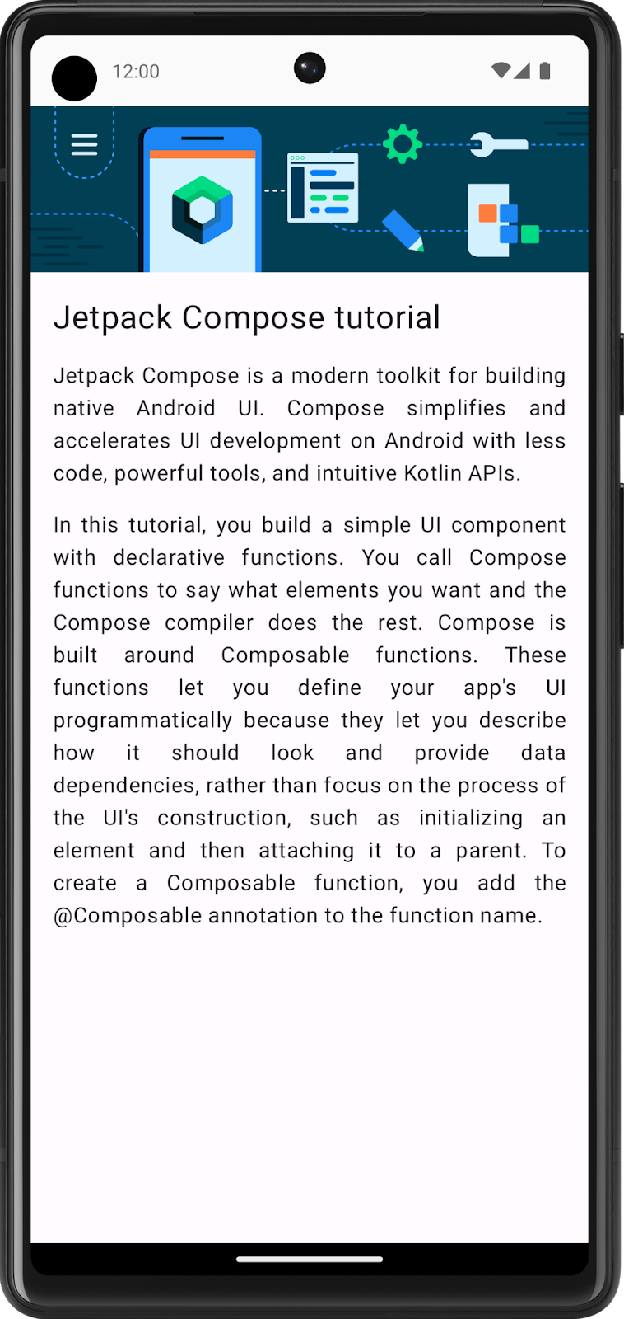

UI specifications

Follow this UI specification:

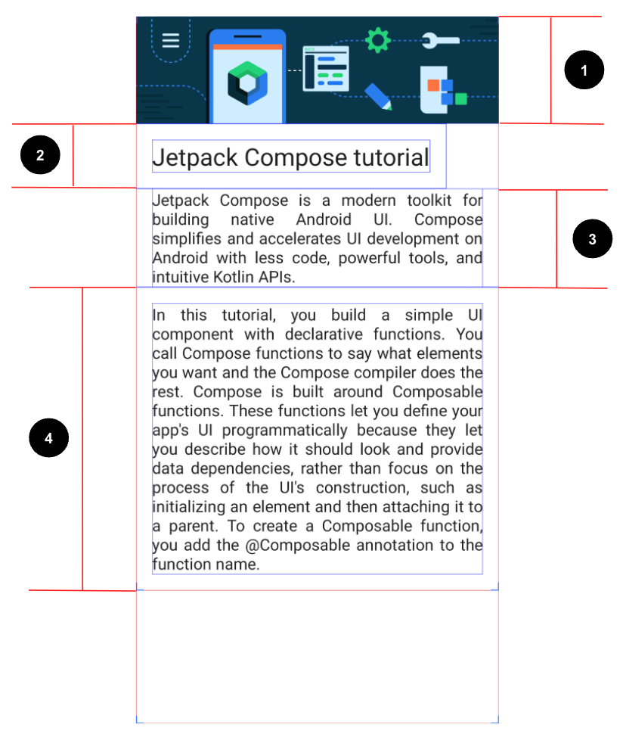

1. Set the image to fill the entire screen's width.
2. Set the first Text composable to a 24sp font size and 16dp padding (start, end, bottom, and top).
3. Set the second Text composable to a default font size, 16dp padding(start and end), and Justify text align.
4. Set the third Text composable to a default font size, 16dp padding (start, end, bottom, and top), and Justify text align.

Resources

You need [this image](https://github.com/google-developer-training/basic-android-kotlin-compose-training-practice-problems/blob/main/Unit%201/Pathway%203/ComposeArticle/app/src/main/res/drawable-nodpi/bg_compose_background.png) to [import into your project](https://developer.android.com/codelabs/basic-android-kotlin-compose-add-images#0) and these strings:

* Jetpack Compose tutorial
* Jetpack Compose is a modern toolkit for building native Android UI. Compose simplifies and accelerates UI development on Android with less code, powerful tools, and intuitive Kotlin APIs.
* In this tutorial, you build a simple UI component with declarative functions. You call Compose functions to say what elements you want and the Compose compiler does the rest. Compose is built around Composable functions. These functions let you define your app\'s UI programmatically because they let you describe how it should look and provide data dependencies, rather than focus on the process of the UI\'s construction, such as initializing an element and then attaching it to a parent. To create a Composable function, you add the @Composable annotation to the function name.

**Hint:** Which composable aligns its children vertically?

References

* [TextAlign.Justify](https://developer.android.com/reference/kotlin/androidx/compose/ui/text/style/TextAlign#Justify()) property

[3. Task manager](https://developer.android.com/codelabs/basic-android-kotlin-compose-composables-practice-problems?continue=https%3A%2F%2Fdeveloper.android.com%2Fcourses%2Fpathways%2Fandroid-basics-compose-unit-1-pathway-3%23codelab-https%3A%2F%2Fdeveloper.android.com%2Fcodelabs%2Fbasic-android-kotlin-compose-composables-practice-problems#2)

The Task Manager app lets users manage their day-to-day tasks and check the tasks that they need to complete.

In this exercise, you build a screen that users see when they complete all the tasks for a given day.

Final screenshot

After you finish the implementation, your design should match this screenshot:

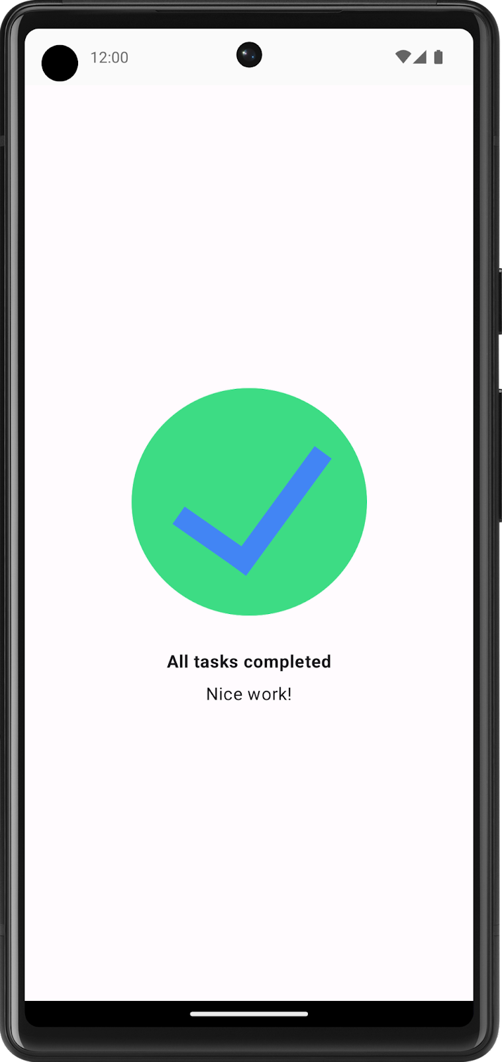

UI specification

Follow these UI specifications:

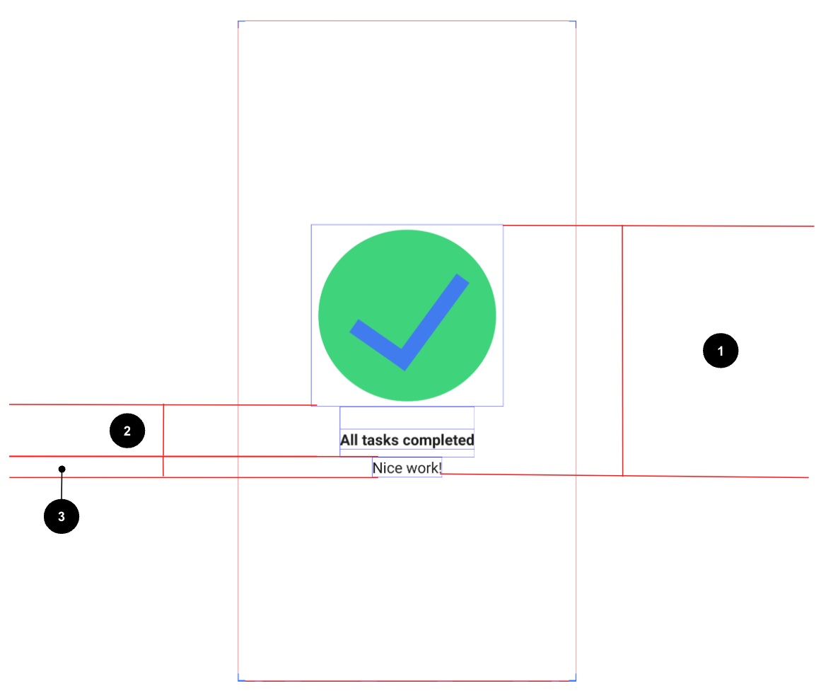

1. Center align all of the content vertically and horizontally on the screen.
2. Set the first Text composable to a Bold font weight, 24dp padding top, and 8dp padding bottom.
3. Set the second Text composable to a 16sp font size.

Resources

[This image](https://github.com/google-developer-training/basic-android-kotlin-compose-training-practice-problems/blob/main/Unit%201/Pathway%203/TaskCompleted/app/src/main/res/drawable/ic_task_completed.png), which you need to download and then import into your project, and these strings:

* All tasks completed
* Nice work!

[4. Compose quadrant](https://developer.android.com/codelabs/basic-android-kotlin-compose-composables-practice-problems?continue=https%3A%2F%2Fdeveloper.android.com%2Fcourses%2Fpathways%2Fandroid-basics-compose-unit-1-pathway-3%23codelab-https%3A%2F%2Fdeveloper.android.com%2Fcodelabs%2Fbasic-android-kotlin-compose-composables-practice-problems#3)

In this exercise, you need to apply most of the concepts that you learned so far and then go a step further to explore a new Modifier and properties. This might look like an extra challenge, but don't worry! You can check the **References** section for this problem, where you can find the links to these Modifier classes and properties, and use them for implementation.

You need to build an app that displays the information about the Composable functions that you learned.

The screen is divided into four quadrants. Each quadrant provides the name of a Composable function and describes it in one sentence.

Final screenshot

After you finish the implementation, your design should match this screenshot:

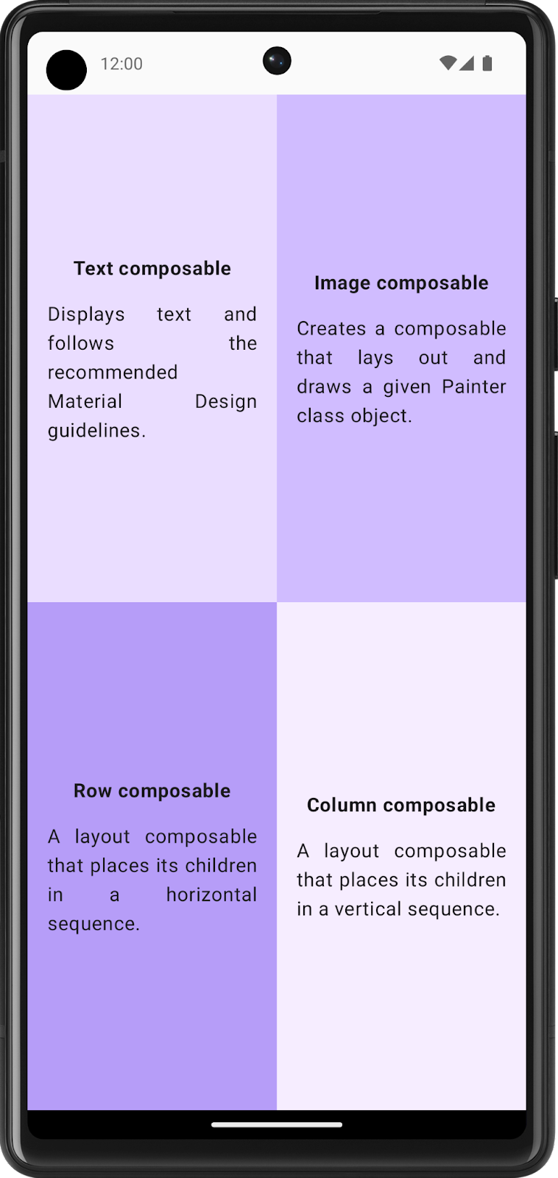

UI specifications

Follow these UI specifications for the entire screen:

* Divide the entire screen into four equal parts, each of which contains a Compose card and displays information about a Composable function.

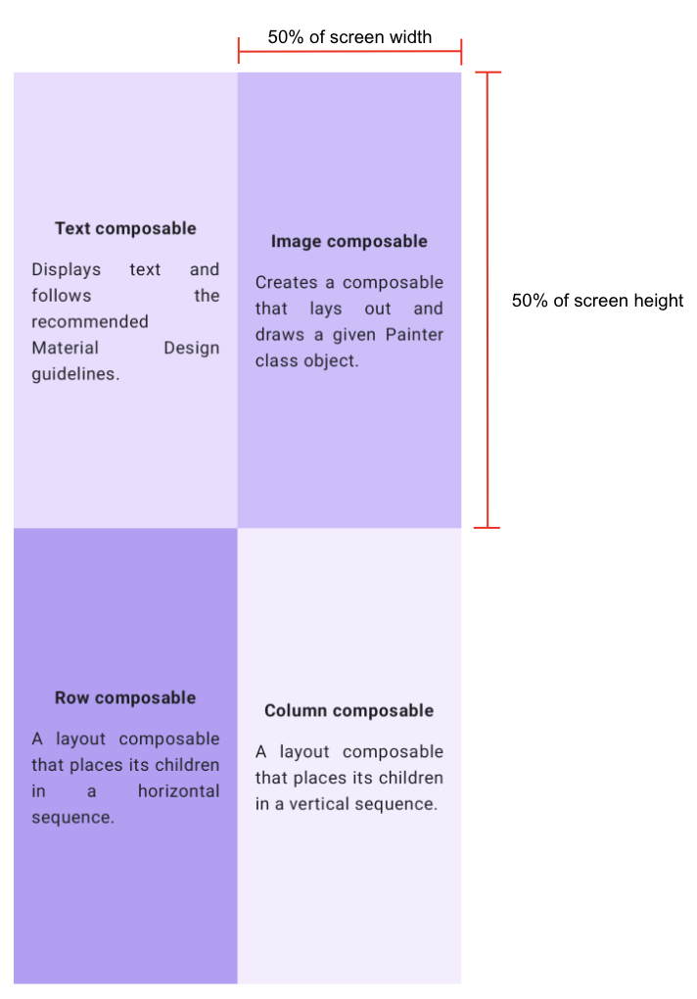

Follow these specifications for each quadrant:

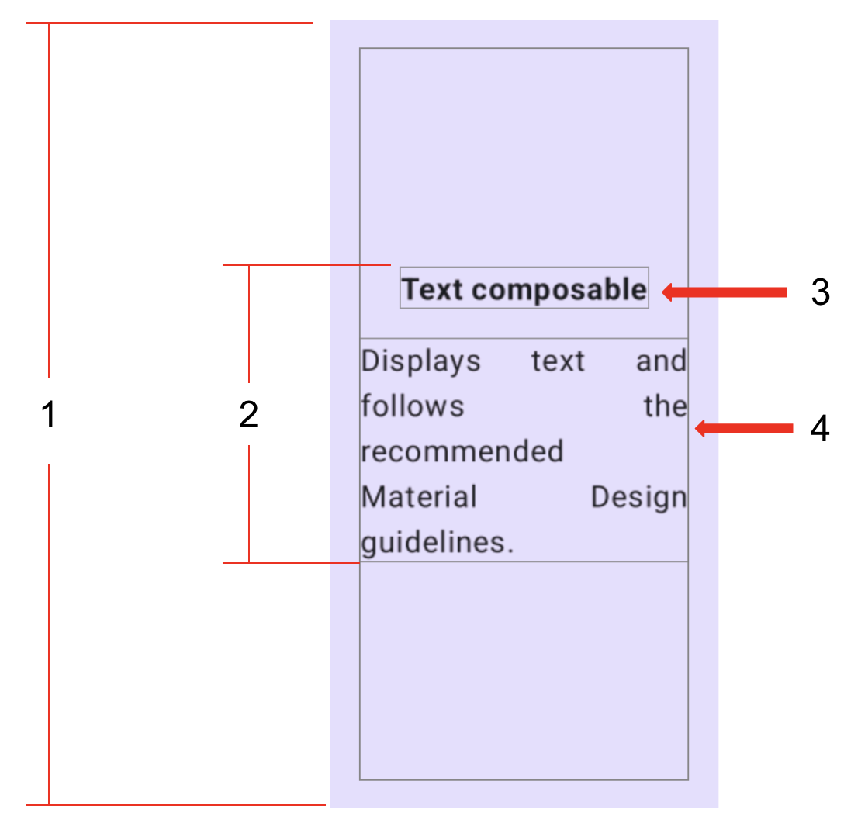

1. Set the entire quadrant (start, end, top, and bottom) to a 16dp padding.
2. Center align all of the content vertically and horizontally in each quadrant.
3. Format the first Text composable in bold and set it to a 16dp padding bottom.
4. Set the second Text composable to a Default font size.

Resources

These colors:

* Color(0xFFEADDFF)
* Color(0xFFD0BCFF)
* Color(0xFFB69DF8)
* Color(0xFFF6EDFF)

These strings:

* Text composable
* Displays text and follows the recommended Material Design guidelines.
* Image composable
* Creates a composable that lays out and draws a given Painter class object.
* Row composable
* A layout composable that places its children in a horizontal sequence.
* Column composable
* A layout composable that places its children in a vertical sequence.

References

* [Weight modifier](https://developer.android.com/reference/kotlin/androidx/compose/foundation/layout/RowScope#(androidx.compose.ui.Modifier).weight(kotlin.Float,kotlin.Boolean)) function
* [FontWeight.Bold](https://developer.android.com/reference/kotlin/androidx/compose/ui/text/font/FontWeight#Bold()) property
* [TextAlign.Justify](https://developer.android.com/reference/kotlin/androidx/compose/ui/text/style/TextAlign#Justify()) property

[5. Solution code](https://developer.android.com/codelabs/basic-android-kotlin-compose-composables-practice-problems?continue=https%3A%2F%2Fdeveloper.android.com%2Fcourses%2Fpathways%2Fandroid-basics-compose-unit-1-pathway-3%23codelab-https%3A%2F%2Fdeveloper.android.com%2Fcodelabs%2Fbasic-android-kotlin-compose-composables-practice-problems#4)

* [Compose article](https://github.com/google-developer-training/basic-android-kotlin-compose-training-practice-problems/tree/main/Unit%201/Pathway%203/ComposeArticle)
* [Task manager](https://github.com/google-developer-training/basic-android-kotlin-compose-training-practice-problems/tree/main/Unit%201/Pathway%203/TaskCompleted)
* [Compose quadrant](https://github.com/google-developer-training/basic-android-kotlin-compose-training-practice-problems/tree/main/Unit%201/Pathway%203/ComposeQuadrant)
* Project:
* Create a Business Card app

[1. Before you begin](https://developer.android.com/codelabs/basic-android-kotlin-compose-business-card?continue=https%3A%2F%2Fdeveloper.android.com%2Fcourses%2Fpathways%2Fandroid-basics-compose-unit-1-pathway-3%23codelab-https%3A%2F%2Fdeveloper.android.com%2Fcodelabs%2Fbasic-android-kotlin-compose-business-card#0)

You apply what you learned in this unit to create your own business card app. Unlike previous codelabs in which you were given step-by-step instructions to follow, here you're only provided with guidelines and suggestions about what you can build with the concepts that you learned so far. You're encouraged to use your creativity to build the app independently with limited guidance.

It's a challenge to build an app on your own, but don't worry because you've had enough practice! You can use the same skills that you learned in this new context. You can always refer to previous codelabs if you're unsure of how to implement certain parts of the app.

When you build this app on your own and solve the problems that you face along the way, you learn faster and retain the concepts longer. As a side benefit, the app is completely customized, so you can personalize and showcase it to your friends and family!

Prerequisites

* Ability to create and run a project in Android Studio.
* Experience with composable functions, which includes Text and Image composables.

What you'll learn

* How to build simple layouts with Row and Column composables, and arrange them with horizontalAlignment and verticalArrangement parameters.
* How to customize Compose elements with a Modifier object.

What you'll build

* An Android app that displays a business card.

What you'll need

* A computer with Android Studio installed.
* The Android logo to display in the app, which is provided for your use in this [repo](https://github.com/google-developer-training/basic-android-compose-training-assets/tree/main/Unit%201/Pathway%203/Project:%20business%20card%20app).

Here's a sample of how your app might look at the end of this project:

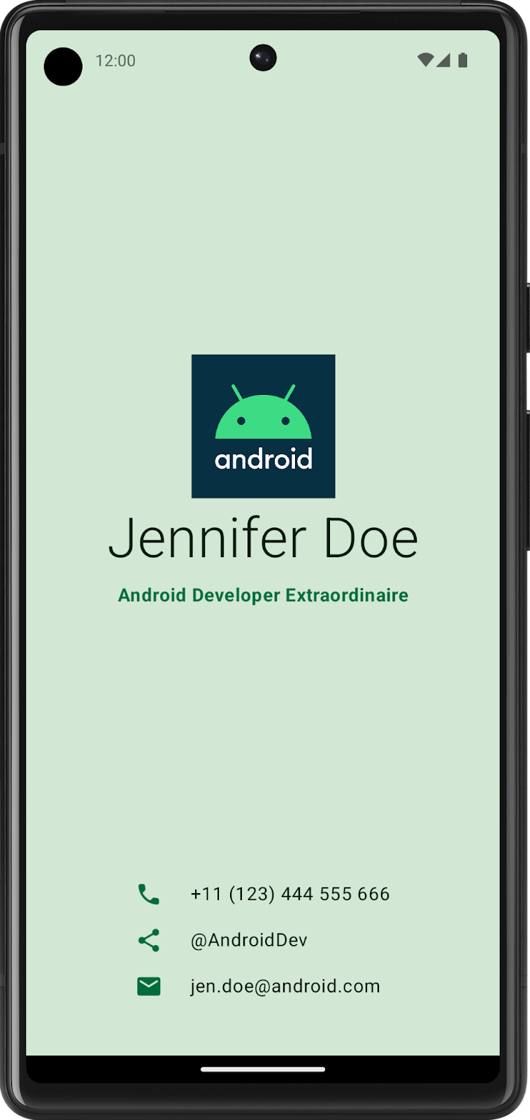

[2. Build UI with composables](https://developer.android.com/codelabs/basic-android-kotlin-compose-business-card?continue=https%3A%2F%2Fdeveloper.android.com%2Fcourses%2Fpathways%2Fandroid-basics-compose-unit-1-pathway-3%23codelab-https%3A%2F%2Fdeveloper.android.com%2Fcodelabs%2Fbasic-android-kotlin-compose-business-card#1)

Create a low-fidelity prototype

When you begin a project, it's useful to visualize how UI elements need to fit together on the screen. In professional-development work, oftentimes there are designers or design teams that provide developers with UI mockups, or designs, that contain exact specifications. However, if you don't work with a designer, you can create a low-fidelity, or low-fi, prototype on your own. Low-fi prototype refers to a simple model, or drawing, that provides a basic idea of what the app looks like.

Surprisingly, it's common to work without a designer, which makes the ability to sketch simple UI mockups a handy skill for a developer. Don't worry, you don't need to be a professional designer or even know how to use design tools. You can simply use a pen and paper, [Slides](http://slides.google.com/), or [Drawings](https://docs.google.com/drawings/) to help you build it.

To create a low-fidelity prototype:

1. On your preferred medium, add elements that make up your app. Some elements to consider include the Android logo, your name, title, and contact information, icons that indicate contact information. For example, a telephone icon indicates a phone number.
2. Add these elements in different positions and then evaluate them visually. Don't worry about getting it perfect the first time. You can always settle on one design now and iteratively improve it later.

**Note**: There are principles that help make design better for users, which is outside the scope of this project. To learn more, see [Understanding layout](https://m3.material.io/foundations/layout/understanding-layout/overview).

You may come up with a low-fi design that looks like this image:

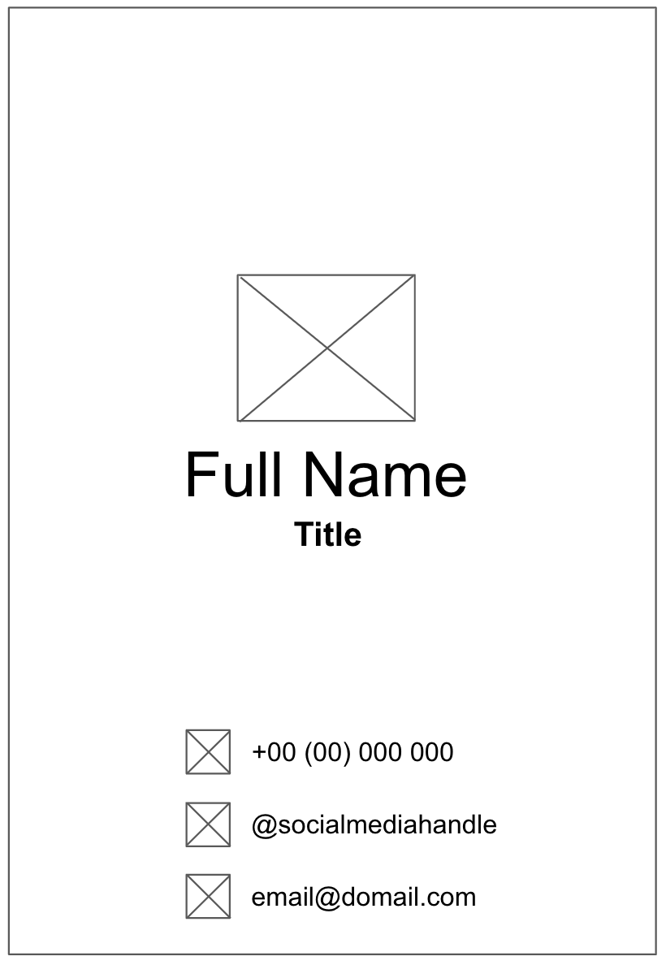

Convert design into code

To use your prototype to help translate your design into code:

1. Identify different logical sections of the apps and draw boundaries around them. This step helps you divide your screen into small composables and think about the hierarchy of the composables.

In this example, you can divide the screen into two sections:

* Logo, name, and title
* Contact information

Each section can be converted into one composable. This way you are able to build your UI with small composable building blocks. You can arrange each of these sections with layout composables, such as a Row or Column composable.

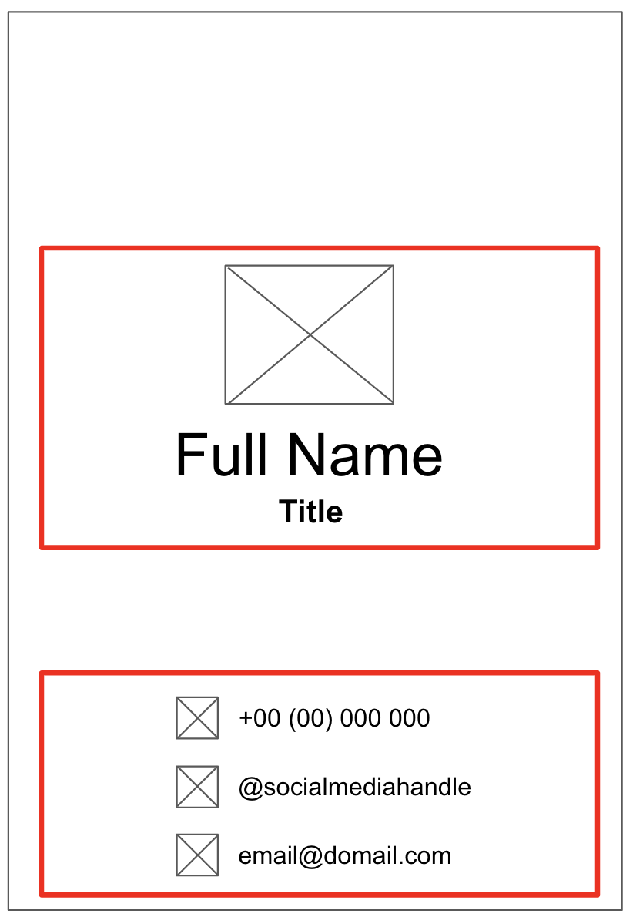

1. For each section of the app that contains multiple UI elements, draw boundaries around them. These boundaries help you see how one element relates to another in the section.

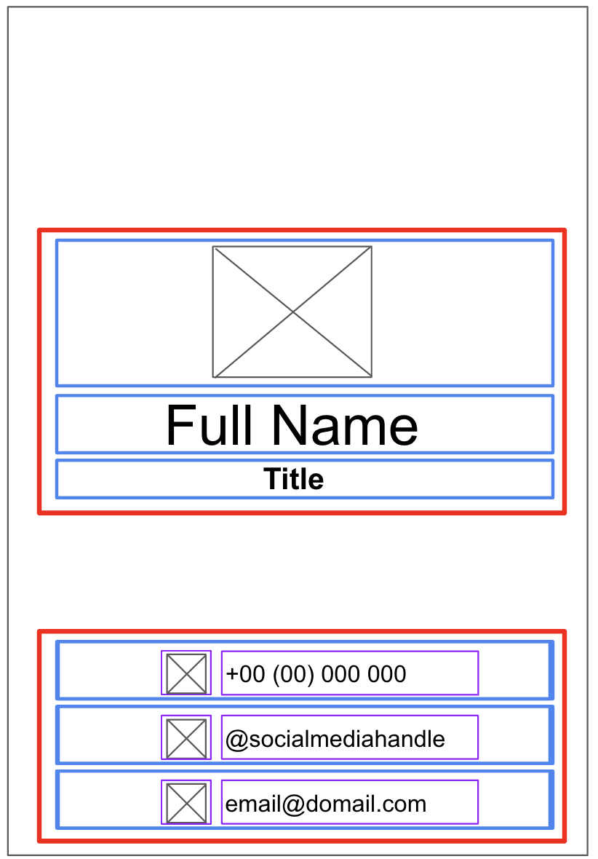

Now it's easier to see how you can arrange Text, Image, Icon, and other composables with layout composables.

Some notes on various composables that you may use:

Row or Column composables

* Experiment with various horizontalArrangement and verticalAlignment parameters in Row and Column composables to match the design that you have.

Image composables

* Don't forget to fill in the contentDescription parameter. As mentioned in the previous codelab, TalkBack uses the contentDescription parameter to help with the accessibility of the app. If the Image composable is only used for decorative purposes or there's a Text element that describes the Image composable, you can set the contentDescription parameter to null. You can also customize the size of the image by specifying the height and width modifiers in the modifier parameter.

Icon composables

* You can use the [Icon composable](https://developer.android.com/reference/kotlin/androidx/compose/material/icons/Icons) to add [icons from Material Design](https://fonts.google.com/icons?selected=Material+Icons). You can change the [Tint parameter](https://developer.android.com/reference/kotlin/androidx/compose/material/package-summary#Icon(androidx.compose.ui.graphics.vector.ImageVector,kotlin.String,androidx.compose.ui.Modifier,androidx.compose.ui.graphics.Color)) to adjust the icon color to fit the style of your business card. Similar to the Image composable, don't forget to fill in the contentDescription parameter.

Text composables

* You can experiment with various values of fontSize, textAlign, color, and fontWeight parameters to style your text.

Spacing and alignment

* You can use Modifier arguments, such as padding and weight modifiers, to help with the arrangement of composables.
* You can also use [Spacer composable](https://developer.android.com/reference/kotlin/androidx/compose/foundation/layout/package-summary#Spacer(androidx.compose.ui.Modifier)) to make spacing more explicit.

Color customization

* You can use custom color with the Color class and the color [hex code](https://www.w3schools.com/colors/colors_hexadecimal.asp) (a hexadecimal way to represent a color in RGB format). For example, the green color of Android has a hex code of #3DDC84. You can make your text the same green color with this code:

Text("Example", color = Color(0xFF3ddc84))

1. Run the app in an emulator or on your Android device to ensure that it compiles.

## [3. Good luck!](https://developer.android.com/codelabs/basic-android-kotlin-compose-business-card?continue=https%3A%2F%2Fdeveloper.android.com%2Fcourses%2Fpathways%2Fandroid-basics-compose-unit-1-pathway-3%23codelab-https%3A%2F%2Fdeveloper.android.com%2Fcodelabs%2Fbasic-android-kotlin-compose-business-card#2)

Hopefully, this guide inspires you to create your own business card with Compose! You can further customize your app with your own logo or even your own photo! After you're done, showcase your work with your friends and family. If you'd like to share your work on social media, use the hashtag #AndroidBasics.